Indie Beer Week launched

14/02/2025 by Timothy Hampson

Industry

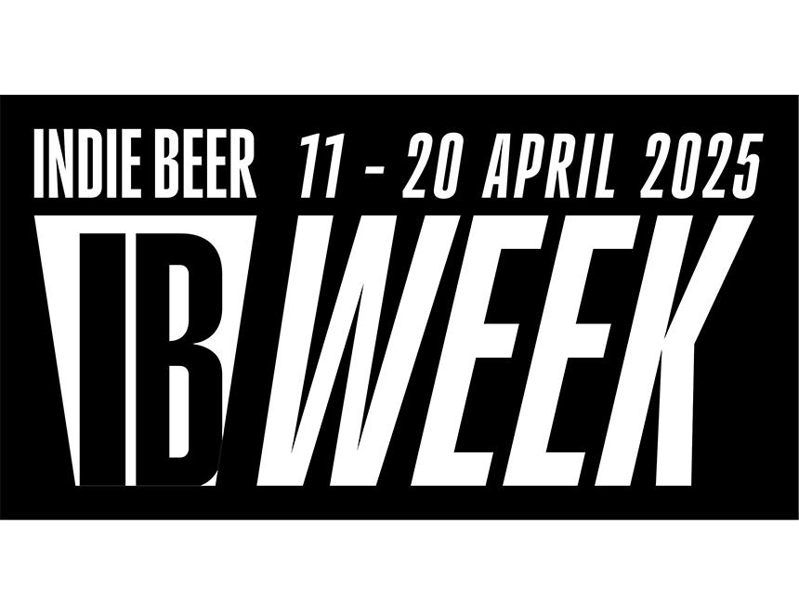

A UK-wide week has been launched by smaller producers and pub operators to promote independent beer. “It feels more important than ever to help customers make informed choices about supporting local, independent breweries through the beers that they buy. The Indie Beer campaign does just that,” said Billericay brewery owner Richard Coppack. Building on the launch of the Indie Beer campaign at the end of 2024, Indie Beer Week will take place 11-20 April. The celebration is being launched at the Maltings Beer Festival in Newton Abbot, Devon, ahead of events taking place across the UK. Society of Independent Brewers and Associates (SIBA) spokesman Neil Walker said: “Indie Beer Week is a national celebration of great independent beer and a chance for our superb pubs and breweries to attract new customers, or give regulars a great new experience by running special events, festivals, tap takeovers, meet the brewer evenings or tastings which celebrate local producers. “The huge response to the launch of the Indie Beer campaign, which is now supported by more than 400 breweries and has been used by tens of thousands of consumers, shows how important supporting local independent beer is to people. “The Indie Beer campaign and Indie Beer Week shines a light on genuinely independent breweries and makes it easier for consumers to find out what is or isn’t independent via the IndieBeer.uk website.” YouGov data published by SIBA found 75 per cent of people surveyed believe consumers are being misled when buying beer from once-independent craft breweries. People were shown images of five beers that have been bought out by global companies: Beavertown Neck Oil (Heineken), Fuller’s London Pride (Asahi), Camden Hells (Budweiser), Brixton Reliance Pale Ale (Heineken), and Sharp’s Doom Bar (Molson Coors). When told these breweries were owned by global companies and not independent, three-quarters of people surveyed said they felt buyers were being misled, with the figure for the beer drinkers even higher at 81 per cent. The campaign is open to all independent UK breweries and is supported by consumer and industry organisations representing the beer-and-pub sector, including CAMRA, British Institute of Innkeepers, and the Independent Family Brewers of Britain.