CAMRA brands Crooked House appeal an insult

13/02/2025 by WB Reporter

Campaign

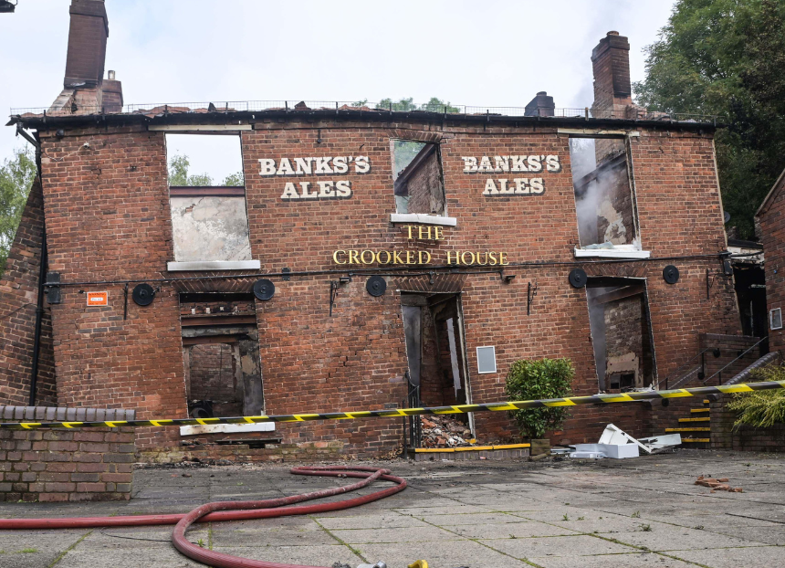

With the appeal for the Crooked House (pictured) case set to begin on 11 March, CAMRA has said if the decision to rebuild is reversed it would make a mockery of pub protection. Pub and Club Campaigns director Gary Timmins said: “The appeal requested by the owners of the Crooked House, ATE Farms Limited, was expected but no less insulting. Accountability must be taken for the complete destruction of this iconic pub, and this hearing undermines South Staffordshire Council’s enforcement notice to rebuild it. “The Crooked House in Himley was destroyed more than 18 months ago, and this appeal delays a much-needed outcome. The UK’s wonkiest pub needs to be rebuilt, back to what it was prior to the fire, as ordered by South Staffordshire Council. If this appeal leads to this decision being reversed, it would be a complete mockery of pub protection and campaigning efforts from the local community. “The Crooked House saga lifted the lid on the wider scandal of potentially unlawful pub conversions and demolitions across the UK, and we continue to demand tighter, stronger planning policies and a requirement in law to rebuild pubs brick-by-brick.” Photo from Alamy. Do not republish.