Gold takes gold

12/02/2025 by WB Reporter

Campaign

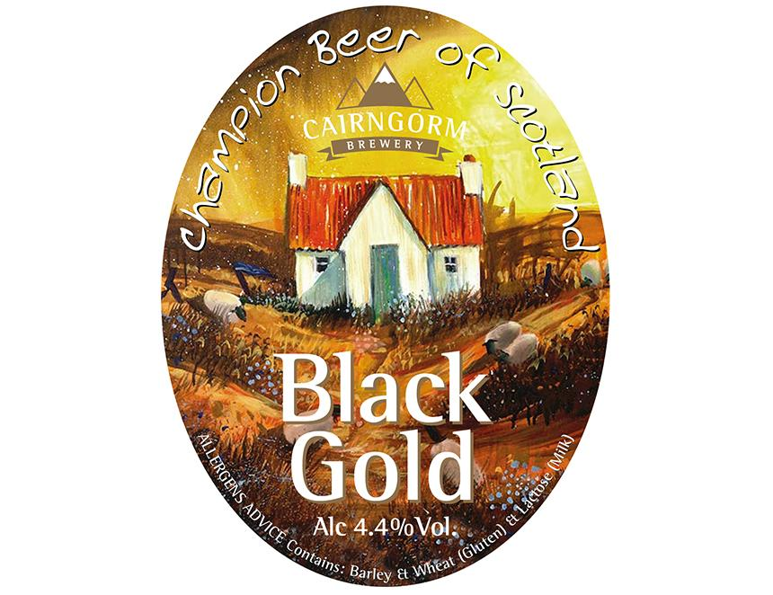

Cairngorm’s Black Gold has been crowned CAMRA’s Champion Winter Beer of Britain at the Great British Beer Festival Winter 2025. Following more than a year of blind-tasting panels and regional heats, the final round of judging took place at the festival with the 4.4 per cent ABV session stout from Scottish brewer Cairngorm taking the overall crown.  Champion Beer of Britain judging panel organiser Christine Cryne described the beer as having: “Roasted coffee nose with dark fruits and earthy hops. The flavour is of refreshing coffee with sweet malt, orange and dark fruits, leading to a satisfying dry, chocolatey finish. Very easy drinking.”   Cairngorm’s sales director Merlin Sandbach said: “After winning Champion Beer of Scotland two years consecutively, and four years in total, the team is ecstatic. Our head brewer Liam, Gemma from productions and I are absolutely over the moon!" The runners up were Sarah Hughes Snowflake (8 per cent), which took home silver, and Grain Slate (6 per cent) which claimed bronze. CAMRA’s awards director Gary Timmins said: “Massive congratulations to Cairngorm for its fantastic win plus all the amazing category winners in this year’s competition. Black Gold is a cracking pint and, even in such an incredibly competitive shortlist, it is a worthy winner. “Every year our judges find it harder to pick a winner, which speaks volumes of the brewing talent in the UK. Despite their evident quality, our brewers struggle to find a place at the bar of our locals. Soulless global conglomerates have a greedy stranglehold on the industry, restricting true customer choice and our independent brewers’ access to market. “Everyone should get out to their pub, social club or taproom and look out for one of your local brews – it might be one of our award-winning beers!” This year’s award winners will be available at the Great British Beer Festival Winter this week while stocks last.  The category winners from the competition will be entered into the overall Champion Beer of Britain contest later this year.   The Champion Winter Beer of Britain competition kicked off CAMRA’s Great British Beer Festival Winter 2025, which is running from 12-15 February at the Magna Science Adventure Centre in Rotherham, Yorkshire. More information about the Great British Beer Festival Winter, including tickets, can be found here: winter.gbbf.org.uk  Who won what Overall: Gold: Cairngorm Black Gold Silver: Sarah Hughes Snowflake Bronze: Grain Slate  Brown ales, red ales, old ales and strong milds: Gold: Tintagel Caliburn Silver: Orkney Dark Island Bronze: Merlin Dark Magic  Session stouts and porters:  Gold: Cairngorm Black Gold Silver: Blackjack Manchester Stout Bronze: Dancing Duck Dark Drake  Strong stouts and porters: Gold: Grain Slate Silver: Fixed Wheel Blackheath Stout Bronze: Acorn Gorlovka Imperial Stout   Barley wines and strong ales: Gold: Sarah Hughes Snowflake Silver: Abbeydale Black Mass  Bronze: Exmoor Beast  Speciality, differently produced: Gold: Allendale Adder Lager Silver: Anspach & Hobday Smoked Brown Bronze: Cromarty Red Rocker  Speciality, differently flavoured: Gold: Siren Broken Dream Breakfast Stout Silver: Mr Winter’s Vanilla Latte  Bronze: Purple Moose Cwrw Ysgawen/Elderflower Ale