Why you can’t miss CAMRA’s winter celebration

10/02/2025 by Madeleine Hardman

Campaign

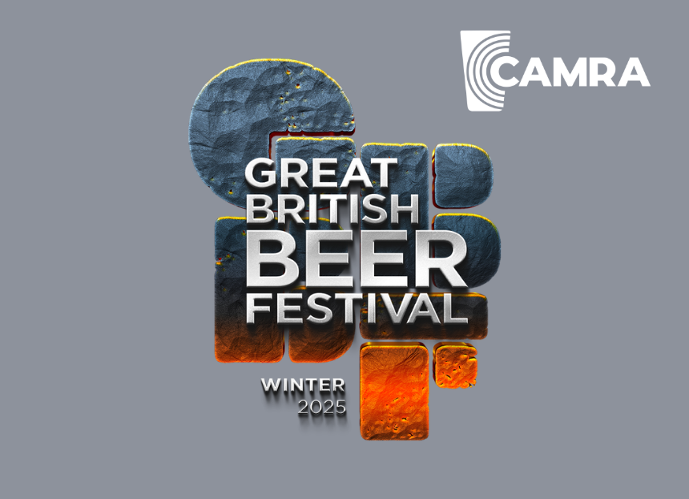

The Great British Beer Festival Winter is coming to Rotherham for the first time from 12-15 February. Here festival organiser Andrew Taylor reveals what visitors can expect and the challenges of putting together one of CAMRA’s biggest events.   What can attendees expect from the first Great British Beer Festival Winter at the Magna Science Adventure Centre?   Attendees will see a vast array of real ales and ciders, as you would expect at a CAMRA beer festival, 300-plus to be more accurate. We are also bringing the world beer bar with a selection of draught beers, bottles and cans available giving a unique look at other breweries we wouldn’t normally see. We will also be bringing a great line up of entertainment on all days of the festival. There will be tasting events throughout the week including the Champion Beer of Britain Winter session hosted by Roger Protz, taking a tour of some of the beers in the competition from the exclusive Champion Beer of Britain Bar. We will also be having an alternative bar, this will have low and no-alcohol beers, plus wine and spirits for the non-beer and cider drinkers in your group.  What makes centre a good venue?  Magna has a long history with beer festivals, hosting the Rotherham Real Ale and Music Festival for a number of years. The venue is close to Rotherham and Meadowhall (Sheffield), with good transport links from lots of locations including the festival shuttle, (see website for details). The venue has large open spaces to give plenty of room for bars, music and our new CAMRA Village that houses everything from membership services to the Discovery Bar, which hosts mini-tastings during the festival.  What are some of the challenges of being a festival organiser?  One of the few I have faced this year was that our original venue was unfortunately not available, however the search for an alternative led us to securing the fantastic Magna Science Adventure Centre. Other challenges included setting up a new working party, making sure we don’t forget something vital and juggling the day job.  What was something unexpected you've found while taking on this role?  Starting a new job in the middle of organising the festival wasn’t the ideal time for myself, having to juggle finishing my old role, training for my new one and also making sure plans are still progressing for the festival, so thanks go to the Great British Beer Festival Winter working party for helping me get this festival off the ground.  How do you go about finding the entertainment for the festival?  Well, I do get lots of help in this area, Stuart Burns has done an amazing job sourcing a great line-up of bands and acts to play throughout the festival, from cover bands to a brass band.  The festival will be hosting a tasting session of Thornbridge Union beer, what makes this beer and the history behind it so special?  The union system has been a unique part of British brewing for hundreds of years, and thanks to Thornbridge, will continue into the future, developing new beers on this system starting with Union. The tasting session will go through the history and tasting some of the beers produced from this, plus it will be launching a brand new union beer at the festival!  The Champion Winter Beer of Britain is crowned at the festival, can you let us know some of your favourite winter beers?  Well I do like a wide variety of beers from pale to Imperial stouts, but I would say my favourites at the moment are:   Brew York, Tonkoko 10.6 per cent  Brouwerij, St Bernardus Winter Ale 10 per cent  Acorn, Gorlovka 6 per cent  Abbeydale, Black Mass  6.66 per cent (I do like a black IPA!)