Pubco’s ‘profitable growth’

10/02/2025 by Timothy Hampson

Industry

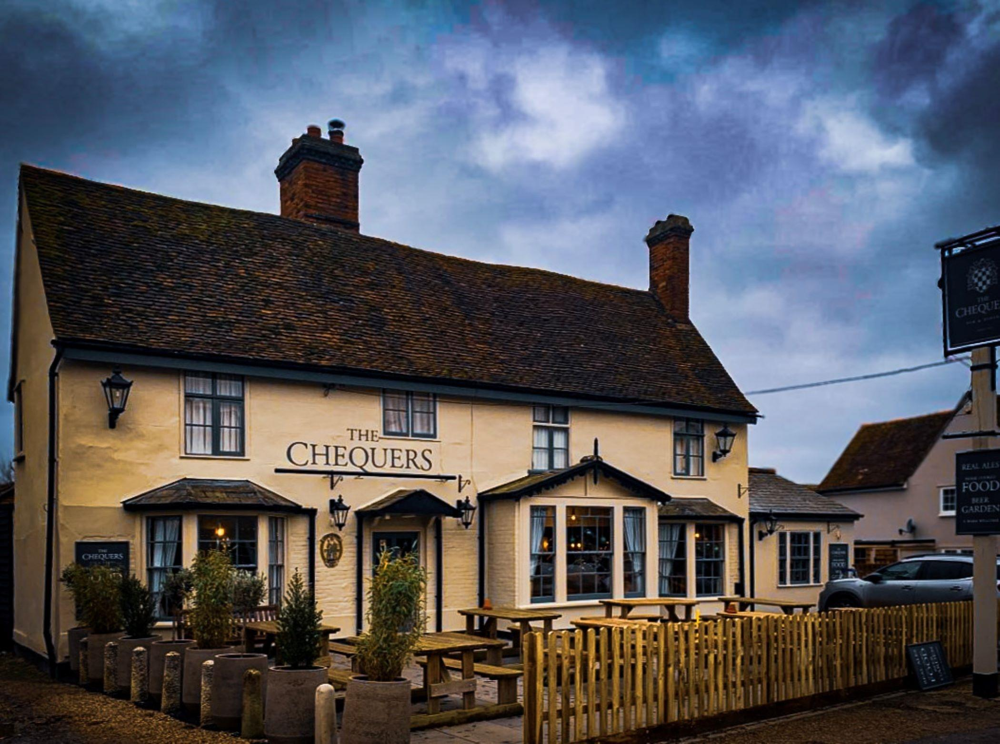

Results released by a major UK leased-and-tenanted pub operator showed that profits are being made in at least one part of the troubled hospitality industry. Admiral Taverns backed itself to “weather the impact” of the forthcoming hike in employer National Insurance contributions and the living wage, which take effect from April, while expressing its appetite for further site acquisitions. It currently has an estate of about 1,400 pubs across the UK. The company continued focus on strategic expansion with the support of investors, Proprium Capital Partners, with significant investment of £36.8m across the group’s pub estate over the period. The investment included buying 37 pubs from Fuller, Smith and Turner and 18 from Marston’s in the year. The group's financials for the 52-week period ended 26 May 2024 showed a turnover of £194.5m and an underlying operating profit of £37.2m. CEO Chris Jowsey said: “I’m particularly proud of the strong progress we have made against our strategic plans, delivering profitable growth across our estate as we continue to expand our footprint and cement our position as a champion of UK community pubs. “Indeed, in these evolving macro conditions, the resilience of our model has come to bear, and we anticipate a further structural shift towards leased and tenanted pubs. “The investments made across our estate with over £36m reinvested over the year in supporting our licensees to develop and improve their wet-led pub offering, have clearly been fundamental to helping drive trading performance. “However, it is perhaps the breadth of our wider support offering, from investment in energy-saving initiatives to enhancements of our pub’s retail offering, that have been critical in helping our entrepreneurial licensees optimise profitable trade growth. “Current trading is ahead of our expectations, demonstrating the strength and resilience of our business and estate, and the group remains well positioned to continue to deliver profitable group growth and sustained strategic progress.” Pictured: Chequers, Great Tey, Essex