CAMRA welcomes Jennings purchase

07/02/2025 by WB Reporter

Industry

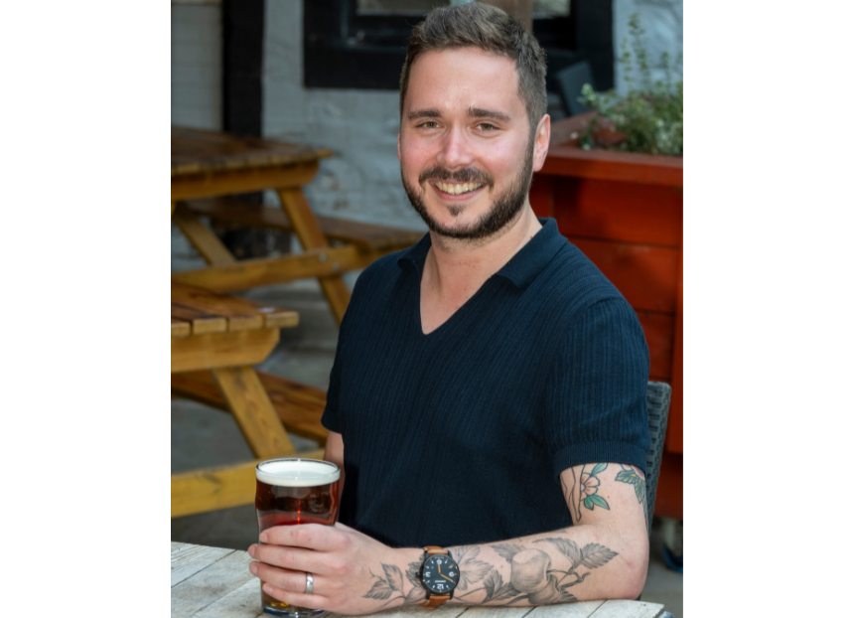

Following the news that Jennings brewery in Cockermouth, Cumbria, has been bought and brewing will restart at the site, CAMRA national chairman Ash Corbett-Collins said: “When the historic Jennings brewery was closed in 2022 by Carlsberg Marston’s Brewing Company [now Carlsberg Britvic], it was yet another victim of the global brewer’s consolidation quest that has seen regional brewers shuttered, and classic cask beers pulled from bars. The casualty list including the likes of Banks’s, Ringwood and Wychwood is a rotten reminder that large companies do not care about our brewing history. “To hear that Jennings will make a comeback is fantastic news, but it should have never been closed in the first place. It will be great to see nearly 150 years of brewing heritage return to Cumbria, which can only benefit the local community and economy. I wish the new local owners the best of luck and look forward to having a pint of Jennings!”