Free beer qualifications for women’s brew day participants

07/02/2025 by Timothy Hampson

Industry

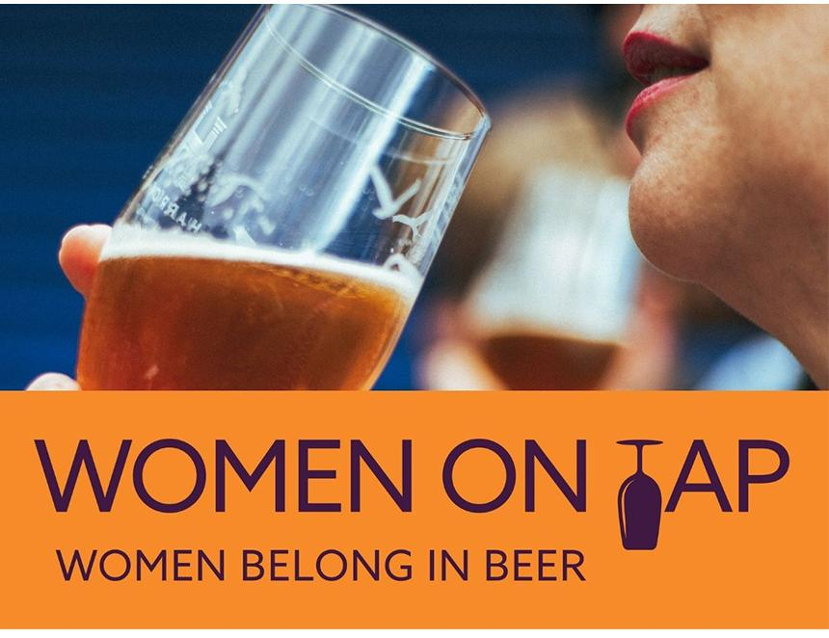

The Wine & Spirit Education Trust (WSET), the global leader in drinks education, has partnered with the 2025 International Women’s Collaboration Brew Day campaign, offering 18 free beer qualifications to participants. Founded in 2013 by Sophie de Ronde, head brewer at Burnt Mill brewery, Suffolk, International Women’s Collaboration Brew Day is a worldwide annual event that takes place on and around 8 March in conjunction with International Women’s Day. The WSET Level 1 Award in Beer is a globally recognised qualification for anyone interested in learning the basics about lagers, ales, sours and more. Through a short and interactive course, students learn the foundations of beer production, styles, service, food pairing and tasting. All participants in any brew days signed up to the main IWCBD 2025 campaign are eligible to register for a chance to be offered one of the places, and 18 names will be drawn at random. The award has a minimum requirement of six hours of guided learning with a WSET course provider, including a 45-minute exam. This is a fully guided course with no private study requirement. As IWCBD Education Partner, WSET will create a custom online course for the Level 1 Award in Beer exclusively for 18 global IWCBD participants across all regions (EMEA, Americas, and APAC). It’s likely the course will take place in May with guidance from an expert educator alongside networking opportunities, and the participants will gain a globally recognised qualification once they’ve successfully passed their exam. The opportunity to access professional development and new qualifications is a critical aspect of getting more women into beer roles, including brewing and leadership, according to Rachel Auty, founder of Women On Tap CIC and leader of IWCBD 2025. Rachel said: “With women significantly underrepresented across the beer industry, offering qualifications in such an accessible way is a fantastic step forward. This initiative will help women develop their interest in beer and, I hope, inspire many to advance – or even start – their careers in the field. “I’m incredibly grateful to WSET for their support. From the outset, I was determined to ensure this campaign left a lasting legacy for women in beer, and this initiative is a brilliant way to achieve that.” For more details on IWCBD and how to sign up or get involved in an existing 2025 project, visit iwcbd.org.