Winter fest debut for latest Burton union beer

06/02/2025 by Timothy Hampson

Campaign

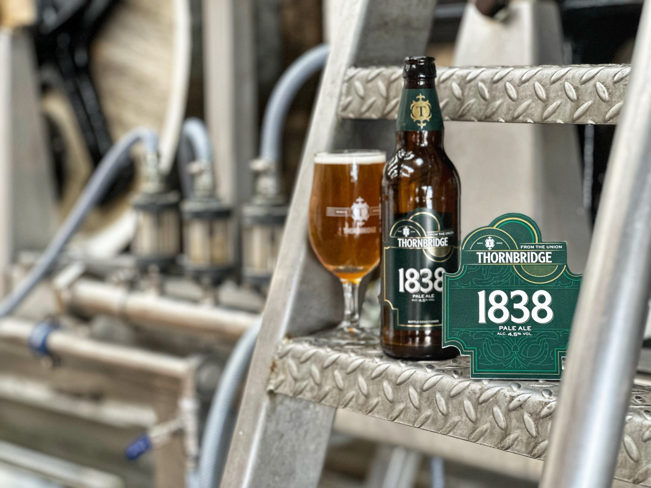

The latest Thornbridge beer created on its historic Burton union brewing system is to make its debut at CAMRA’s flagship winter beer festival. In 2024, Thornbridge brewery preserved a historic piece of British brewing heritage, the Burton union system, which faced the axe after it was retired by Carlsberg Marston’s. Thornbridge transported the equipment to Bakewell, where it has been in active use ever since, including for a special batch of its IPA, Jaipur, and collaborations with Odell Brewing and The Kernel. Following the installation, Thornbridge introduced The Union, a classic IPA made with British ingredients, into its core range. The beer has been met with widespread acclaim in both bottle and cask. Building on this success, Thornbridge is launching a second core union brand. Named after the year Peter Walker patented the Burton union system, 1838 is a premium pale ale and uses Otter malt with Savinjski Goldings hops to create a full-bodied beer with a light amber hue. Expect rich, biscuity malt flavours, balanced by floral hop notes and a crisp, refreshing finish. Thornbridge will unveil 1838 at CAMRA’s Great British Beer Festival Winter, held from February 12 to 15 March at the Magna Science Adventure Centre in Rotherham. For more details go to winter.gbbf.org.uk As part of the launch, Thornbridge will host a tasting with beer writer Roger Protz on the Thursday, run a Discovery Bar on Friday, and operate a brewery bar featuring both cask and keg options throughout the festival.