CAMRA and Mr Porky – a glass act

04/02/2025 by WB Reporter

Campaign

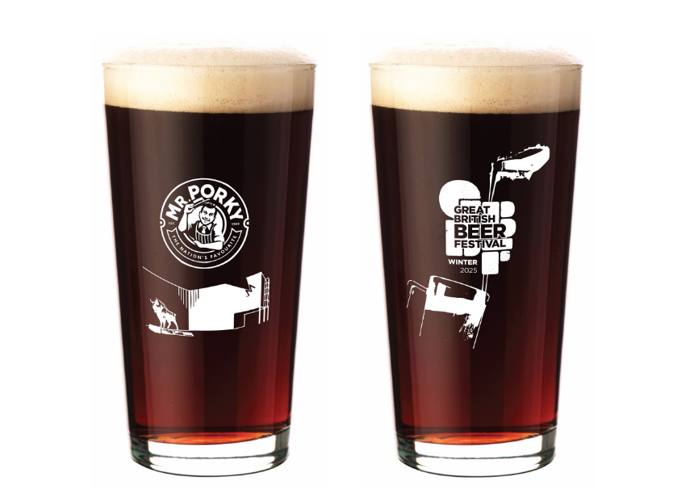

CAMRA has unveiled its latest collectible glass for the upcoming Great British Beer Festival Winter sponsored by Great Taste award-winning pork scratching and snack brand Mr Porky. The festival takes place 12-15 February at the Magna Science Centre, Rotherham and will feature a wide selection of cask beer, traditional ciders and perries, plus a varied food offering and an extensive entertainment line-up. CAMRA’s latest collectible glass will be exclusively available to festival-goers and brings together two cornerstones of UK pub culture – CAMRA and Mr Porky. CAMRA events director Catherine Tonry said: “Our oversized, lined glasses are a staple of the UK beer festival scene, so partnership with the quintessential pub snack Mr Porky is a recipe for a perfect pint. Great British Beer Festival Winter will offer a huge range of beers, ciders, perries and a Champion Winter Beer of Britain Bar where you can sample all the competition entries, and of course, pork scratchings.”