Time to plan your festival trips!

02/02/2025 by George Robbins

Campaign

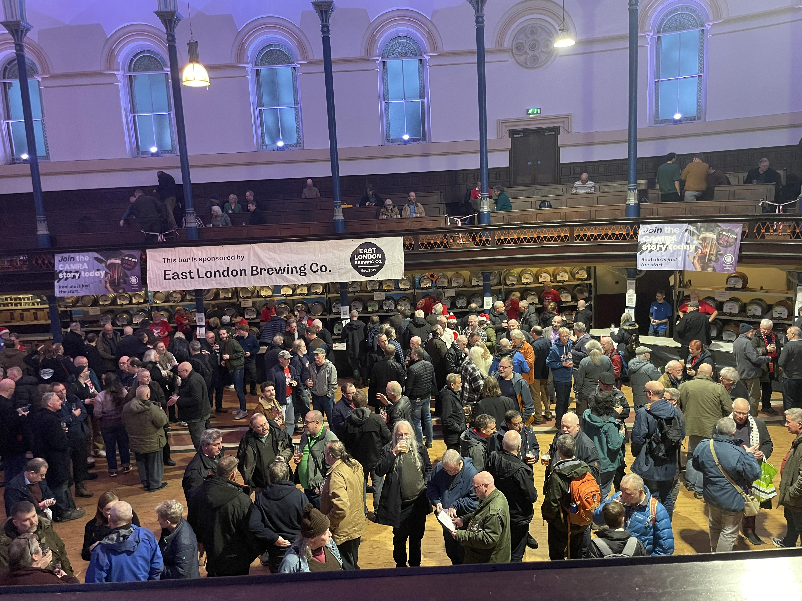

Plan your next festival trip from the list below. To see all upcoming CAMRA events, visit events.camra.org.uk   Bent and Bongs Beer Bash, 6-8 February  Atherton Roller Rink, Bolton Road, Atherton, M46 9JG  bentnbongs.com    Tewkesbury Winter Beer Festival, 6-8 February  65 Barton St, Tewkesbury, GL20 5PX  facebook.com/profile.php?id=100064840352359    Elysian Winter Beer Festival, 7-8 February  The Maltings, Ship Lane, Ely, CB7 4BB  ely.camra.org.uk/viewnode.php?id=170324    Chesterfield Beer Festival, 7-8 February  Holywell Street, Chesterfield, S41 7SA  chesterfield.camra.org.uk/chesterfield-camra-winter-beer-festival-2025    Great British Beer Festival Winter, 12-15 February  Magna Science Adventure Centre, Magna Way, Templeborough, Rotherham, S60 1FD  winter.gbbf.org.uk    Liverpool Beer Festival 2025, 13-15 February  Metropolitan Cathedral Crypt, Liverpool, L3 5TQ  liverpoolcamra.org.uk    Hucknall Beer Festival 2025, 13-16 February John Godber Centre, Ogle Street, Hucknall, NG15 7FQ johngodbercentre.co.uk/hucknall-beer-festival   Darlington Beer Festival 2025, 21-23 February  Hopetown Darlington, McNay Street, Darlington, DL36SW  darlo.camra.org.uk/viewnode.php?id=229748    Chappel Winter Beer Festival, 27 February-1 March  East Anglian Railway Museum, Chappel & Wakes Colne Station, Station Road, Chappel & Wakes, Colne, CO6 2DS  chappelbeerfestival.org.uk/winter    Bradford Beer and Cider Festival 2025, 27 February-1 March  Victoria Hall, Victoria Road, Saltaire, Shipley, BD18 3JS  bradfordcamra.org.uk/bbcf2025    37th Wigan Beer Festival, 27 February-1 March  Robin Park Sports Centre, Loire Drive, Newtown, Wigan, WN5 0UL  beerfestival.wigancamra.org.uk    Gosport Winterfest XXXI, 28 February-1 March  Thorngate Halls, Bury Road, Gosport, PO12 3QX  pseh.camra.org.uk/Winterfest.php    48th Loughborough Beer Festival, 6-8 March  Polish Club, True Lovers' Walk, Loughborough, LE11 3DB  loughboroughcamra.co.uk/beer-festivals/48th-loughborough-beer-festival    Chester Beer Festival, 14-15 March  Northgate Street, Chester, CH1 2HJ  westcheshire.camra.org.uk/viewnode.php?id=230888    Burton and South Derbyshire Beer Festival, 27-29 March  King Edward Place, Burton, DE14 2EB  burtoncamra.wordpress.com/beer-festival    20th Maldon Beer and Cider Festival, 2-5 April Cygnet Room, Swan Hotel Bar & Grill, 73 High Street, Maldon, Essex, CM9 5EP maldonanddengiecamra.org.uk/MaldonBeerFestival   47th Farnham BEEREX, 10-12 April Farnham Maltings, Bridge Square, Farnham, GU9 7QR  farnhambeerex.org.uk/index.html   Oldham Beer and Cider Festival, 11-12 April Queen Elizabeth Hall, West Street, Oldham, OL1 1NL rob.camra.org.uk/viewnode.php?id=60320   Chippenham Beer Festival, 25-26 April Sadlers Mead, Chippenham, Wiltshire, SN15 3PA nwwiltscamra.org.uk/viewnode.php?id=177502