Firs’ first

31/01/2025 by WB Reporter

Campaign

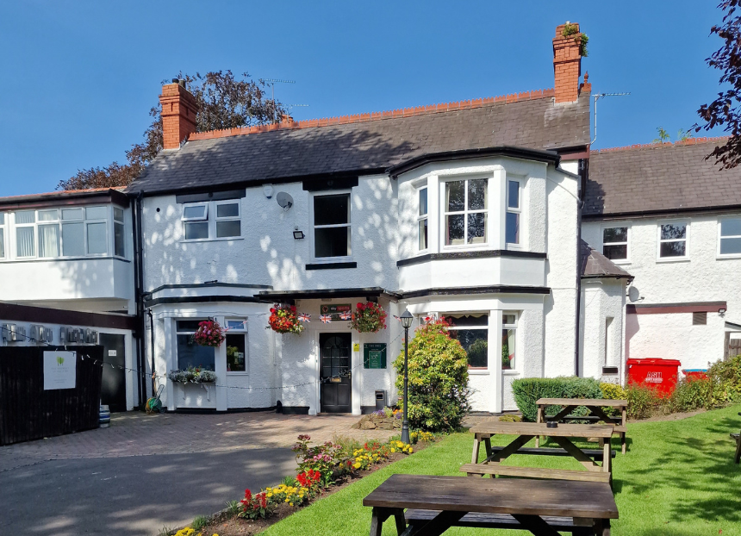

The Firs Club in Codsall, Staffordshire, is CAMRA’s Club of the Year 2024, finally taking the national crown after winning the West Midlands regional title three years in a row.  The multi-award-winning social club is a must-visit for cask beer fans, with a microbrewery on-site which features in its November festival – a highlight in the local beer calendar. Firs brewery has been in CAMRA’s Good Beer Guide and produces a core range of ales, including some exclusives for the club. As well as Firs beers, the bar offers five locally sourced ever-changing cask ales, usually including one mild.   In the comfortably furnished club, guests can enjoy a pint in the bar, relax in the quiet lounge, play pool and darts in the separate sports areas or play snooker upstairs. The club prides itself on being the “number one place in Codsall to watch football”, and in the warm weather hosts live matches outside on the large decking area.   The club hosts many events for the local community and provides a welcoming space for private events including weddings, parties and functions as a meeting space for groups.   Club of the Year coordinator Phil Gregg said: “The 2024 competition was extremely close fought. Each of our finalists were of an extremely high standard, and it made the judging harder than ever! We’re delighted to be announcing a first-time winner, and the Firs Club epitomises what’s great about UK venues like these, and how important they are to their local communities.”  Club manager Anna Reynolds said: “Well what can I say, it's a great surprise and honour to win CAMRA’s Club of the Year award, it's something we thought was out of our reach. We couldn't have done it without the support of our club members, committee, CAMRA members and, of course, the staff who work hard to make the club a great place to visit and hopefully stay for a while.”  West Midlands regional director Shelly Bentley said: “This is a fantastic achievement for the Firs Club. Anna and the team work incredibly hard to create a communal atmosphere and provide a stellar line up of beers for locals to enjoy. I hope this is the first of many successes for the club and its community. 2024 has been a fantastic year for the West Midlands, this award for the Firs Club is truly deserved and comes just a couple of weeks after the Bailey Head in Oswestry was named Pub of the Year 2024.”   The other finalists were: Haydock Reading Room, St Helens; Kettering Midland Band Social Club, Kettering; Marden Village Club, Marden.