Charity brew’s Peak performance

29/01/2025 by Timothy Hampson

Industry

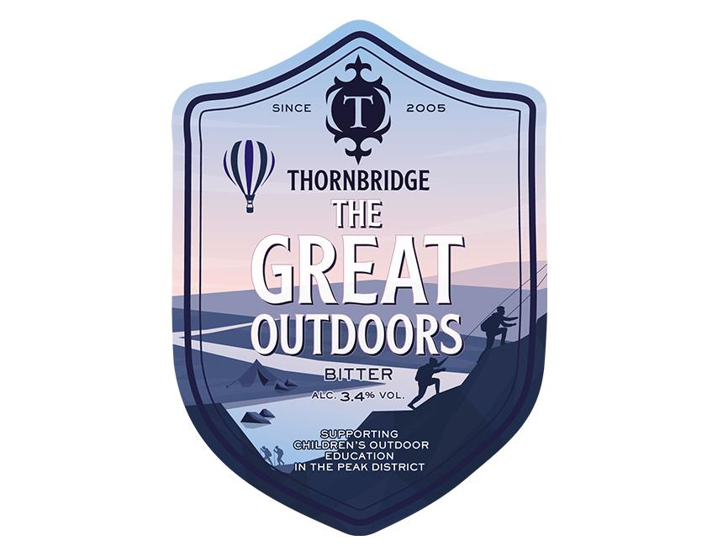

Thornbridge brewery celebrates its 20th birthday in 2025 and enters its third decade continuing a strong focus on its responsibilities within its community. At its home in the Peak District, its employees appreciate the value of connecting with nature and are committed to helping others experience it too. As part of the commitment, staff created The Great Outdoors and, for every pint poured, Thornbridge will donate 20p to a rotating list of local outdoor education charities, giving young people the chance to explore the beautiful landscape it is fortunate to be able to brew in. The Great Outdoors (3.4 per cent ABV) is a classic bitter with a light mahogany hue and earthy, floral aromas. Its smooth body reveals a gentle sweetness with notes of caramel, complemented by subtle hints of toast and hazelnut.