Take a northern beer odyssey

28/01/2025 by Timothy Hampson

Industry

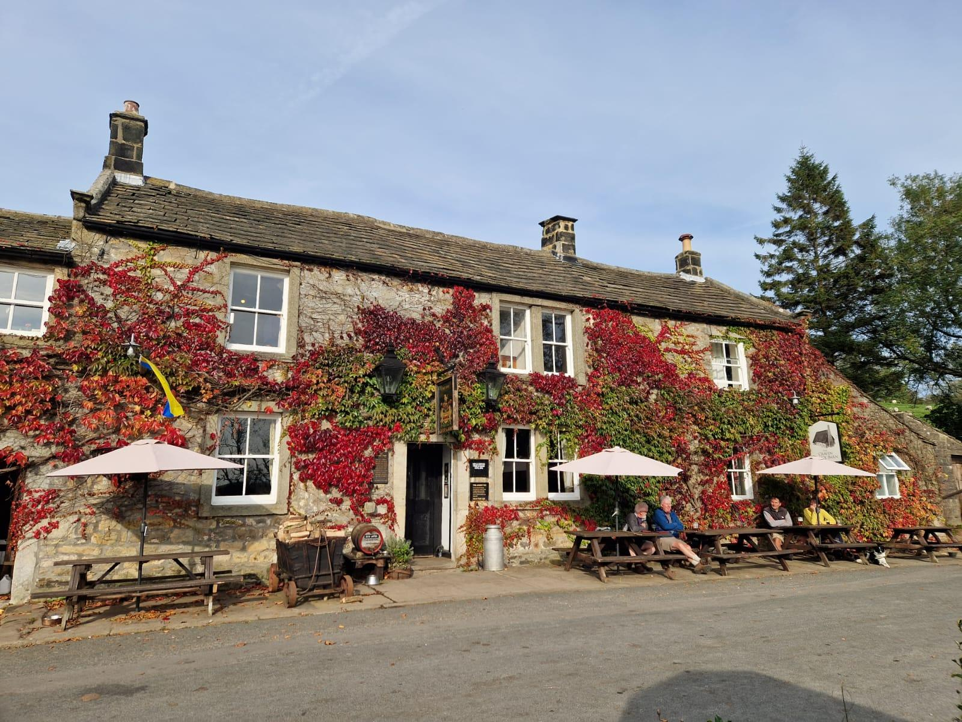

Beer Tours UK is poised to roll out new hoppy adventures for 2025 across Northern England. The new tours are being offered to small groups of beer enthusiasts focussing on the North York Moors, Yorkshire Dales and the Lake District. Destinations include villages and locations featured in television programmes like Heartbeat and All Creatures Great and Small. Tour organiser and What’s Brewing contributor Steve Hobman said: “These tours will run over two to three days to meet demand. For a longer beer adventure, the three area tours can be combined into a spectacular coast-to-coast beer odyssey. “Over four days, this tour will travel from historic Whitby on the rugged North Sea coast across the three beautiful national parks to the sweeping Cumbrian shoreline of the Irish Sea – all along the way exploring independent brewers and characterful pubs. “Pushing out from our established Cheshire heartland is a natural step based on our years of experience. Our original aim remains – to seek out the hidden gemstones of cask-conditioned ale, the original craft beer. “Many overseas visitors seek a true British pint in a true British pub. We meet that desire in spades, helping to fill the gap between the much-visited cities of London and Edinburgh to reveal the glory of Northern England, its beer and pubs. Fascinating beer journeys to remember.” Tour itineraries can dovetail with parties undertaking other activities like fell walking, cycling or enjoying historic sites and heritage railways – or with corporate events. For more information visit www.beertoursuk.com Pictured: Craven Arms in the Yorkshire Dales