Slow-cooked beef and beer chilli

26/01/2025 by Christian Gott

Uncategorised

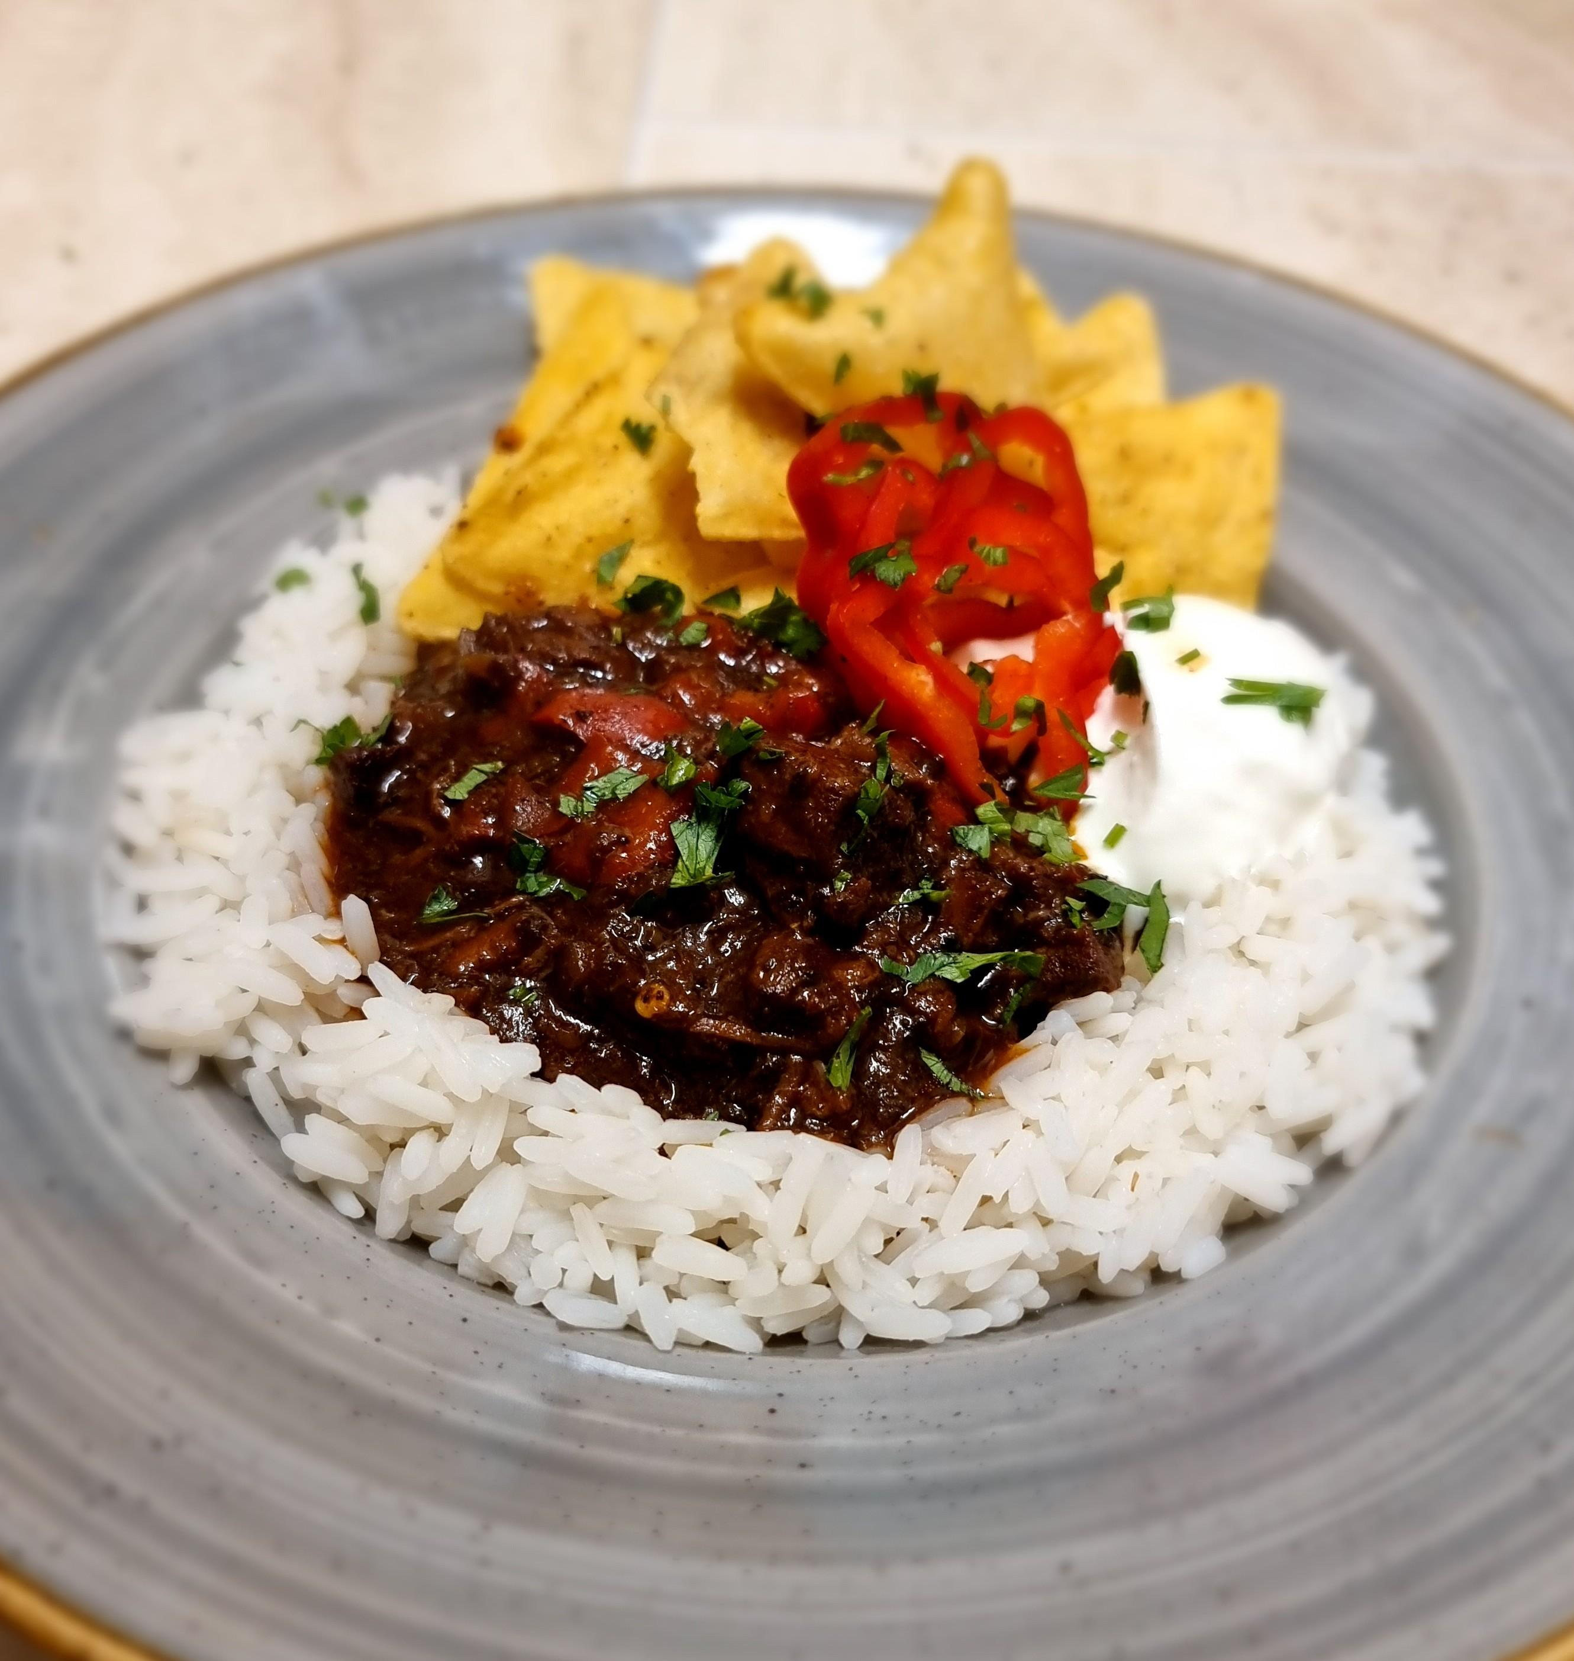

It’s a new year and an extremely cold and wet start for many of us. So, I thought it would be a great idea to post something suitable for the dreary dark winter nights. It's a fabulous recipe for a slow-cooked chunky beef and beer chilli con carne. However, chilli con carne, or chilli, is almost as contentious a subject to write about as your favourite beer, as there are numerous recipes and ingredients. First, let’s start with the building blocks, the beef, should it be made with mince? Well, a lot of “authentic” recipes use chuck or stewing steak which breaks down with slow cooking but retains some texture. Some recipes use minced or ground beef and some use both. I like a chunky chilli which is probably closest to the original Mexican dish, so that is in my recipe. Tomatoes are another thorny ingredient which many recipes omit, although lots of others contain tinned tomatoes or passata and even sauce. Next, we come to the addition of beans. The Texas-based International Chili Society World Championship Chili Cook-Off banned the addition of beans, but most recipes add them. This is one ingredient I will leave to you to decide. Finally, and most importantly, your chilli kick can range from jalapenos to bird's eye chillies depending on your love of heat. I like to add layers of flavour and heat, so I use a mix of sweet paprika, chilli powder and a few chipotle chillies, which are dried, smoked jalapenos. Now we get to the extras most recipes agree on. Garlic, dried oregano and plenty of ground cumin. I like to start with a base of onion and celery and add peppers towards the end of cooking. Other ingredients can include cinnamon sticks, coffee, Marmite, dark chocolate, or cocoa powder, and the bitterness adds another taste profile. I have even seen recipes that add a cigar while simmering the dish, but that isn’t something I want to try any time soon! While many recipes use tomato juice as a cooking liquid, I like the idea of bitter chocolate flavours in my chilli that I can get by adding a porter or stout. I chose Big Sur Moon Cocoa Porter - made with cocoa husks, enhancing the chocolate notes from the toasted malt. Big Sur is brewed year-round by Burnt Mill, a farm-based brewery in Suffolk. Your chilli will improve spending a night in the fridge and reheating served with tortilla chips or cornbread, in a jacket potato or even piled onto chips. Ingredients 1kg diced chuck or stewing steak 440ml Big Sur Moon Cocoa Porter 3 red peppers, chopped 2 onions, peeled and finely chopped 3 sticks of celery, washed and finely chopped 6 cloves garlic, peeled 2 or 3 dried chipotle chillies 2tbs (heaped) tomato puree 2tbs beef dripping or butter 2tbs plain flour Splash olive oil 1tbs dark brown sugar 1tbs sweet paprika 2tsp (heaped) chilli powder 2tsp (heaped) ground cumin 2tsp (heaped) dried oregano Sea salt and freshly ground black pepper Optional Red kidney beans or black-eyed beans Soak the chillies overnight, then blitz with the garlic in a food processor. Heat the dripping or butter in a large heavy-bottomed pan and stir in the flour. Carefully cook until a dark golden brown then remove from the heat and stir in the tomato puree and chilli and garlic puree. Add all of the remaining ingredients, excluding the peppers and sugar, and stir. Add water if required to ensure all the ingredients are covered with liquid. Return to the heat and bring to a gentle simmer. Cook for a couple of hours stirring regularly to prevent sticking. Once the meat is tender, stir in the red peppers and sugar, and cook for another 30 minutes. Season generously and leave to cool before refrigerating overnight. Reheat thoroughly before serving.