Leaseholder pulls out of Britons Protection battle

24/01/2025 by Steve Hobman

Industry

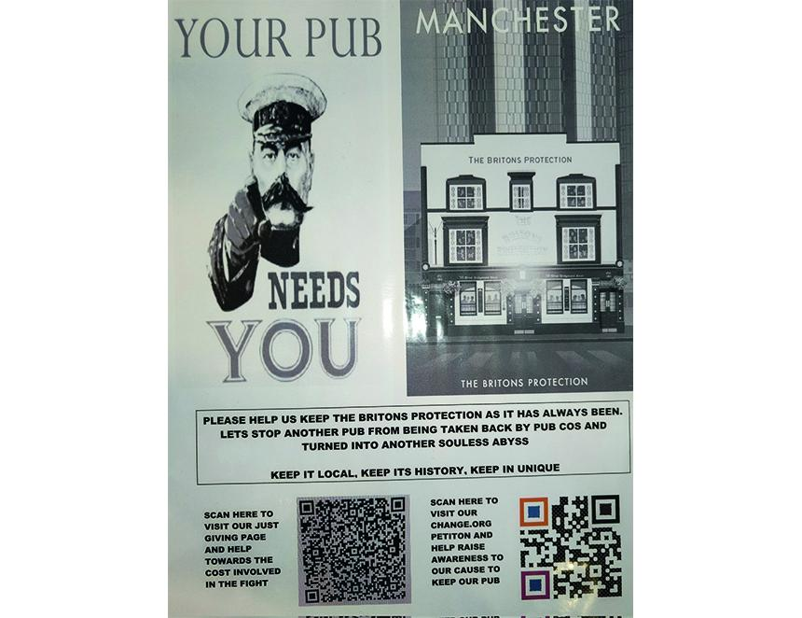

The long struggle to save a much-loved Manchester city pub as an independent beer oasis has ended with a takeover by Star Pubs. In a shock move for supporters, leaseholder and businessman Mark West has handed back the iconic 200-year-old Britons Protection (BP) to the Heineken-owned chain. It concludes the expensive three-year legal dispute to stop landlord Star claiming the Great Bridgewater Street pub for a managed house. In a New Year announcement, Star said the BP would close on 8 January for refurbishment, reopening as a managed house on 16 January. Star pledged to ensure “it maintains its current look and feel”.    A court showdown to decide the fate of the cask ale haven was scheduled last June but adjourned. Then, in September, a Star statement said “an amicable agreement” had been reached, but it did not say multiple operator West would leave. At the time, manager Allan Hudd hailed the deal a “victory for both sides” – “guaranteeing the pub for the next 10 years”. Compounding the confusion, just last week one local media outlet reported the cost of the court action plus poor festive trading was being blamed for West’s departure. Hudd ran the legendary hostelry – famous as a refuge to Peterloo Massacre victims in 1819 – for 13 years under a “free-of-tie market rent only agreement”. He created an eight handpull destination, supporting local brewers, along with a near 400-strong whisky collection, attracting international visitors. During the campaign he said: “If it becomes a managed house, the city will lose a much-loved venue for cask ale and whisky to yet another bland gastro pub.” The legal struggle cost many tens of thousands of pounds and was helped with donations from BP enthusiasts plus a 16,000-signature petition was raised in protest when Star began eviction action in 2022. On 7 January, What’s Brewing found the pub already firmly shut with Hudd clearing the premises. He declined to comment on the handover. Since then, several approaches to Mark West were met with silence. When asked if any compensation was paid for his departure, Star said: "We reached an amicable solution with Mr West, as we’ve said before, but we will not be discussing the specific details of it.” A Star statement said: “Mark West and Star Pubs have amicably concluded the transfer at the Britons Protection, having worked together on a smooth handover. While there is a short closure to carry out some infrastructure upgrades and minor renovations, the plan is to reopen on 16 January. “Although the Britons Protection is moving into a new phase under different operators, all parties concerned are confident that the pub will retain its character and appeal to the local community. “Mark West has committed to continue to provide ad hoc advice and give the benefit of his many years as an operator of one of the most characterful pubs in Manchester. Star Pubs is excited to be taking the Britons Protection on under its managed operator model and ensuring the Britons Protection maintains its focus on serving an interesting range of real ales and whiskies, that it maintains its current look and feel, and ensuring it preserves its historic status.” Listed on the CAMRA National Inventory of Pub Interiors, today the distinctive Grade II-listed building stands alone amid a highly developed area of apartments and hotels. It also is an Asset of Community Value. Over the years, several groups have supported the atmospheric venue including Manchester Civic Society, Peterloo Memorial Campaign and Manchester Whisky Club. The whisky collection remains the property of West, who also holds the lease for the Star-owned, Good Beer Guide-listed City Arms in nearby Kennedy Street and is a director of JML Development of Stockport. Central Manchester branch pub protection officer Steve Ingham said: “The concern has always been that if control reverted to Star, then the offer would be radically different than that provided by Allan Hudd and Mark West. But the proof of the pudding will indeed be in the eating. Star will certainly not offer the broad range of whiskies that the BP provided. Branch officers and members will keep a watching brief on developments, and it will be interesting to see if Star deliver on its promise.”