Cask favourite returns to pubs

22/01/2025 by Timothy Hampson

Industry

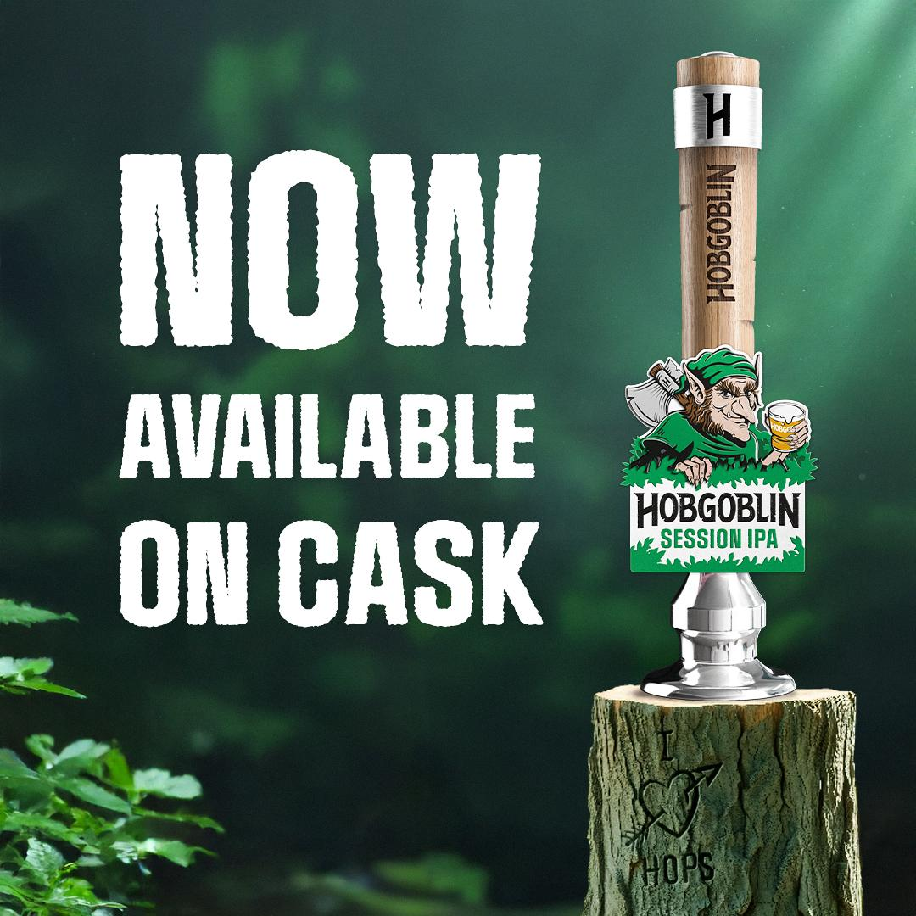

Carlsberg Marston’s (CMBC), which has been criticised for cuts in its cask beer range, has now given a boost to a 30-year-old favourite as Hobgoblin Session IPA is returning to pubs in cask. First brewed in the 1990s when Hobgoblin burst his way onto the beer scene, the brewer has continued to innovate with product launches, culminating in a brand refresh in 2024. CMBC director of marketing for the brand Jo Marshall said: “Hobgoblin Session IPA is a fantastic beer. At 3.4 per cent ABV it’s refreshing and sippable, but with an intense and hoppy flavour while delivering a fresh and zesty aroma. “Like the Hobgoblin itself, our Session IPA is full of personality and has already built a following across the UK. “We’ve been thrilled with the response to Hobgoblin’s updated look, unapologetically dialling up our Hobgoblin character to make the product stand out even more on bars. “We’re now able to offer even more choice to operators and their customers with the launch of Hobgoblin Session IPA in cask.”