Fuller's pubs build market share

21/01/2025 by Timothy Hampson

Industry

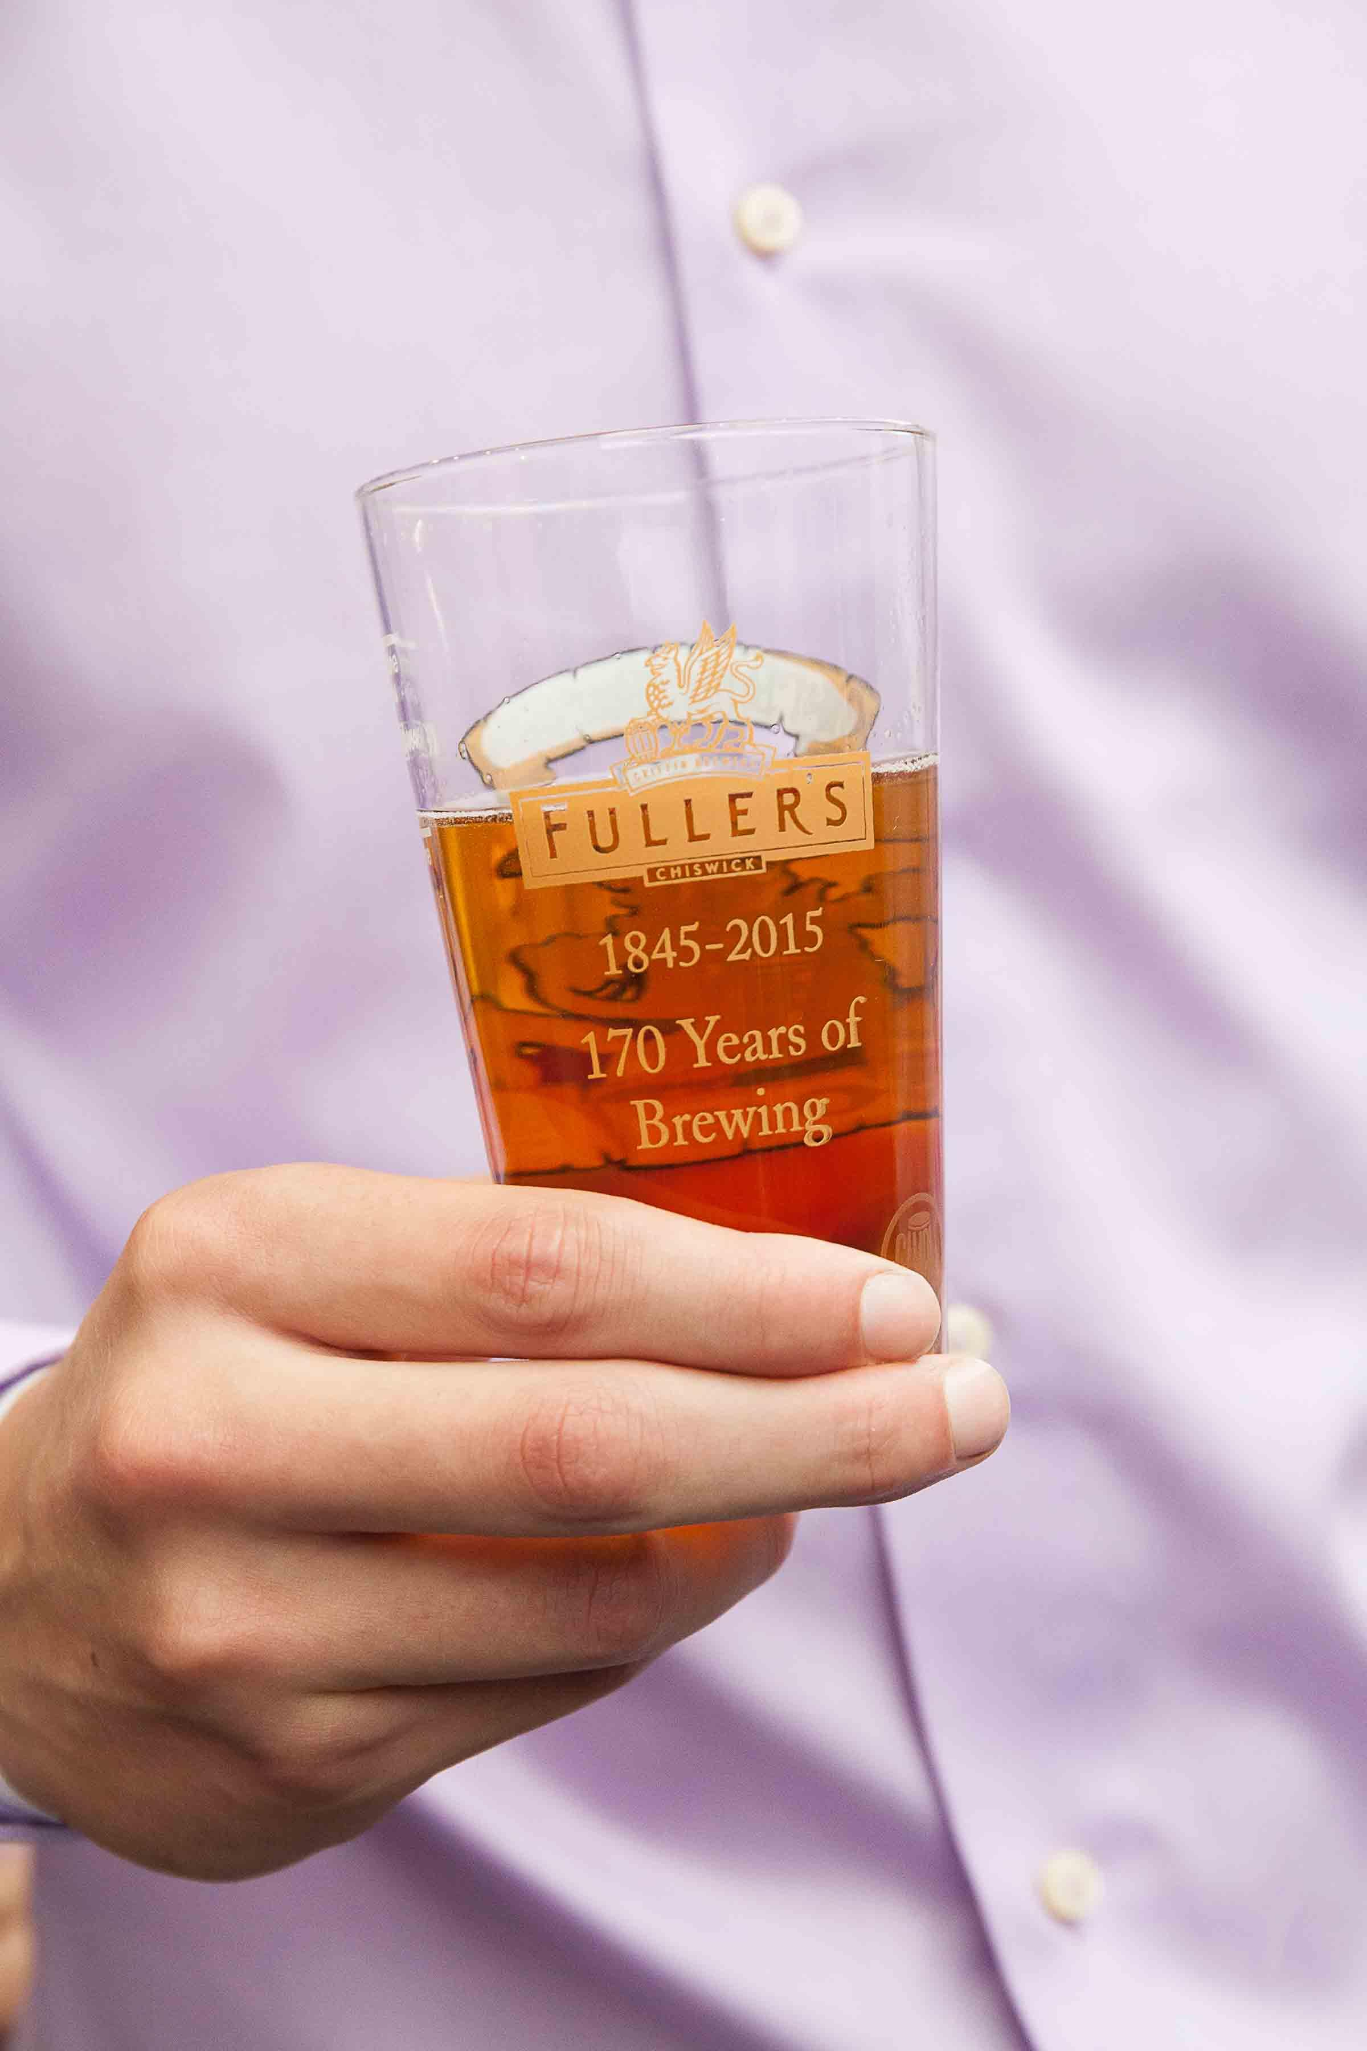

Pub-and-hotel operator Fuller’s has published strong financial results for the six months to 28 September, with adjusted profit before tax up by 21 per cent to £17.6m. Like-for-like sales in the pub company’s managed pubs and hotels in the first half of the financial year were up 5.2 per cent, demonstrating continued market out-performance, says the company. A significant rise in statutory profit before tax, from £14.9m to £29m, reflects a book profit of £17.2m arising from the disposal of the Mad Hatter hotel, in London. Like-for-like drink sales increased by 4.9 per cent over the half-year, with food up 5.5 per cent and accommodation rising 4.9 per cent. Across the estate, £10m was invested. Lovely Pubs, a set of locals in affluent Warwickshire villages, was purchased for £22.5m. Fuller’s chief executive Simon Emeny said: “We have delivered great results throughout 2024, and this has been enhanced with a really strong Christmas. “These results would not be possible without the dedication and passion of our amazing team of people, and I would like to thank them all for their hard work and ongoing commitment. “As we move into the last few months of this financial year, we continue to focus on delivering long-term returns as well as preparing for the year ahead. Our share buyback programme is ongoing, with 5.7m of the planned 6.5m A shares now repurchased. “We also continue to invest in our estate – with a number of major projects planned for the final quarter of the current financial year, including a £4m investment at the Chamberlain Hotel in the City of London, which is already underway. “We are confident of meeting market expectations for the full year. While we will be facing fresh cost challenges in the new financial year – with increases in Employers’ National Insurance Contributions, National Living Wage and Business Rates – we are taking appropriate actions to manage the impact of these market challenges and remain confident and optimistic about the future for our business. “We will next update the market on 11 June 2025, when we announce the Company’s full year results for the 52 weeks to 29 March 2025. “We will be investing a further £20m in our estate during the second half, including substantial schemes at the Drayton Court in West Ealing, The Chamberlain in the City, and the Bel and The Dragon in Odiham. We also continue to look at appropriate opportunities to drive our long-term strategy of growing the estate. “Following our strong first-half results, we have continued to build on our momentum with like-for-like sales for the 32-week period rising by 5.4 per cent. This sustained underlying performance, combined with the added benefit from our Lovely Pubs acquisition and encouraging Christmas bookings up 15 per cent, provides us with confidence that we are on track to meet current market expectations for the financial year. “In summary, everything that is in our control is going well. We have an outstanding, predominately freehold, well-invested estate, a driven and motivated team — who are supported by continuous development — and a clear, consistent strategy.”