PUBlic Affairs round up – January

20/01/2025 by Tori Wood

Campaign

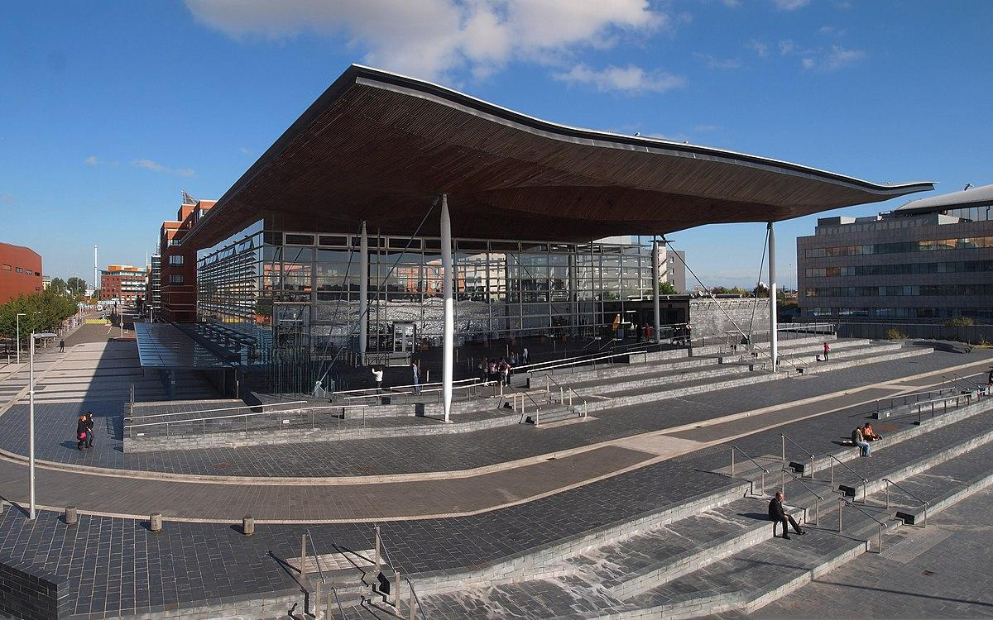

The PUBlic Affairs roundup is kicking off the new year with an update on what the Campaigns and Communications Team has been doing to fight for pubs, pints and people across Westminster, devolved parliaments and local government.  Westminster  House of Commons debates On 4 December, Liz Jarvis MP (Liberal Democrat, Eastleigh) held a Westminster Hall debate on government support for the hospitality sector in Eastleigh which we provided a briefing for.  A transcript of the debate can be found here.  Access to market review In light of the chancellor’s announcement to review independent brewers’ access to the pub market, Ash Corbett-Collins (CAMRA national chairman) Tom Stainer (CAMRA chief executive) and Ellie Hudspith (CAMRA senior campaigns and communications manager) met the Department for Business and Trade officials who will be carrying out the review.   CAMRA’s involvement in the review, and its views on global brewers dominating the market as well as the need for more consumer choice, led to a productive conversation.  CAMRA hopes to meet with the minister during later stages of the review.  The chancellor promised a consultation exercise, so we will push for a formal process as part of the review.  Business rates The legislation for the new permanent lower-multiplier rate for retail, leisure and hospitality businesses, promised by the chancellor in her Autumn Budget, will come into effect in England in 2026/27.  As the new rates system is set to be introduced next year, CAMRA is committed to calling on the government to monitor the impact of the rates hike pubs in England will face when the current 75 per cent relief drops to 40 per cent for 2025/26.  Due to the Barnett Formula, as a result of the 40 per cent rates relief in England, Scottish, Welsh and Northen Irish governments received extra funding – although it is up to those bodies whether or not they implement a similar relief.  CAMRA has been campaigning for devolved nations to introduce rates relief for pubs.  As well as the new legislation, a Transforming Business Rates discussion paper has been published by the Treasury. Ellie Hudspith attended a discussion with hospitality sector representatives and Treasury civil servants in December to discuss proposals for reforming the rates system.  Smoking ban (England only) Proposals to ban smoking in beer gardens, ( see CAMRA’s press comment here), have been dropped from the Tobacco and Vapes Bill.  The UK government’s announcement said: “In England, hospitality settings, including outside areas of pubs and bars, will not be included in the proposed extension to the indoor smoking ban.”  CAMRA continues to monitor this legislation for attempts to reintroduce the smoking in beer gardens ban, and for potential proposals to introduce similar legislation within devolved nations.   High Street rental auctions [England only] The High Street rental auctions scheme officially came in to force on 2 December 2024. Local authorities now have the power to provision the use of empty premises, including pubs, which could see the removal of fixtures and fittings with local authority permission.  CAMRA continues to encourage its branches to use Campaign resources in contacting local authorities to mandate that empty pub premises are let for pub use, and to refrain from removing fixtures and fittings.  Branches are monitoring the scheme in their areas to understand how High Street rental auctions are impacting pubs.  Carlsberg/Britvic merger Following CAMRA’s formal submission to the Competition and Markets Authority (CMA) about concerns regarding the purchase of Britvic by Carlsberg Marston’s Brewing Company (CMBC), the CMA has now cleared the merger for completion.  Handpump Hijack An enquiry has been sent to West Northants Council’s Trading Standards (which provide trading standards advice to Carlsberg) for an update on its investigation into Fresh Ale.  Scottish government and parliament  Tori Wood (campaigns and communications assistant) attended a cross-party group meeting on 16 December.   HIT Training, the apprenticeship and training provider for the UK’s hospitality, catering and retail industries, gave a presentation on jobs, skills and apprenticeships in the beer and pubs sector.   Parliamentary debate Convenor of the Cross Party Group on Beer and Pubs Craig Hoy MSP sponsored a debate in the Scottish parliament about the recent inquiry and Brand Scotland report for the Scottish beer and pubs sector.  The team thanked Craig Hoy MSP on our social media account X.  Scottish Pubs Code The Scottish Pubs Code adjudicator’s stakeholder group held a meeting in Edinburgh on 15 January which Scotland director Stuart McMahon attended.  Implementation of the code’s market-rent only options for tied tenants has been delayed until June 2025. The rest of the code, including the new guest beer right for tied pub tenants, will come into force in April 2025.  Welsh government and Senedd Cymru (above)  The Welsh government’s draft Budget that proposed the continuation of the 40 per cent rates relief for pubs in 2025/26 was published in December 2024.  The final Budget will be published in February.  Northern Ireland executive and assembly   Licensing review Ministers are expected to respond to the independent review of the licensing system in the next few months.  The team continues to meet and correspond with MLAs from all parties to build support for reform when the independent review is published.   Non-parliamentary  Guinness shortage The team created a 12 Stouts of Christmas list featuring award-winning beers in light of the Guinness shortage in December.   The list received a great deal of social media and traditional media responses, putting many brewers and their beers in the spotlight.