Gluten free is Best for brewer

20/01/2025 by Timothy Hampson

Industry

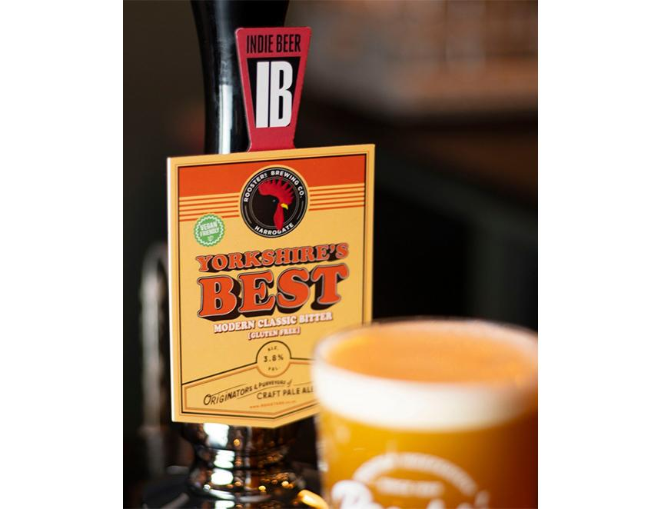

Harrogate’s Rooster’s Brewing Co has extended its core cask range for 2025 with the addition of a cask gluten-free beer. Yorkshire’s Best, at 3.8 per cent ABV, is smooth, amber in colour, and packed with a blend of three British hops. The beer is also available in keg and can. Rooster’s Ian Galbraith said: “2025 is shaping up to be another exciting year for the brewery and will see Rooster’s remain at the forefront of the indie beer industry. “We now have no fewer than five gluten-free beers along with the rest of our core range. It is a great step forward as we continue to bang the drum for the importance of great-tasting independent beer.”