Plan your new year festival trips now!

19/01/2025 by Matthew Rogers

Campaign

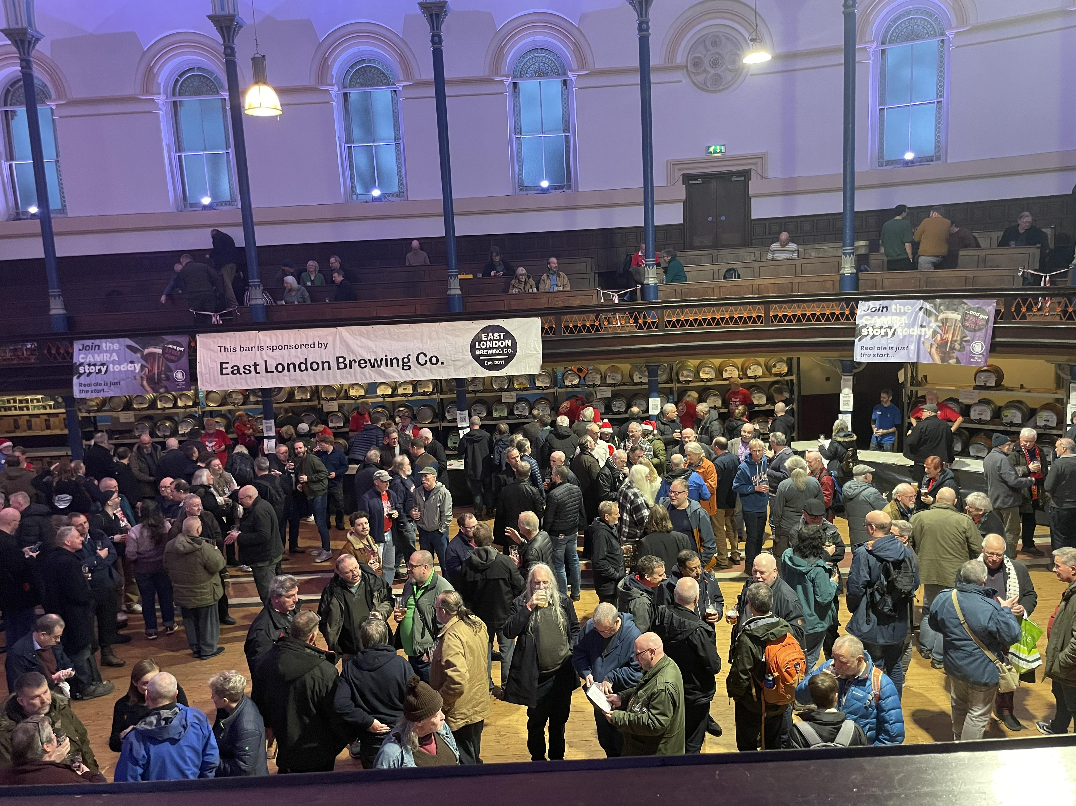

Plan your next festival trip by viewing the list below. To see all upcoming CAMRA events, visit https://events.camra.org.uk/   Salisbury Winterfest, 24-25 January The Guildhall, Market Square, Salisbury, SP1 1JH https://salisburycamra.org.uk/event/winterfest-xxvi-2025/   16th Colchester Winter Ale Festival, 29 January-1 February Colchester Arts Centre, Church St, Colchester, CO1 1NF https://colchesterbeerfestivals.co.uk/   Pendle Beer Festival, 30 January-1 February The Muni Theatre, Albert Road, Colne, Lancashire, BB8 0AE https://www.pendlebeerfestival.co.uk/   Dorchester Beerex, 31 January-1 February 26 High East Street, Dorchester, Dorset, DT1 1EZ https://beerex.co.uk/   Bent and Bongs Beer Bash, 6-8 February Atherton Roller Rink, Bolton Road, Atherton, M46 9JG http://www.bentnbongs.com/   Tewkesbury Winter Beer Festival, 6-8 February 65 Barton St, Tewkesbury, GL20 5PX https://www.facebook.com/profile.php?id=100064840352359   Elysian Winter Beer Festival, 7-8 February The Maltings, Ship Lane, Ely, CB7 4BB https://ely.camra.org.uk/viewnode.php?id=170324   Chesterfield Beer Festival, 7-8 February Holywell Street, Chesterfield, S41 7SA https://chesterfield.camra.org.uk/chesterfield-camra-winter-beer-festival-2025   Great British Beer Festival Winter, 12-15 February Magna Science Adventure Centre, Magna Way, Templeborough, Rotherham, S60 1FD https://winter.gbbf.org.uk/   Liverpool Beer Festival, 13-15 February Metropolitan Cathedral Crypt, Liverpool, L3 5TQ https://www.liverpoolcamra.org.uk/   Darlington Beer Festival, 21-23 February Hopetown Darlington, McNay Street, Darlington, DL36SW https://darlo.camra.org.uk/viewnode.php?id=229748   Chappel Winter Beer Festival, 27 February-1 March East Anglian Railway Museum, Chappel & Wakes Colne Station, Station Road, Chappel & Wakes, Colne, CO6 2DS https://chappelbeerfestival.org.uk/winter/   Bradford Beer and Cider Festival, 27 February-1 March Victoria Hall, Victoria Road, Saltaire, Shipley, BD18 3JS https://www.bradfordcamra.org.uk/bbcf2025   37th Wigan Beer Festival, 27 February-1 March Robin Park Sports Centre, Loire Drive, Newtown, Wigan, WN5 0UL https://beerfestival.wigancamra.org.uk/   Gosport Winterfest XXXI, 28 February-1 March Thorngate Halls, Bury Road, Gosport, PO12 3QX https://pseh.camra.org.uk/Winterfest.php   48th Loughborough Beer Festival, 6-8 March Polish Club, True Lovers' Walk, Loughborough, LE11 3DB https://www.loughboroughcamra.co.uk/beer-festivals/48th-loughborough-beer-festival   Chester Beer Festival, 14-15 March Northgate Street, Chester, CH1 2HJ https://westcheshire.camra.org.uk/viewnode.php?id=230888   Burton and South Derbyshire Beer Festival, 27-29 March King Edward Place, Burton, DE14 2EB https://burtoncamra.wordpress.com/beer-festival/