The low down

18/01/2025 by Matthew Curtis

Opinion

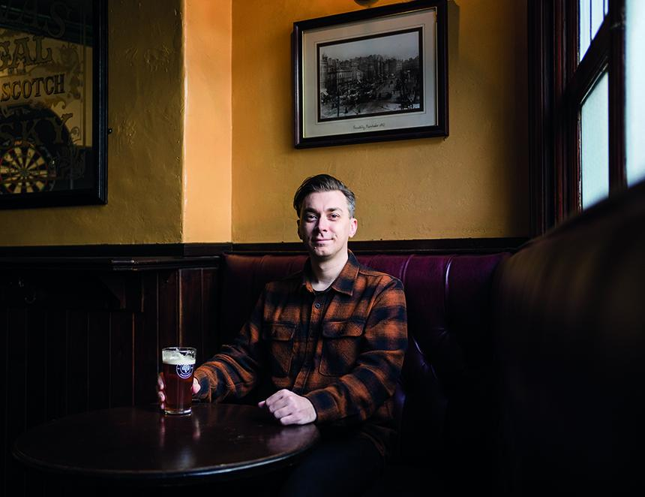

According to estimates from the British Beer and Pub Association (BBPA) more than 120m pints of low and no alcohol beer were enjoyed by British consumers in 2023. Presently the fastest growing drinks category in the country, the BBPA also estimates this figure grew by 16.7 per cent in 2024 – equal to a further 20m pints on top of the previous year’s total. As with anything, however, perspective is crucial. While the boom in high-quality, low-alcohol options is undoubtedly a net positive for drinkers, as a sum of all beer consumed in the UK it only amounts to around 1.15 per cent in total. Or, to look at it in simpler terms, slightly more than one in every 100 pints of beer sold in the UK falls into the low and no-alcohol category, which is defined as any beer containing equal to or less than 1.2 per cent alcohol by volume (ABV). There are numerous factors influencing the rapid growth of the no and low alcohol drinks category, first among them being the vastly improved quality of products available. Compared to just a few years ago, when the likes of Kaliber Lager was often a solitary, and in all honesty, deeply-unpleasant offering loitering idly in pub fridges, there are now quite literally hundreds of options available, from crisp German-style pilsners, right the way through to modern hazy IPAs. An increasing preference for low and no alcohol beer has coincided with changing consumer habits. As drinkers look to live healthier and increasingly mindful lives, many of them are looking to either moderate their alcohol input or cut it out completely. Popularised in 2024 and now included with the Collins English Dictionary, the term “zebra striping” refers to alternating between alcoholic and non-alcoholic drinks during a drinking session. But there’s another factor behind this rise that has little to do with what consumers are actually drinking: profit. All alcoholic drinks in the UK are subject to duty. This is payable by the manufacturer per litre of alcohol produced, in accordance with the changes to duty introduced by the previous Conservative government in August 2023. As part of the update to these regulations all produced beverages rated at 1.2 per cent alcohol or lower were declared exempt from duty. In many instances there is little difference in retail price between modern alcoholic and non-alcoholic options, so producers are able to claw back larger margins on these products. This could be a reason why the category has seen so many new entrants over the past 18 months, and why so many small breweries are adding no and low beers to their existing portfolios. Just this month both Cornwall’s St Austell and Derbyshire’s Thornbridge have introduced 0.5 per cent alcohol versions of their respective flagship brands: Proper Job and Jaipur. Meanwhile Manchester’s Cloudwater brewery recently informed me that its Fresh AF 0.5 per cent IPA was one of its best-selling beers of 2024. While it’s positive to see this small, yet buoyant sector of the beer trade thriving, the explosion of new low-alcohol brands feels almost endless, and one has to wonder when the market will reach its inevitable saturation point. A decade ago the industry was similarly positive about the emergence of small, independent breweries throughout the UK, but increased market pressures and inflationary costs – plus the fact that the sector was likely overburdened with too many options – has seen the net number of breweries in the UK decrease for the past four years consecutively. Most recently the Huddersfield-based Magic Rock brewery was forced to call in the administrators, despite being heralded as a trailblazer not long after it was initially established in 2011. One brewery that has pivoted in the opposite direction to the no and low alcohol boom is Manchester’s Marble Beer. In December it announced that it would be restoring the ABV of its own flagship, Pint, to its original strength of 3.9 per cent. It had previously reduced its strength to 3.4 per cent in order to take advantage of a duty break that was implemented as part of the 2023 legislation applied to beers between 3.4 and 1.2 per cent ABV. Several breweries sought to take advantage of this new loophole with Carlsberg and Grolsch among two major brands to quickly adapt to this new criterion. By reducing the ABV of its signature IPA by just 0.2 per cent, Greene King brewery of Bury St Edmunds was able to claw back a reported £7m in annual duty expenditure. Despite the obvious advantage this presents to breweries, Marble’s sales director Paul Plowman told me his customers were unhappy with the decision to reduce Pint’s strength, repeatedly asking for it to be restored to its original ABV. When the brewery eventually did, sales began to increase – evidence, maybe, that consumers still maintain plenty of appetite for mid-strength alcohol drinks. It’s certainly a reassuring bit of data for those, like me, who are all too aware that any particular boom or bust within the beer industry is only temporary, and in the end, good beer will always prevail.