Our national champ completes remarkable rags-to-riches story

17/01/2025 by WB Reporter

Campaign

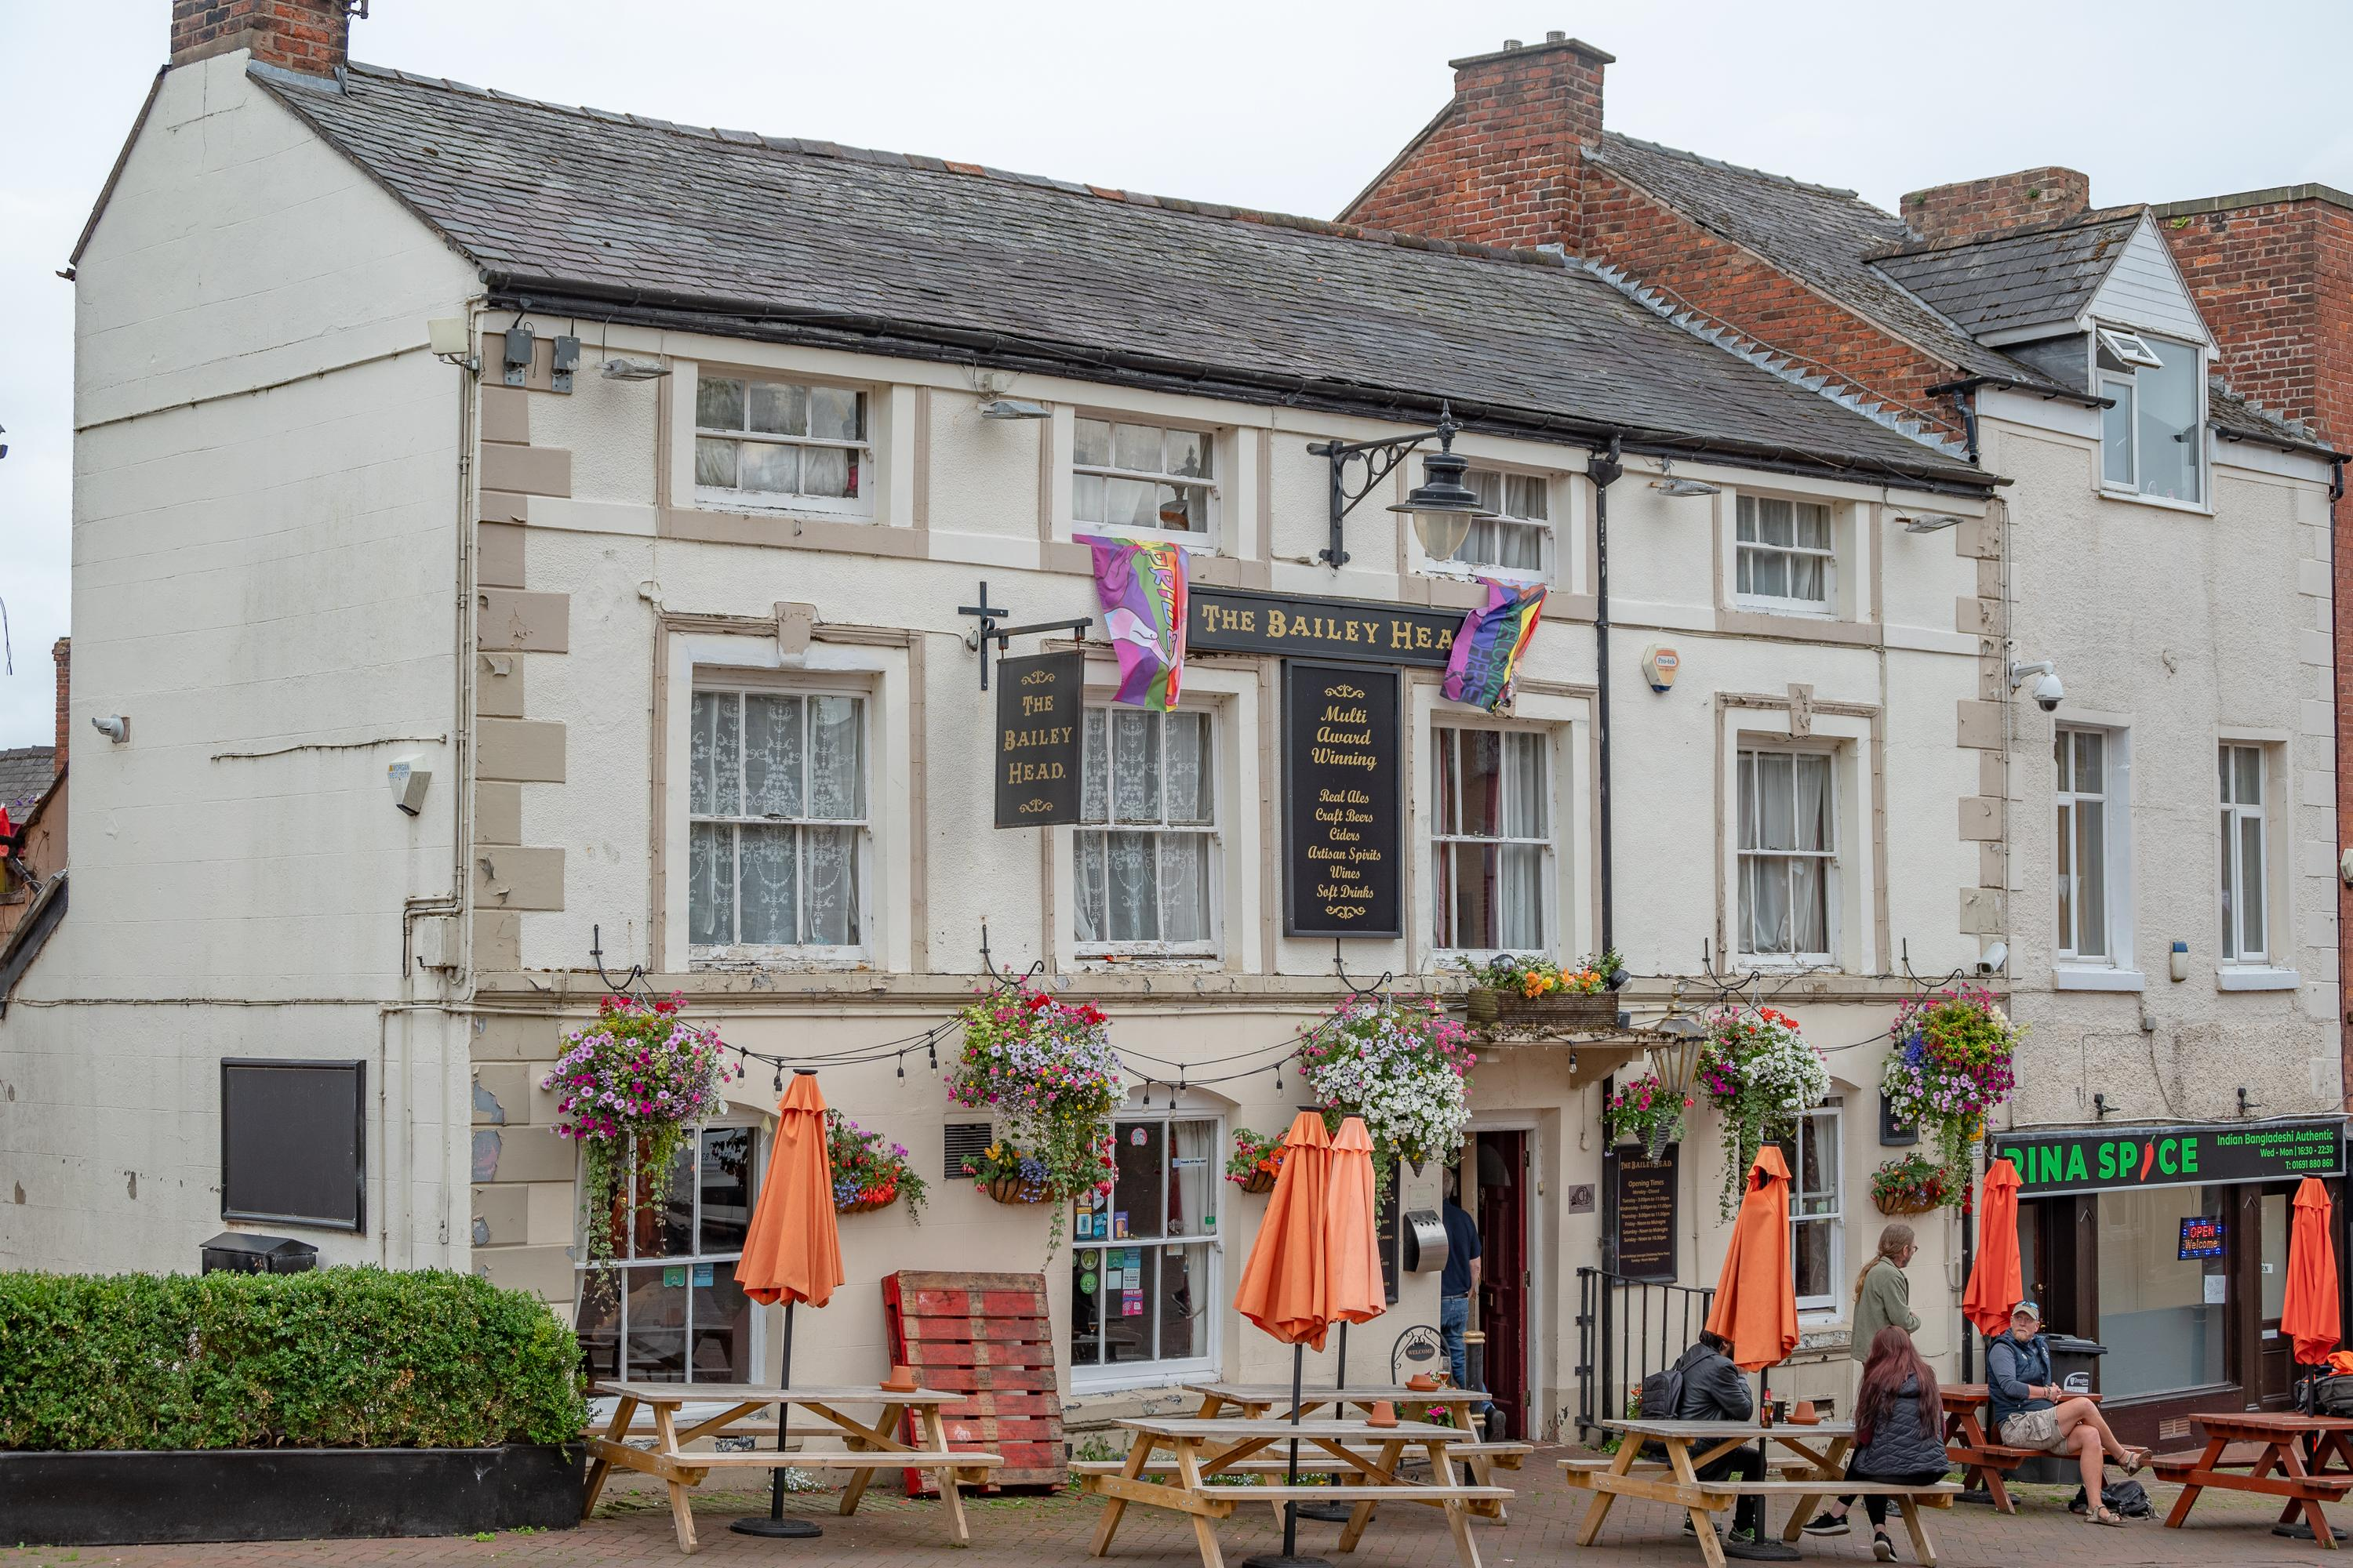

The Bailey Head (above) in Oswestry, Shropshire is CAMRA’s National Pub of the Year, topping a remarkable rags-to-riches success story after the owners turned what was once a closed local into a haven for the community. The Bailey Head had been failing under the ownership of a major pub company and was listed by CAMRA as an Asset of Community Value (ACV) to protect it from redevelopment. Nine years ago, it was bought by Duncan Borrowman and Grace Goodlad who poured their knowledge and passion into transforming the pub. Their dedication means that the Bailey Head has won a staggering roster of awards from CAMRA, the Society of Independent Brewers and Associates (SIBA), The Shropshire GOAT and TripAdvisor. Community and inclusion are at the heart of the pub, and it acts as a hub for locals to come together for good causes through events like its charity pub quizzes and live music. Duncan said: “We have always had a policy of everyone welcome, any person should feel happy and comfortable coming in by themselves and enjoying a drink, either on their own or chatting to other customers. We thrive on being the heart of the community and a place where people gather to celebrate or commiserate. “While all of the focus tends to be on us as a couple, this win was also down to our incredible team of welcoming and knowledgeable staff, and to our wonderful regulars who have become very much a community in their own right.” Aside from providing a welcoming atmosphere, the Bailey Head also boasts an impressive array of cask beer and cider. Grace said: “We are thrilled, we hope we can live up to the award. In our wildest dreams we never thought we would win CAMRA Pub of the Year. From small beginnings nine years ago, we have taken everything one step at a time, through Covid, slowly improving to the point where we now have 12 handpulls serving six cask beers and six ciders and perries, plus 16 other draught lines. “When we bought the pub nine years ago it was failing and had been listed as an Asset of Community Value by the local CAMRA branch. That listing made it possible for us to save it from potentially becoming housing and turning it into the pub it is today.” Shrewsbury and West Shropshire CAMRA chairman David Ricketts said: “The story of the Bailey Head from humble beginnings proves that any pub can become the best in the UK with some hard graft. Huge congratulations to Duncan and Grace and their hardworking team at the pub. We are so proud that our local branch plays host to them, and I hope this win can bring plenty of new visitors to their doorstep.” CAMRA awards director Laura Emson said: “There could not be a more deserving winner for the Pub of the Year than the Bailey Head. In a time when running a pub is a significant challenge, the commitment and enthusiasm Duncan and Grace show should be highly commended and seen as an example. January can be an especially tough time for our locals, so please get out and visit them and provide the support that is so desperately needed for pubs across the UK.” The other finalists were: Black Horse, Preston A visually stunning Victorian Grade II-listed pub opposite the historic Preston open market, the Black Horse is a fantastic example of Victorian architecture, retaining original fittings from the era. Three B’s, Bridlington Run by a husband-and-wife team which is passionate about beer and cider, the popular micropub is described as “Bridlington’s Real Ale Destination”, showcasing four cask beers with a focus on stocking Yorkshire beers. Little Green Dragon, Winchmore Hill A former shop, Enfield’s first micropub opened in 2017. Focussing on the quality and diversity of cask beer, the Little Green Dragon has an ever-changing selection of four cask beers sourced from local microbreweries and other independent brewers from further afield, plus real cider, perry and four keg beers. All the pubs in the competition are selected by CAMRA volunteers and judged on their atmosphere, decor, welcome, service, value for money, customer mix and most importantly – quality of beer. More information on CAMRA’s Pub of the Year competition can be found here. Photo: Graham Mitchell