Find the best pubs faster with new CAMRA website

16/01/2025 by WB Reporter

Campaign

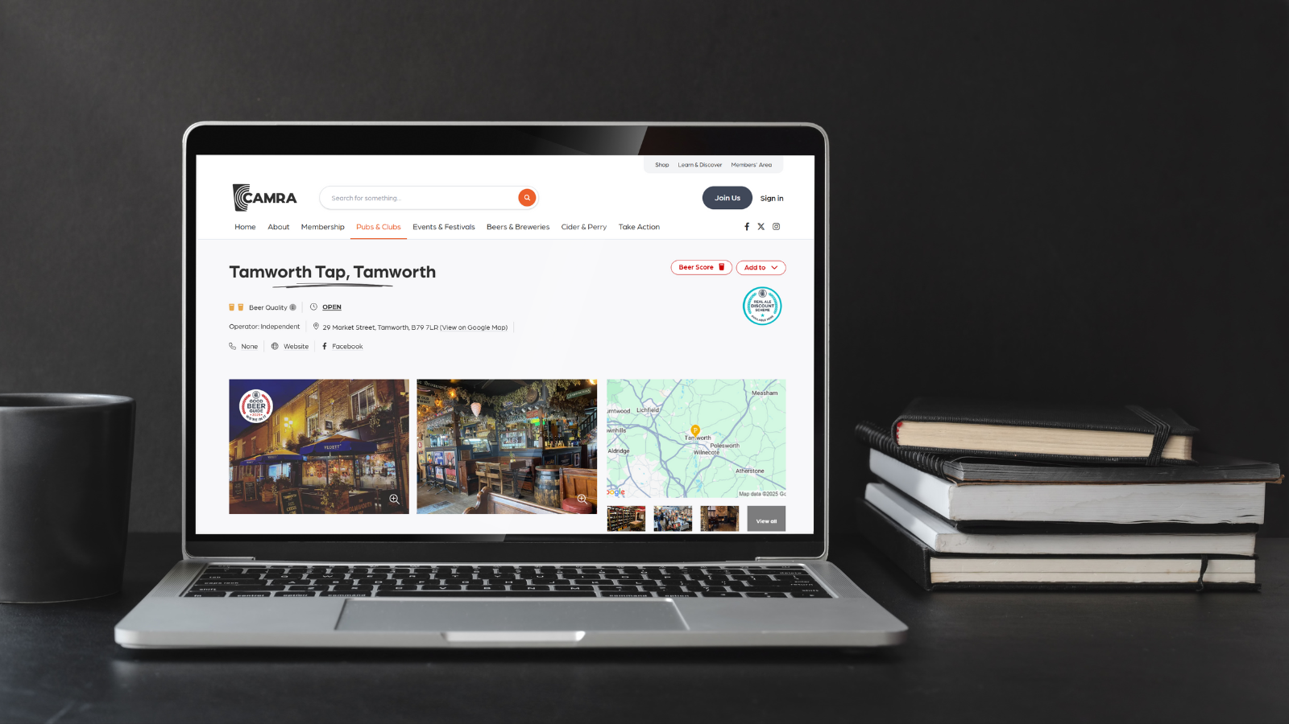

CAMRA has launched its new website, giving members and new users tools to explore pubs, social clubs, brewers and cider makers across the UK.  The new website has been built in-house with the input of surveys, focus groups and extensive user testing using a mix of open-source software and bespoke technologies combined with CAMRA’s comprehensive data systems to create a compelling front-end. Flexible new access options give users the option to choose the right route for them.   Registering for a free user account includes access to the extensive database of pubs, clubs and pints, the trip planner and view suggested pub walks up to three times plus the latest on CAMRA news and events. For those wanting to experience these features to their fullest, the option of becoming a subscriber is available at just 99p a month. This includes extensive tasting notes for beers, as well as unlimited trip planning to make the most of visiting pubs and breweries across the UK. Subscribers can also favourite pubs and clubs, adding them to their personalised list for future trips. CAMRA members are able to use the website and all its features, as well as provide their own input via beer scoring, improving the ratings and recommendations available to them, as well as which pubs make it into the Campaign’s flagship Good Beer Guide publication.   CAMRA’s new website can be found here: camra.org.uk