Capture spring and win £150

16/01/2025 by Timothy Hampson

Industry

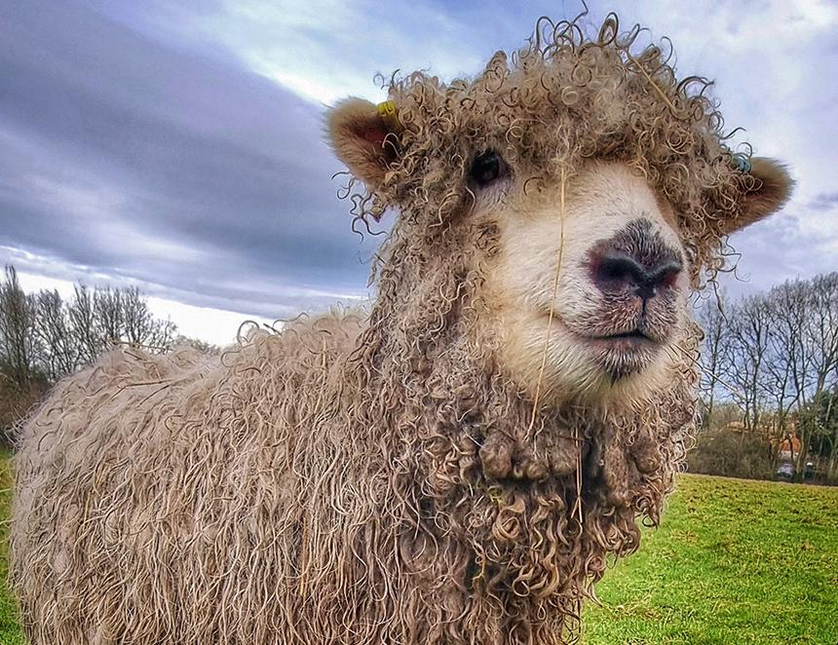

Shepherd Neame has launched its latest Spring Photography Competition with top prizes up for grabs. The Kent brewer is encouraging people to get outdoors and capture the changing seasons in all their glory – whether that be natural landscapes, springtime surprises, or wildlife wonders. The winner will receive a £150 Shepherd Neame gift card while four runners-up will get a £25 voucher. To enter, capture the perfect moment and send it to comms@shepherdneame.co.uk with a couple of lines explaining where the photo was taken and any other background information. If there is a Shepherd Neame link, bonus points will be awarded! Entries also need to have been taken in Shepherd Neame’s heartland – Kent, Surrey, Sussex, Essex, Hampshire and London. Email up to three images by Monday 17 March ensuring photos are in jpg format and at least 1MB in size. The winning images will be displayed at Shepherd Neame’s brewery in Court Street, Faversham in April. Pictured: last year Mirram Simmonds won a runner-up prize for her picture of a bedraggled sheep.