Sign up now for women’s collaboration brew day

15/01/2025 by WB Reporter

Industry

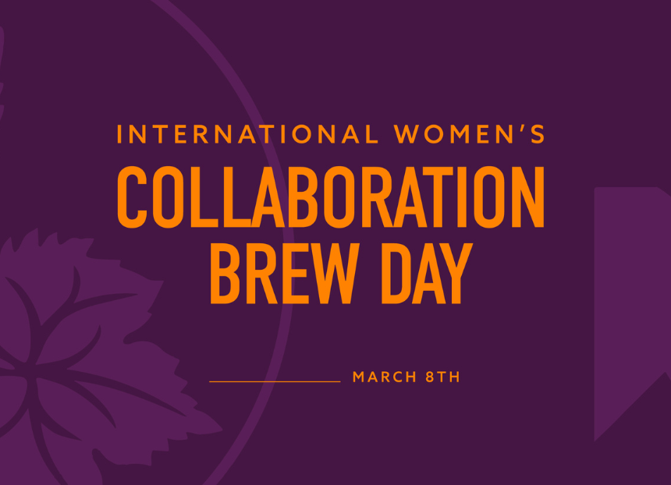

Sign-up for International Women’s Collaboration Brew Day (IWCBD) projects is now live, marking the return of the global initiative in 2025 under the Unite Society theme. By signing up, projects become part of the main IWCBD campaign, including inclusion on a central map and in a programme of communications leading up to and beyond International Women's Day. Women On Tap CIC is the new organiser of IWCBD and has partnered with the Society of Independent Brewers and Associates (SIBA) as the headline sponsor, with additional support from Simpsons Malt and WSET (Wine & Spirit Education Trust) as an Education Partner. Originally launched in 2014 by Burnt Mill head brewer Sophie de Ronde, IWCBD has been a platform for women in the beer industry, homebrewers, and communities to unite and create new beers in celebration of International Women’s Day. From 2014 to 2023, it brought together brewing projects on a global map. While various International Women’s Day brewing events took place in 2024, the central IWCBD campaign took a hiatus. Now, Women On Tap CIC is revitalising the campaign with several updates. Inspired by the Brave Noise initiative, participating breweries are now encouraged to pledge a donation to a non-profit women’s organisation or group at sign-up. The recommended minimum donation is £100, though breweries can alternatively donate a percentage of profits from their IWD beer sales. Hand Brew head brewer Kate Hyde said: “We’ve been holding an IWCBD at Hand Brew Co now for three years, and 2025 will be our fourth. Honestly, it is one of my proudest personal and professional achievements here at the brewery and in 10 years of brewing: the community we have built with this day of connection once a year. We’ve raised more than £2,000 for charitable causes and organisations we believe in.” Breweries are encouraged to support local or personally significant non-profit women’s causes, including those that align specifically with the beer diversity mission. A list of suggested groups is available to guide participants, and nominations for this list are also invited via a dedicated sign-up form until 31 January 2025. Alongside Hand Brew, a number of breweries have been quick off the mark, with sign ups already from Turning Point, Beerworks, Kerroo, Bríd’s Cross, Pillars, Wild Horse, and River's Edge. For more details and to sign up or find out how to get involved in an existing 2025 project, visit www.iwcbd.org.