CAMRA calls for new government cash to save community locals

15/01/2025 by WB Reporter

Campaign

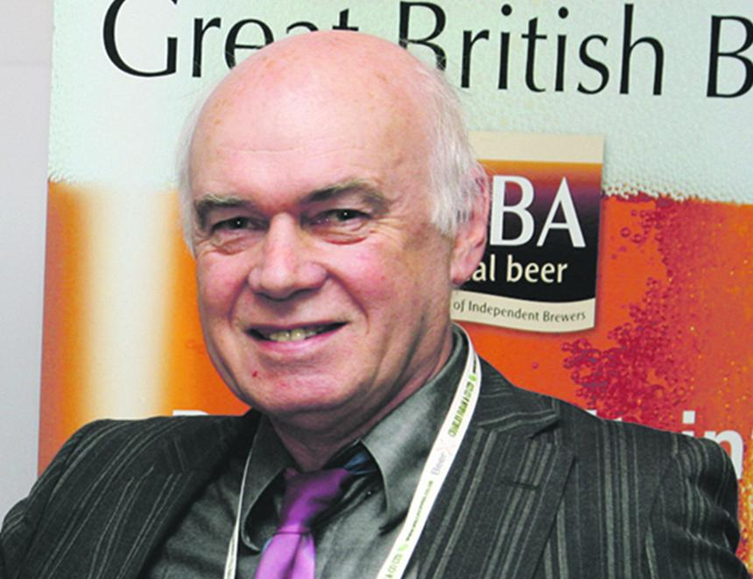

CAMRA is calling on the deputy prime minister Angela Rayner and her Ministry of Housing, Communities and Local Government to introduce a fund for community groups looking to take ownership of their pub. The call comes after the existing fund, which helped people purchase their pub as a community-owned business, came to a sudden end before Christmas 2024. The Community Ownership Fund provided cash for groups to take ownership and the running of community facilities that would otherwise be sold, converted or demolished, including pubs. The government announced on 23 December that the final Community Ownership Fund money had been awarded to successful bidders, including eight community pubs. These were the Old Neighbourhood, Chalford Hill, Gloucestershire; Rectory, Chesterfield; Fox Inn, Little Ryton, Shropshire; Crown Inn, Newcastle on Clun, Shropshire; Kings Arms, Cleeve Prior, Worcestershire; Punch Bowl Inn, Burton in Lonsdale, North Yorkshire; Tafarn y Plu, Llanystumdwy, Gwynedd; Swan on the Green, West Peckham, Kent. Ministers also said there would be no further funding. The government is introducing a new community right to buy for groups looking to take ownership of a pub in their neighbourhood. CAMRA believes right to buy must come alongside a dedicated programme of advice, guidance and funding to make sure community pubs go from strength to strength. CAMRA’s Planning Advisory Group chair Paul Ainsworth (above) said: “Having thriving pubs at the heart of community life can be a key part of the government’s mission to have vibrant communities and thriving local economies. There are now more than 200 community-owned pubs in the country, and this has proved to be a remarkably successful model, with previously struggling pubs now popular and successful enterprises – pubs for the people by the people. “Ministers have already announced they are going to introduce a community right to buy for assets like pubs that are under threat of closure or conversion. This is very welcome and is set to be a gamechanger for people wanting to save their pub. “However, it is vital that as well as a right to buy community assets, groups can also access advice, support and funding to help make sure bids to take over pubs as community-owned businesses can be successful, securing the pub at the heart of community life for decades to come.”