City pub tour made easy

14/01/2025 by Timothy Hampson

Campaign

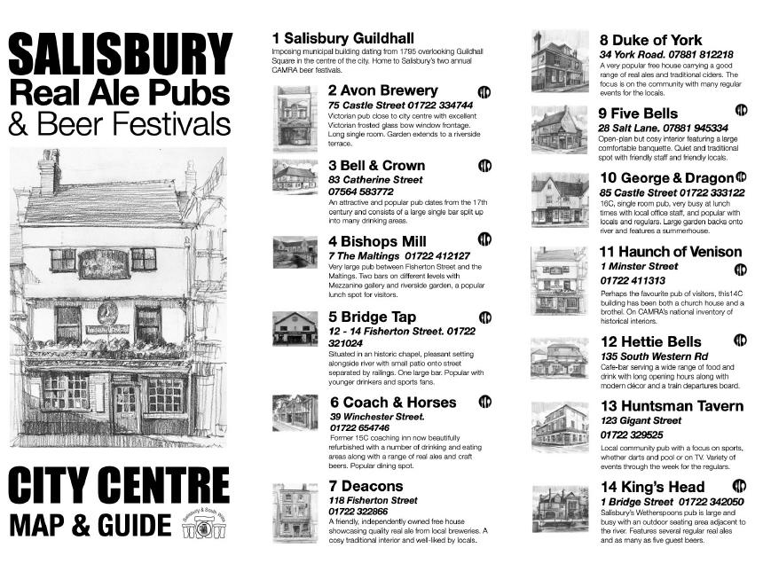

A map for beer lovers showing Salisbury pubs selling cask beer plus a circular walking tour from the city’s rail station has been published by the local CAMRA branch. The guide (above), which includes brief details of 27 city-centre pubs listed and information about local beer festivals, is aimed at both locals and tourists. Salisbury and South Wiltshire branch’s City Centre Map & Guide, with a drawing of the historic Haunch of Venison by local artist Fred Fieber on the front cover, has already been distributed to pubs and the information office at the Guildhall. The plan is to make it available at all the points where visitors arrive or stay in Salisbury. The map already features on the Experience Salisbury webpages, has won support from local bus company Salisbury Reds and been welcomed by local hoteliers. One said: “I am often asked by guests – particularly German and Dutch visitors – where they can get traditional British beer, and now I will be able to give them this guide which contains the information that they need.” The guide is the creation of branch member Andrew Ward, who felt that the city lacked a simple user-friendly map showing its pubs. He enlisted the support of Fred Fieber, who provided the pub illustrations and the artwork. “We are very grateful to Fred whose contribution has transformed the guide from a factsheet into a very attractive document,” said Andrew. The walking tour, which can easily be followed from the coach station and city-centre bus stops as well as the railway station, features pubs that will usually be open during the day. The guide also contains information about Salisbury’s beer festivals – Summerfest and Winterfest organised by the branch and the two held by the Winchester Gate pub. QR codes on the leaflet can be scanned in to obtain information about pubs in and around Salisbury and CAMRA events in South Wiltshire. “Life is not easy for pub landlords at the moment and the local economy in Salisbury has been through tough times in recent years, so CAMRA wants to promote the city’s pubs and the cask beers that they sell,” said Andrew.