Lion roars back to life

13/01/2025 by Timothy Hampson

Pub

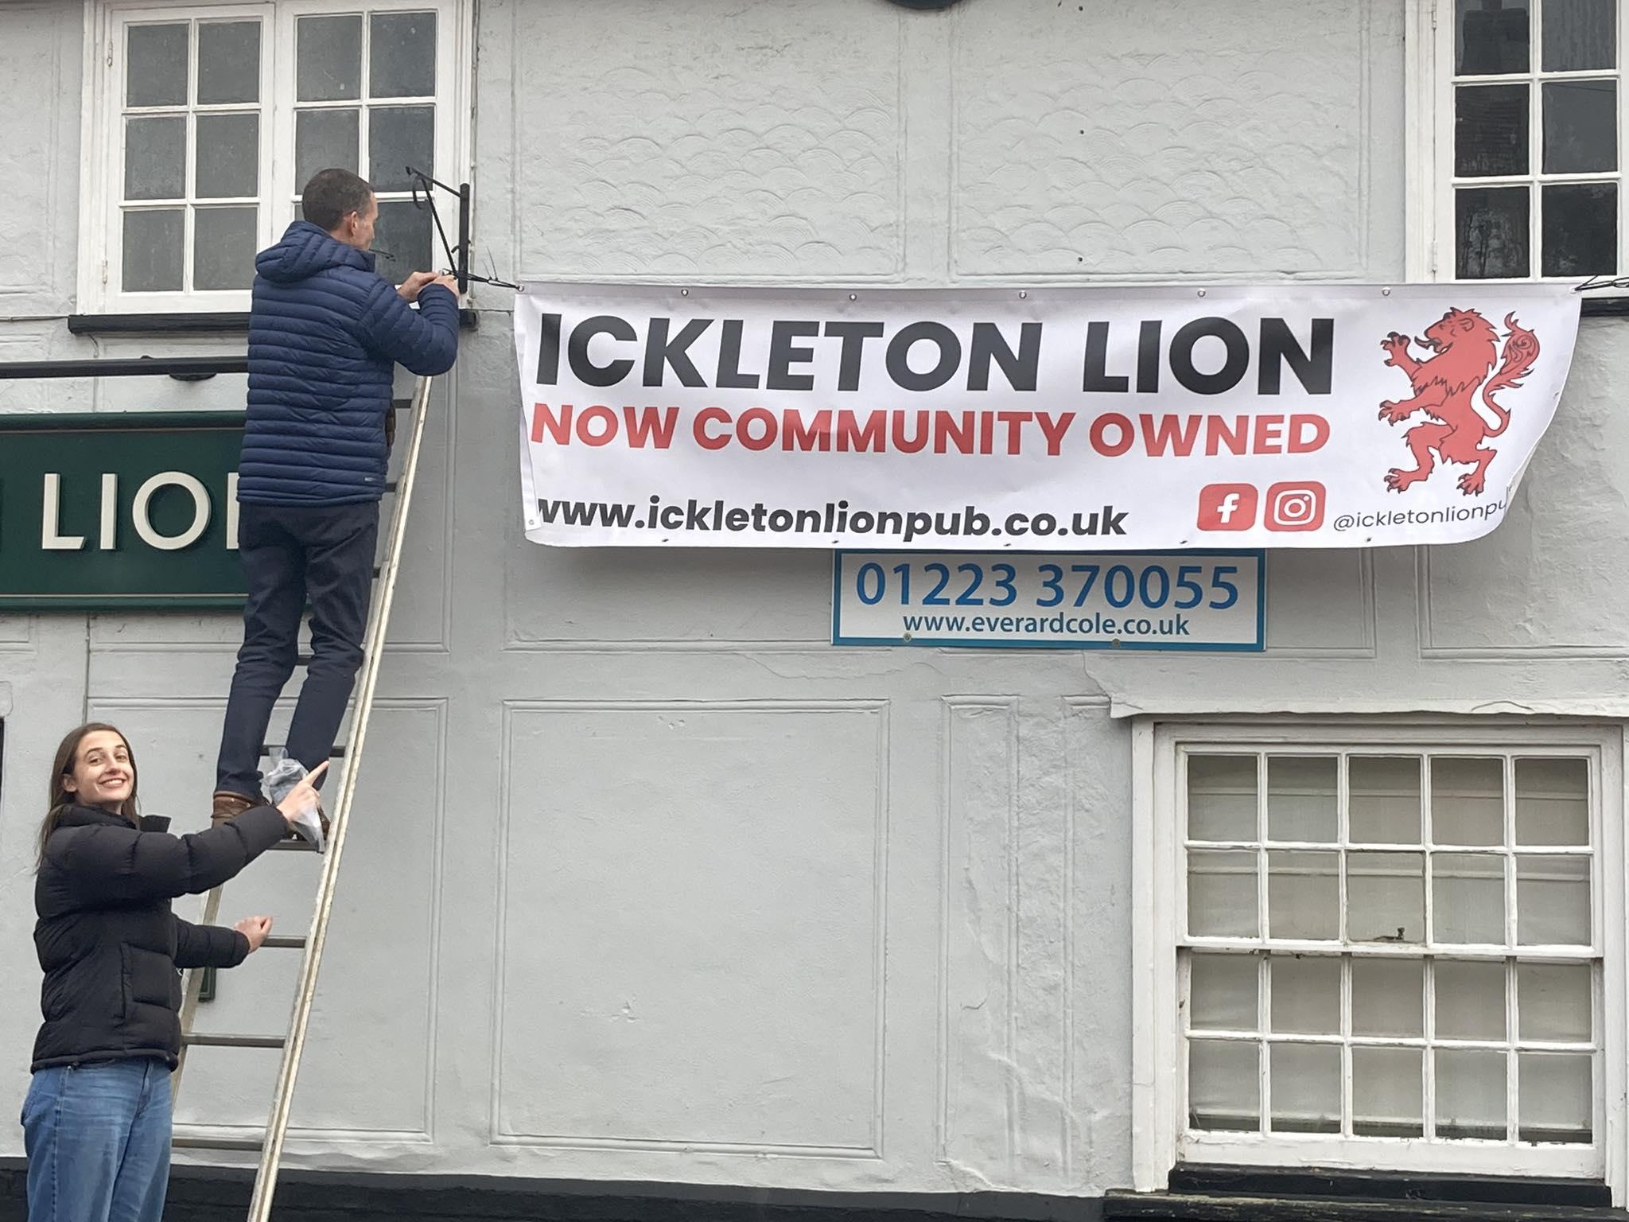

Lionhearted campaigners who fought to save their beloved pub in Ickleton, Essex are celebrating after being handed the keys. A community benefit society, known as Ickleton Lionhearted, was set up to purchase the Ickleton Lion – the only remaining pub in the village. The group, made of 415 shareholders, managed to raise more than £440,000 to buy the pub, and was handed the keys from former owner Greene King before Christmas. Campaigners cut a ribbon across the pub gate, hung a banner and the group enjoyed carol singing, mulled wine, hot chocolate and mince pies, while small parties of shareholders were given exclusive access into the pub building for the first time since it closed in the summer of 2023. Group chair Rachel said: “There’s been such a lot of work behind the scenes in recent weeks to negotiate the successful purchase of the Lion. “What better gift for everyone involved than the keys to our very own pub just days before Christmas. “It’s been wonderful to share this moment with so many people in the community and to celebrate the goodwill and generosity that’s got us this far. “We hope this event will be the first of many joyful celebrations as we get the pub back up and running again.” Advice, support and access to funding was also provided by Plunkett UK – a national charity supporting community-owned businesses. Project manager Hannah Barrett said: “We are absolutely delighted that Ickleton will have a pub at the centre of its community once more. "Community pubs tackle isolation and loneliness, create local employment and volunteering opportunities, and they are truly inclusive to the wider community.” The vision for the pub is to create a warm and welcoming space with affordable food and drink, serving as a social hub for residents and a meeting place for groups and clubs. Calls for further support to get the pub ready for customers, both through financial donations and volunteering, will be made at ickletonlionpub.co.uk and on the Ickleton Lion Community Hub social media pages. Refurbishing the pub is expected to take several months, but the aim is for the Lion to open its doors to customers again in mid-2025.