Winter festival announces stellar line-up of tastings and entertainment

10/01/2025 by WB Reporter

Campaign

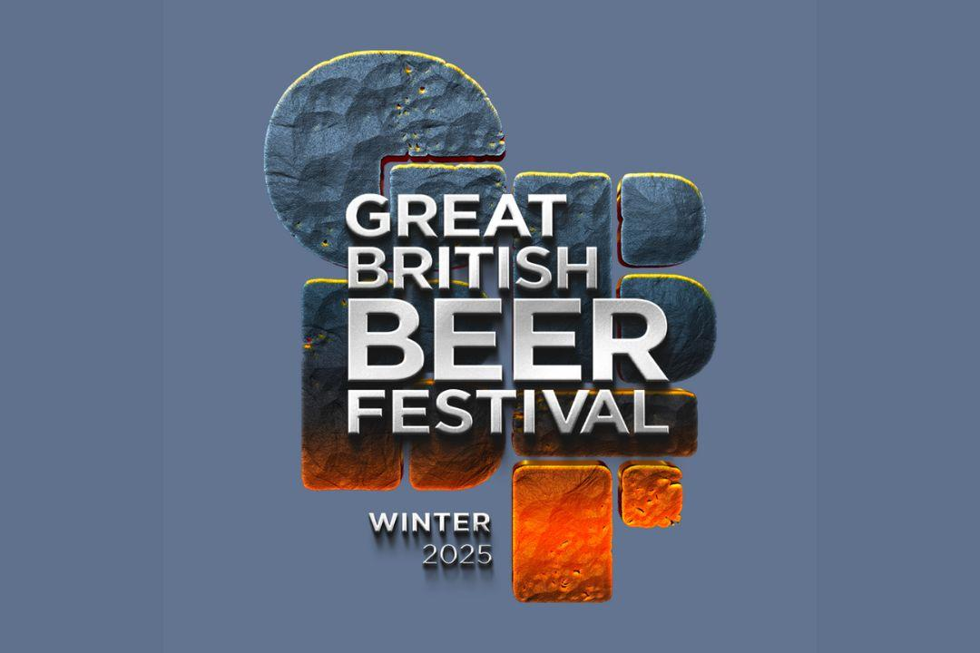

CAMRA’s flagship winter event, the Great British Beer Festival Winter 2025, has unveiled a series of exclusive tutored beer tastings and a host of exciting entertainment.  The festival takes place at the Magna Science Adventure Centre, Rotherham on 12-15 February where tutored beer tastings will be guided by beer specialists and brewers. This is a chance for visitors to sample rare and limited-edition beers, learn from experts with insights into brewing techniques and tasting notes, and discover new favourites.  On 12 and 13 February, beer author and What’s Brewing and BEER columnist Roger Protz hosts the Champion Winter Beer of Britain competition tasting. Roger will guide festivalgoers through a tasting of the six winning brews from the competition, including the overall champion.  Roger will also be hosting a tasting and conversation with Thornbridge head brewer Rob Lovatt, and Dominic Driscoll on 13 February talking about the fascinating history of the iconic Burton union system. This is a great opportunity to learn about the wood-barrel fermentation system and sample the beers Thornbridge is making with it. On Friday 14 February beer sommelier, educator, writer and broadcaster Annabel Smith will be hosting a beer-and- cheese tasting session, exploring five British beers, each paired with mouth-watering cheeses.  Award-winning beer writer, author and journalist Pete Brown will also be hosting a beer-and-music pairing masterclass on Friday 14 February. Over the past decade, these musical beer events have captivated thousands and challenges everything you thought you knew about beer. The audio-visual experience is the inspiration for a new book, Tasting Notes: the art and science of pairing beer and music, to be published by CAMRA in June. Guests will enjoy a special discount on this upcoming release. For further information and tickets, visit the Great British Beer Festival Winter website: winter.gbbf.org.uk/beer-tastings The festival will also be home to a host of musical acts throughout the week. From indie rock and a brass band to blues and reggae, there is an act for all musical tastes.  Music schedule:  12 February – Bone Broke Kings, Lightning Threads, The Fargo Railroad Co. 13 February – FloodHounds, Northern Citizens. 14 February – Daniel Horsham, Eboney Jayne O’Brien, Kiziah and the Kings, Soul Battalion, The Leptons.  15 February – Jack T Harper, Maltby Miners Welfare Band, Matilda Shakes, Republic, Handsome Dan and the Mavericks. For more information on these artists visit the Great British Beer Festival Winter website: winter.gbbf.org.uk/entertainment  Tasting schedule: 12 February at 6:30pm - Champion Winter Beer of Britain competition tasting with Roger Protz. 13 February at 2pm - Champion Winter Beer of Britain competition tasting with Roger Protz. 13 February at 6pm - Brewed on the Union tasting with Thornbridge brewery and Roger Protz. 14 February at 2pm - Beer and cheese tasting with Annabel Smith. 14 February at 6pm - Beer and music matching with Pete Brown. More information about the tastings can be found here: winter.gbbf.org.uk/beer-tastings Tickets for the Great British Beer Festival can be purchased here: winter.gbbf.org.uk/