Growler goes goes for growth

09/01/2025 by Timothy Hampson

Industry

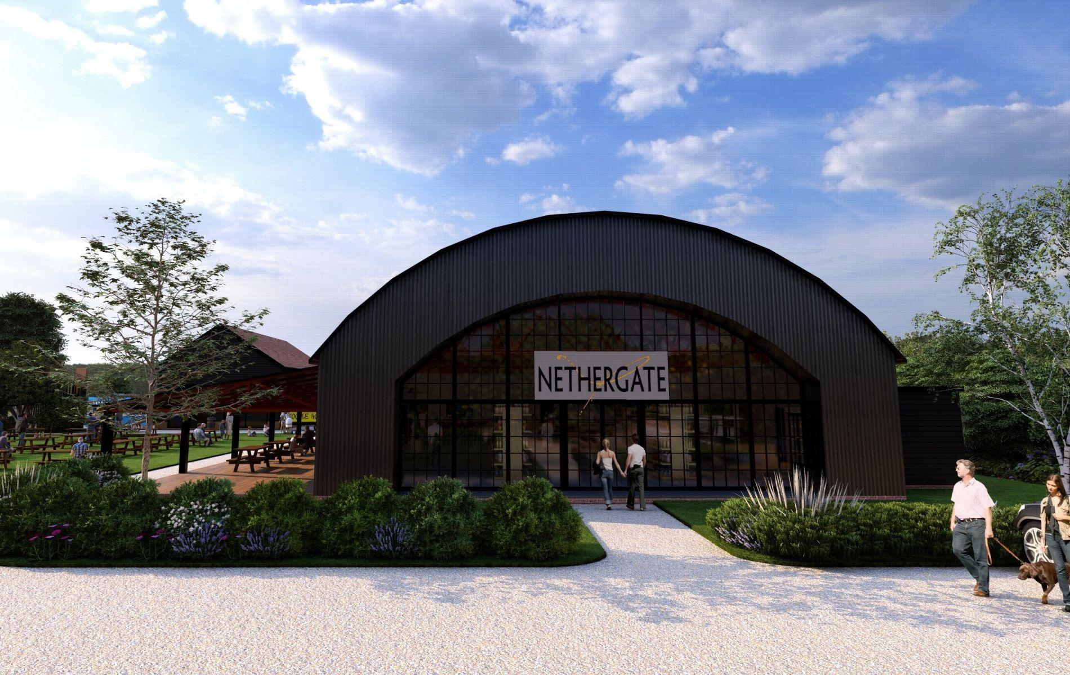

Nethergate brewery has submitted a planning application for an ambitious expansion project on the recently acquired eight-acre field next to its Long Melford, Suffolk base. The new site will help Nethergate tackle practical challenges, such as parking for visitors to both the brewery and the neighbouring country park, as well as creating much-needed production space. The brewery is also exploring ways to use the space to benefit both the business and the local community. Plans include: new café and a larger, improved shop and visitor taproom (artist’s impression above) children’s play area to create a more family-friendly destination electric car charging and a ground-source heat pump. General manager Rob Crawford said: “This is a really exciting new chapter for us. We’re committed to growing our business in a way that benefits our community and visitors. These plans not only address practical needs, such as parking and production space, but also present an opportunity to create something special that enhances the village’s charm and attraction.” The brewery – owned by more than 100 shareholders, most local residents – has engaged with stakeholders to ensure the plans align with community expectations. The brewery was founded in 1986 and is a key part of Suffolk’s craft beer and spirits scene. It is renowned for its award-winning beers, including Old Growler, and its innovative spirits.