Campaign celebrates pub and heritage heroes

08/01/2025 by Timothy Hampson

Campaign

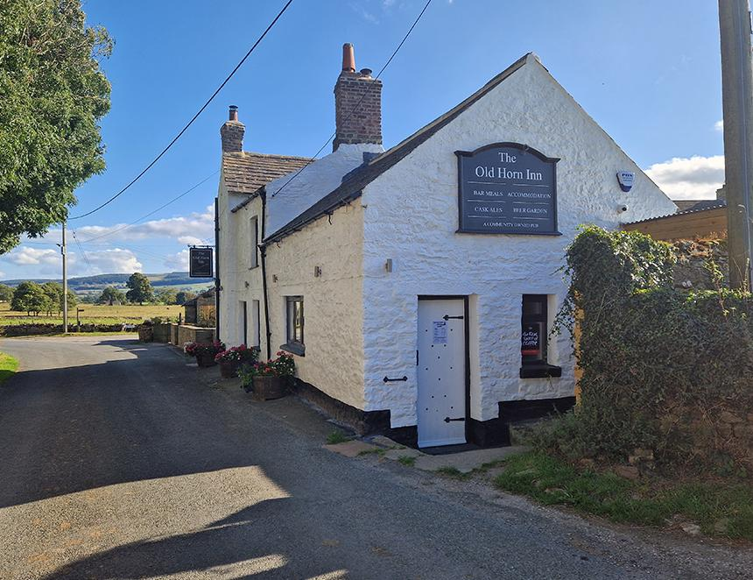

CAMRA has revealed the winners of its Pub Saving Award 2024 including the first Heritage prize. The Old Horn Community Pub Society, which saved the Old Horn Inn (pictured) in Spennithorne, North Yorkshire is the Pub Saving Award 2024 winner. Runner-up was the Roxwell Chequers Community Benefit Society, which rescued the Chequers Inn in Roxwell, Essex. The Drewe Arms in Drewsteignton, Devon is the inaugural Heritage Award winner, and the Kings Head in Bristol was runner-up. The Pub Saving Award recognises people that have come together to rescue a local that would have been demolished or converted to another use.  The Old Horn Inn, a pub more than 200 years old, closed in 2022 with a planning application submitted to convert it into housing. As a vital community hub for the people of Spennithorne and Harmby, plus surrounding areas of North Yorkshire, villagers banded together to form the Old Horn Community Pub Society to protect the local.   The group approached Nick Love, Pub Protection Officer of the York CAMRA branch, who offered invaluable advice and support to fight the application. The local branch helped with drafting an objection to the planning application and assisted to make the pub an Asset of Community Value (ACV). An epic campaign then began to bring the Old Horn into community ownership, raising £180,000 from more than 140 investors in less than two months. On 16 June 2023 the community became the proud owner of the Old Horn.   A mammoth renovation effort followed, enlisting a team of volunteers, ranging from teenagers to pensioners. Former prime minister Rishi Sunak also visited to encourage the team.   The pub reopened on 21 May 2024 providing a community hub to combat social exclusion. The pub now hosts the village football, cricket, darts and dominoes teams, plus quiz nights, coffee mornings and a knit and natter group.  Society chairman Richard Wortley said: “This is a perfect example of what can be achieved when a community joins together in a common aim. A lot of people said when the pub closed it took the heart out of the village, now it’s back. Huge thanks go to our members, volunteers and committee for all their hard work.”   Treasurer Alan Cape added: “We had tremendous support from shareholders, volunteers and wonderful local tradesmen who gave their time either at reduced rates or free of charge. We cannot thank them enough for their generosity.”    Runner-up, the Chequers Inn in Roxwell, Essex, had been closed since January 2020. With the pub under threat of being converted to housing, the Roxwell Chequers Community Benefit Society (RCCBS) was formed, with the aim to buy and refurbish it, re-establishing it as a homely, traditional country local.  The two-year project, starting in 2022, generated great enthusiasm and commitment from the village of Roxwell and surrounding area, with public meetings regularly attracting more than 150 people. The campaign drew supporters from as far as Australia and the USA.  In 2024, the society raised £675,000 from shareholders and grants to buy and renovate the Chequers, with ownership transferred to the community in April. This was made possible through the amazing £400,000 share issue in March 2024, the successful Community Ownership application and an array of local funding activities, including a classic car cruise and beer festivals.   The project recruited a small army of volunteers to help with the renovation of the pub, reinstatement of the garden and the entire refurbishment of the tenant’s two-bedroom accommodation.  The society’s Emma Swift said: “We are deeply honoured to be recognised by CAMRA. This acknowledgment is a testament to the incredible efforts of our community, which came together to save the Chequers and restore its role as the beating heart of Roxwell.   “While we’re proud of what we’ve accomplished so far, this is just the beginning. The Chequers is well on its way to reopening as a vibrant, inclusive space that welcomes everyone. We hope our story inspires others to rally behind their local pubs and reminds people just how vital these spaces are to our communities.” The Heritage Award is open to pubs on CAMRA’s National Inventory of Historic Pub Interiors. It recognises and celebrates the achievements of a heritage pub that has been revitalised. CAMRA’s first Heritage Award winner is the Drewe Arms in Drewsteignton, Devon. Located in front of the parish church in a picturesque Dartmoor village square, the 17th-century inn has remained unchanged for 100 years. When the Grade I\*-listed pub closed in 2022, it was feared that the Drewe Arms would be lost forever.   The Drewsteignton Community Society was formed and villagers came together to launch a fundraising campaign to reopen the pub under community ownership. The campaign was a huge success, raising more than £550,000 in just six weeks with an excess of 600 shareholders. It was the largest sum ever raised for a community pub on the Crowdfunder platform. On 16 March 2024, the Drewe Arms opened its doors once again.   One of Devon’s oldest pubs, the Drewe Arms has an interior of outstanding national historic importance, as it is one of the few pubs left in the UK without a conventional bar, instead beers are served straight from the cask, from stillage to hatch.   Glyn and Jane Martin on behalf of the Drewe Arms said: “All those associated with the Drewe Arms: the pub team, the Drewsteignton Community Society and the near 600 shareholders will be thrilled to be the first holders of the CAMRA Heritage Award. CAMRA has recognised the very special qualities of the Drewe Arms for many years and has given its very welcome support to our campaign to buy and revitalise this historically and socially significant pub for the community.  “This award is a wonderful endorsement of the combination of an exceptional social tradition, an outstanding historic building and a community ready to back, support and volunteer to realise the project of reopening the Drewe Arms as a vibrant community pub.”  The Heritage runner-up was the Kings Head in Bristol, which was restored by Good Chemistry brewery. Shut since the Covid pandemic, the mid-17th-century building has been restored it to its former glory by the brewery, displaying care and attention to detail in an extensive but sympathetic refurbishment. It is now reenergised and a recognised cask beer haven.   The Grade II-listed pub boasts some of the oldest bar fittings in the UK, and a unique snug shaped like a tramcar, making the interior of outstanding national historic importance.   Good Chemistry Brewing and Kings Head co-owners Kelly Sidgwick and Bob Cary said: “The beautiful and historic Kings Head is the only Three Star-rated Bristol pub on CAMRA’s Historic Pub Interiors list. We were incredibly proud to become its latest custodians at the end of 2022, undertaking a big renovation to restore the pub and allow its beauty to take centre stage, while honouring the listed building status of the venue. Alongside the restoration of the interior, we’ve also focused on establishing the reputation of the Kings Head as somewhere to find beers from the best independent breweries from around the country. We’re really pleased to have our work recognised with this award.”  Award coordinator Paul Ainsworth said: “When a pub closes, it is incredibly hard to open the doors again, with many losing the battle to conversion or demolition. That is why these awards are so important, the hard work and dedication shown by these campaigns to save local pubs deserve recognition. “They are all inspirational stories, that will hopefully encourage more pub-saving campaigns, so future generations can enjoy the wonderful sense of community that only a pub can provide. “2024 marked the one-year anniversary of the wanton destruction of the Crooked House pub in Himley, serving as a grim reminder that pubs in the wrong hands can sadly disappear. January is a tough time for pubs, so please make sure to support your local and seek out beautiful heritage pubs across the UK.” The pubs will be presented with the award at events organised by their local CAMRA branches in early 2025.  CAMRA has detailed guides and resources for anybody looking to save their local here: camra.org.uk/save-your-local-pub