Tony Millns – national influencer

06/01/2025 by Christine Cryne

Campaign

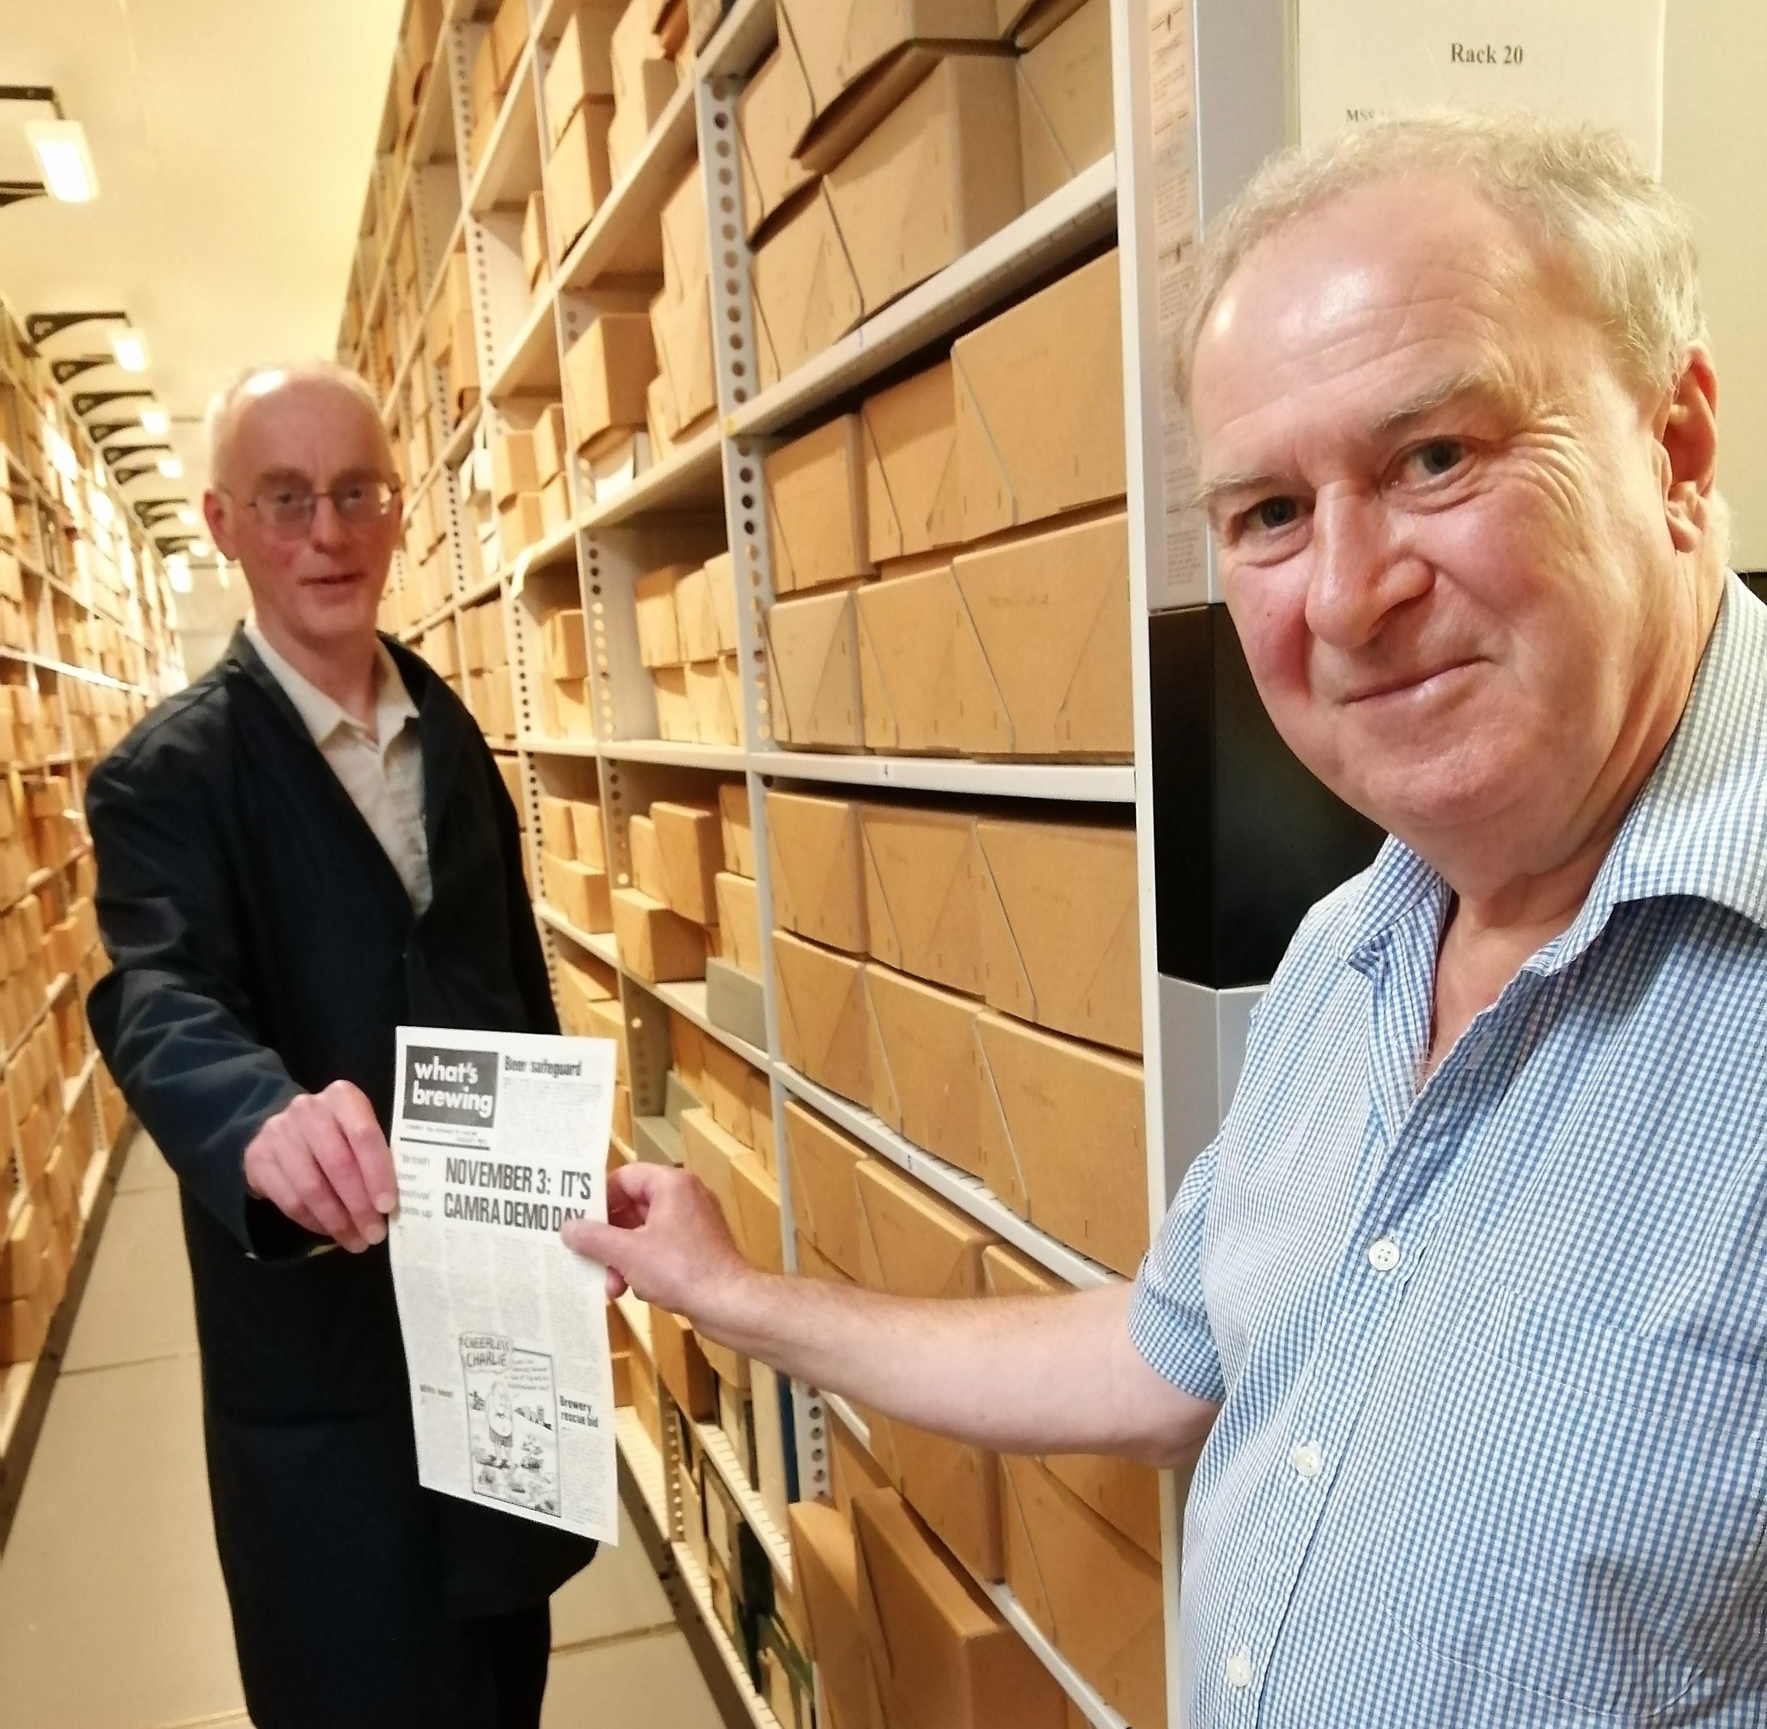

As CAMRA gets older, it’s inevitable that we will lose many members who made a major impact on the Campaign and there will be many that newer members will not have heard of. But when they pass, it would be a crime not to commemorate their life. Tony Millns (pictured right) is one such person, being CAMRA’s national chairman between 1982 and 1985. His impact and influence on CAMRA has been continuous during his lifetime. Tony was born in Doncaster in 1951. For anyone who met him, his intellectual prowess was indisputable, so it is probably no surprise to hear that he left Yorkshire to go to Merton College Oxford and then taught Anglo-Saxon literature at Cambridge. According to an interview in Laura Hadland’s book on 50 years of CAMRA, Tony was not impressed with the beer he found at university. “He enjoyed a wonderful selection of beer in the back streets of Doncaster where he grew up: local breweries such as Sam Smiths and John Smiths, Sheffield brewers such as Wards and Stones...” But “The charming college bar with beer on stillage from the barrel that he had encountered during his interview had been ripped out and replaced by a ‘huge new student vomitorium’ with modern Formica tables and all keg beer”. This experience clearly had an impact on Tony who joined CAMRA in the 1970s. Rumour has it that he was involved with the establishment of the Tyneside & Northumberland branch when he lived in the North-East some 50 years ago. He eventually moved to Cambridge, where he became active with the Cambridge Beer Festival, one of CAMRA’s very early beer festivals. Tony joined CAMRA’s National Executive (NE) in 1980 and very soon started to influence the Campaign nationally. At this time, the membership system was run using metal plates and ink! Tony worked with Pat O’Neill, an NE member who worked for IBM, to introduce a computerised membership system, which was ahead of the time. But investments like this didn’t come cheap and CAMRA was not on a good financial footing with the membership costs being more than the subscriptions and membership was declining. But there was no reduction in the need for campaigning funds, so a perfect storm was brewing. Tony became CAMRA chairman in 1982 with a clear vision to put the Campaign onto a more professional and fiscally stable platform and took steps to build a team around him that did exactly that. By the time Jim Scanlon took over from him as chairman, CAMRA was in a much better situation. But despite his seriousness, Tony could also show his sense of fun. In 1989, he stood as CAMRA’s ‘Keep Theakston's British’ candidate in the Richmond by-election as part of the campaign to stop Australian brewer, Elders IXL taking over S&N (which owned Theakston's at the time). During the election campaign he appeared with the candidate for the Corrective Party, Lindi St Clair, otherwise known as Miss Whiplash. Who could beat that! Tony subsequently stood down from the NE. Outside CAMRA, he had a large range of roles, ranging from a public relations officer at Cambridgeshire County Council to a CEO for several organisations and he continued to bring his wealth of experience to bear not just then but in subsequent years. This ability to apply his skills to different situations can be summed up by Roger Protz: “Tony Millns was a professional to his fingertips. He was for several years responsible for CAMRA Books, What’s Brewing and the Good Beer Guide and I appreciated, as editor of the latter, his support and his vital relationship with local CAMRA branches who supply the basic information for the Guide.” Latterly, Tony was the driver on setting up an archive with the University of Warwick to preserve key material relating to CAMRA’s formation and history over its first 50 years and onwards (above). And the last piece of work Tony was involved in was as chair of the Regions Review, which he had to stand down from due to ill health. But the last word, and a great summary, goes to Paul Carter: “Like so many others, I have many vivid memories of times working and socialising with Tony. It was always great fun debating contentious issues with him – despite any deep-down disagreements; he would make sure there was never any lasting animosity. During his tenure as national chairman, I was honoured to serve as Tony’s vice chair for a short time and I learned so much from him. He was in a league of his own.” Our thoughts are with Jill, his wife of many years.