Brewer’s January pub challenge

03/01/2025 by Timothy Hampson

Industry

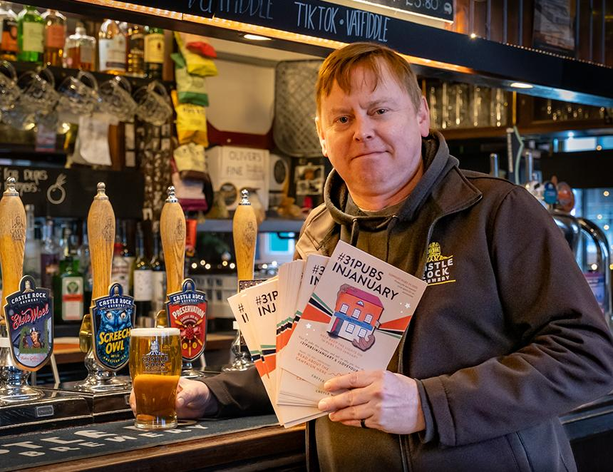

Castle Rock has set a challenge to Nottingham drinkers – visit 31 pubs this January. The idea is to get people out of their homes and into pubs. Customers will be encouraged to take to social media, sharing the hashtag #31PubsinJanuary along with a photo of the pub they are supporting. The hope is to prevent the eerily quiet period that pubs face once the festivities are over, which is renowned as being a particularly challenging month for the industry. The challenge is to visit the pub 31 times throughout January – the equivalent of one a day, although how customers take part in the challenge is up to them. Castle Rock’s MD Colin Wilde said: “I first saw this last year, when a friend of a friend challenged themselves to visit 31 pubs over January. “It was great fun to watch her journey and this year we wanted to amplify that brilliant idea, in hope that all pubs, not just our own, might feel the benefit.” Castle Rock’s marketing manager Jess Collins explained, while the campaign hopes to counter trends like Dry January, it’s not all about drinking: “On the contrary, our own findings have shown that the reasons people value their local pub is very rarely about alcohol at all.” Latest statistics show that on average, one in three pub visits in the UK are now alcohol free. “The fact consumer habits are changing and in general, people are drinking less and being more health conscious is a positive. What we’re looking to do this January isn’t to get people drinking – it’s to get people in the pub. Which can look very different depending on when and where you go. We’re encouraging people to celebrate the humble pub and what it represents, and it’s our hope we get people on board with a pledge to protect these places at their most vulnerable time, so that they’re still there when we are at ours.” Pubs are already finding new and positive ways to get people through the doors. The Poppy and Pint in Lady Bay hosts the Heron Wellbeing Music Café, a Monday morning meet up which aims to combat loneliness, especially for those suffering from dementia. Run by Musicworks, the café recently received an £80,000 National Lottery grant to support the work it does in the community. In a climate where loneliness is endemic, and research shows loneliness can be as detrimental to your health as smoking 15 cigarettes a day, Castle Rock sees pubs as essential spaces for communities to thrive. For years, the brewery has been collecting responses to the simple question, “What does your local mean to you?” One customer replied: “My local is a place of comfort and sanctuary, where worldly troubles are left at the door” and another, “my local is whatever I need it to be, whenever I need it. Long may it last!” While we are used to messages such as use it or lose it, which do not necessarily inspire support, Jess argues it’s easier than ever to benefit from the pub. “If you work from home, you can probably save money by working from the pub. Wi-Fi is usually free, you can save on your heating bills and lots of pubs also have fantastic lunchtime offerings that are miles better than a meal deal! "And because January can be so quiet, you’ll normally find that’s when all the really interesting events start happening – local history talks, wine tastings, art classes and everything else there’s no time for when summer finally comes around!” Pictured: Castle Rock’s head of sales Ian Bogie