Campaign pioneer remembered

02/01/2025 by Colin Valentine

Campaign

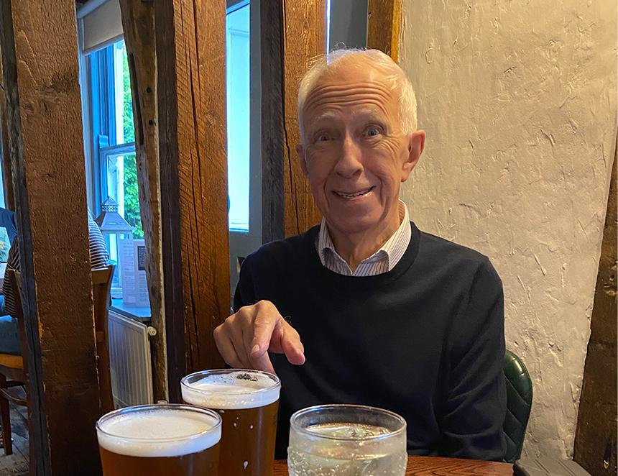

Former National Executive member and Edinburgh branch chairman Roger Preece has died in Norwich at the age of 82 after a short illness. He was an active member of CAMRA from the mid-1970s and was at the meeting in the Black Swan in Leith on 16 January 1975 when the Edinburgh branch was formed. He quickly became Scottish organiser before joining the National Executive (NE) in 1978, serving under the chairmanship of both James Lynch and the late Joe Goodwin, retiring in 1980. I asked James for his recollection of Roger, and he said: “Roger was one of the unsung heroes of CAMRA. Never in it for any personal recognition, praise or glory. A voice of calm, a voice of reason and utterly dependable and capable. Similar in those respects to other CAMRA giants like John Bishopp, Mike Nutt and Alan Hill, all, sadly, now dead. “Roger believed in everything that was positive about CAMRA. He knew there was a contribution he could make to the Campaign, and he did just that, going above and beyond what anyone could have asked or expected of him. “He was a good friend too and a real asset to the NE, which he joined when I was chairman. Someone to whom I could turn to for wise counsel and I did that many times. During the Revitalisation Project in 2016, at the consultation event in Norwich which I addressed, it was a great surprise to see him there with that beaming smile of his. Roger wasn’t an active member in the 1980s and 90s as he concentrated on his career and family but when he and wife Kate moved back north to Penicuik in 2003, he immediately threw himself back into local branch affairs, which was a real plus for me when I was branch chairman. We had a problem with the accounts when our treasurer left unexpectedly. Roger stepped in and sorted them out. We then had an issue with our branch magazine, Pints of View, when the editor had to give up. Roger again stepped in and edited it for a year or so while we sought a permanent editor, having been part of the editorial team when it was first launched in 1983. And when I had to step down as branch chairman due to being elected national chairman – well, I’m sure you already know who stepped up. Roger worked with Mercat Tours when he and Kate returned north, showing tourists the sights of Edinburgh’s historic Old Town. He put his love of history and breweries to good use when he designed a walk down the Royal Mile which visited the sites of many of the breweries on either side of this famous thoroughfare and I was one of the people who volunteered to be educated and entertained on the first trip. Some of the breweries are still standing and he filled us in on the history of each of the breweries and the surrounding area before heading to a local pub for a couple of pints. Roger was a genuine real ale pioneer and a real asset to the Campaign, both locally in Edinburgh and nationally during his spells as Scottish organiser and on the NE. It was a privilege to have known him and a real pleasure to sit in the pub and share a pint with him.