Seasons greetings from What's Brewing

24/12/2024 by Timothy Hampson

Campaign

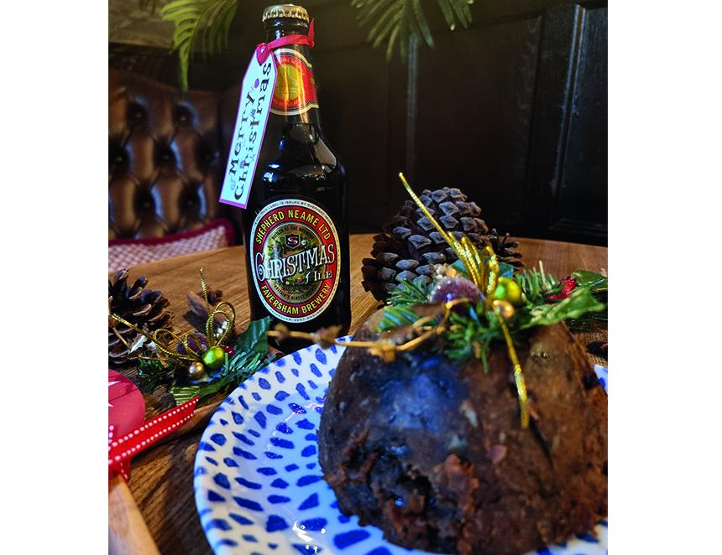

Seasons greetings to all What’s Brewing readers. The editorial team will be taking a few days off over the festive period, however, if you want to continue reading about CAMRA and its campaigns, did you know the Campaign has launched its new website? It is designed to get you to the pubs and pints you want, with the people you like, quicker and easier than ever before. As a member, it's all included. Look out for national chairman Ash Corbett-Collins’ New Year’s message on 31 Dec and What's Brewing posts will start again on 2 January. Log in to the new CAMRA site here.