Extra special St Austell flagship released

20/12/2024 by Timothy Hampson

Industry

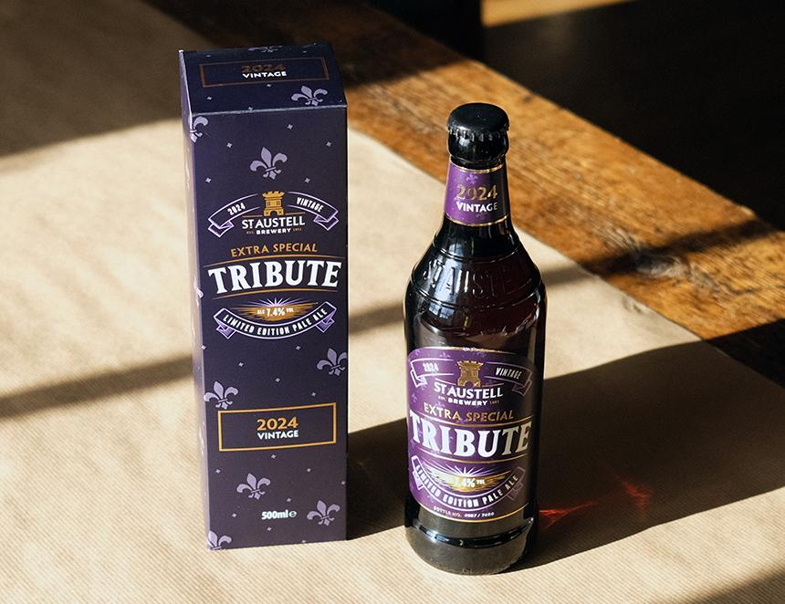

St Austell has released a supercharged version of its hugely popular flagship ale Tribute as a limited-edition brew. Crafted in small batches, Extra Special Tribute (EST) is as unique as the story behind it. Originally brewed in 2023 to celebrate the coronation of King Charles III at age 74, its 7.4 per cent ABV pays tribute to this milestone. With fewer than 6,000 bottles produced this year, each bottle is individually numbered to highlight its exclusivity, and with a five-year shelf life, the beer will mature and develop over time. St Austell’s brewing director Georgina Young, who was responsible for the special recipe, said: “In its debut year, the theme for our Extra Special Tribute focused on British heritage, showcasing carefully selected British hops. “For 2024, we’ve drawn inspiration from the original Tribute recipe, blending British Fuggles for bittering with American Willamette and Slovenian Celeia hops for a beautifully aromatic finish. “We bottled the beer in May, and it has been aged under perfect conditions. The beer’s secondary fermentation creates rich, maturing flavours reminiscent of fruit cake and Madeira. “This collectible beer will only grow more complex over time – making it perfect for savouring now or saving for next year’s release to enjoy a side-by-side comparison. It’s the perfect way to own a piece of brewing history, too!” This is the second in the EST series of limited-edition takes on the business’ flagship Tribute pale ale, which will be released annually as a collectible special edition.