Mitre joins historic elite

18/12/2024 by Timothy Hampson

Pub

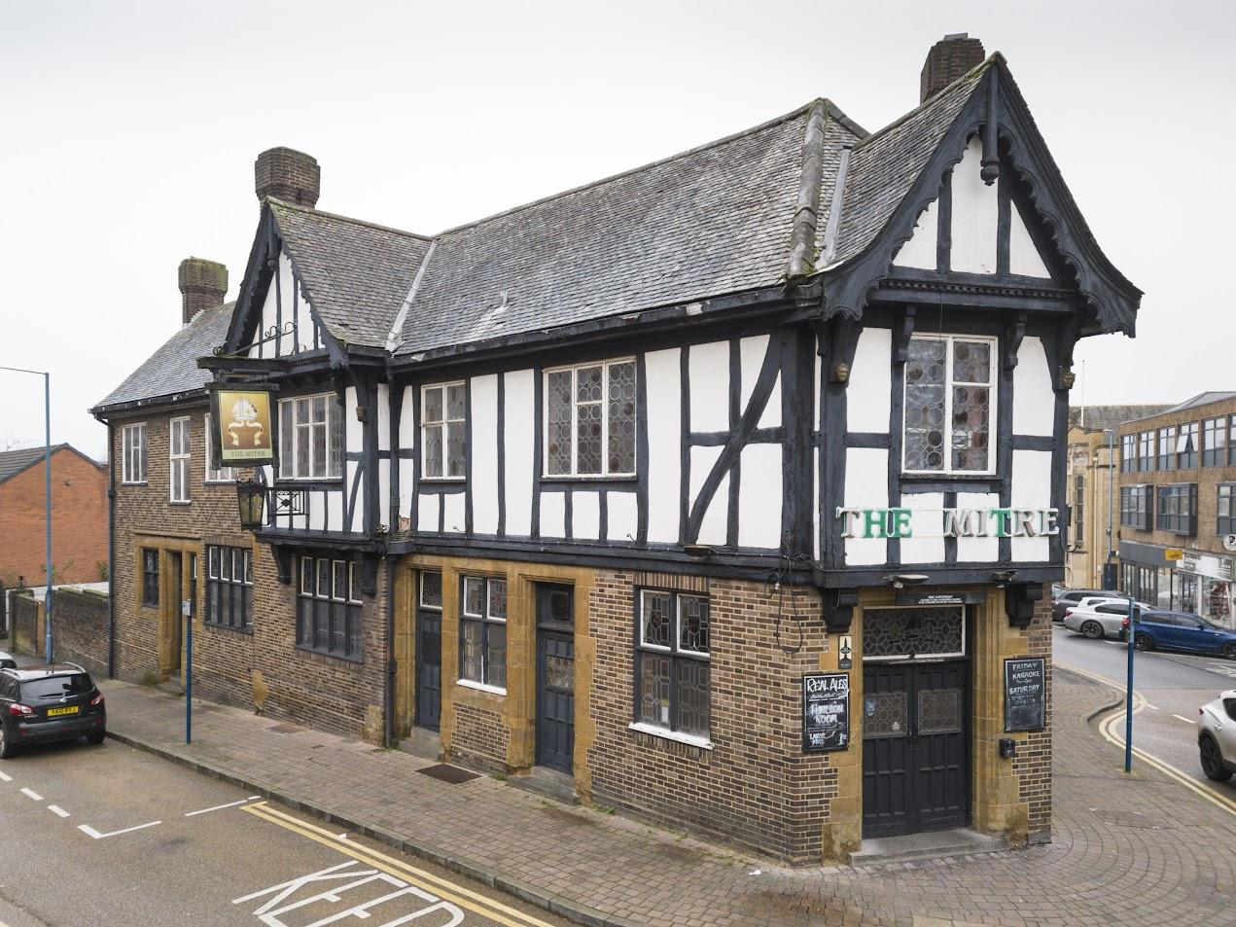

A 1930s Stourbridge pub has been given Grade II-listed status by Historic England following its nomination by CAMRA and the West Midlands Combined Authority. The Mitre Inn in Lower High Street is one of 17 “remarkable and unusual historic places that have been granted protection in 2024”. The pub was built in an era “that witnessed the transformation of British pubs for a more respectable clientele”. Other builds listed in the year include an innovative bungalow maternity ward – a leap forward in public healthcare for new mothers from 1928; a brutalist church above shops and three rare 17th-century chest tombs including the one of Mary Haddock whose son inspired the character of Captain Haddock in the Adventures of Tintin comics. Historic England chief executive Duncan Wilson said: “These remarkable places granted protection in 2024 show the diversity of England’s heritage.” The Mitre Inn, built between 1932 and 1934, is a remarkable example of the nationwide movement to transform public houses into more respectable drinking establishments. Its design, known as Brewer’s Tudor, was aimed at elevating the status of pubs through a more refined architectural style. Designed by Scott and Clarke of Wednesbury, nearby architects who designed many high-quality pubs in the inter-war years, the Mitre Inn boasts a bold exterior reminiscent of a medieval pub, with striking black-and-white timber beams on the first floor and embellished glass windows. The interior of the pub retains its original fittings, including intricate stained glass, bespoke fireplaces and an ornately decorated ceiling.  According to the pub’s citation: “This Brewer’s Tudor style pub stands as a hallmark of the ‘improved pub’ movement during the inter-war years. “With its bold exterior and richly decorated interior, the Mitre Inn represents a turning point in British pub culture to attract a more respectable, middle-class audience, leaving behind the reputation of drunkenness of Victorian pubs.”