Multinationals dominate pub cask sales

17/12/2024 by Timothy Hampson

Industry

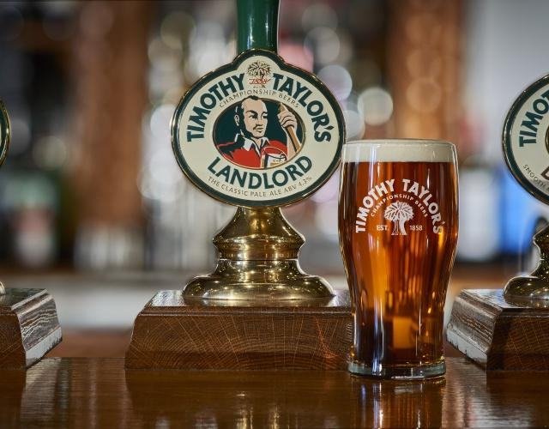

Keighley’s Timothy Taylor’s Landlord, is the top-selling cask ale by value in the annual Morning Advertiser Drinks List. Sharp’s Doom Bar retained the title of best-selling cask ale by volume, but Landlord has now overtaken it in value. Landlord has consistently been one of the strongest performing cask ales in the market, placing eighth in 2018, fifth in 2019 and 2020, third in 2021, second in 2022 and 2023 and again this year by volume, but first by value. In a list dominated by breweries now owned by multinationals – Sharp’s has been owned by Molson Coors since 2011 and Greene King were acquired by CK Assets in 2019 – Timothy Taylor’s stands out as one of the few regional, family-owned, and still independent breweries in the top 10. Taylor’s chief executive Tim Dewey said: “Here at Timothy Taylor’s, everything we do is designed to achieve the best and consistent quality. “The ongoing success of Landlord can be put down to our uncompromising brewing process, the very finest ingredients that we use in our beers, and the relentless hard work and commitment of our team. “From the brewery team to the sales team, office staff and our drays, and of course the dedicated pub and wholesaler teams responsible for looking after our beer once it’s left our brewery. “Landlord’s success rests on all our shoulders, and to see it become the top-selling cask ale by value in the UK, and top independently produced cask ale, is testament to that hard work. All for that taste of Taylor’s.” Top 10 by volumeSharp’s Doom BarTimothy Taylor’s LandlordGreene King IPAFuller’s London PrideWainwright GoldGreene King Abbot AleSt Austell Tribute Ale    Marston’s PedigreeOld Speckled HenBlack Sheep Best Bitter Data provided by CGA for the 12 months to 5 October 2024.