Neil Kellett – Campaign pioneer

16/12/2024 by Roger Protz

Campaign

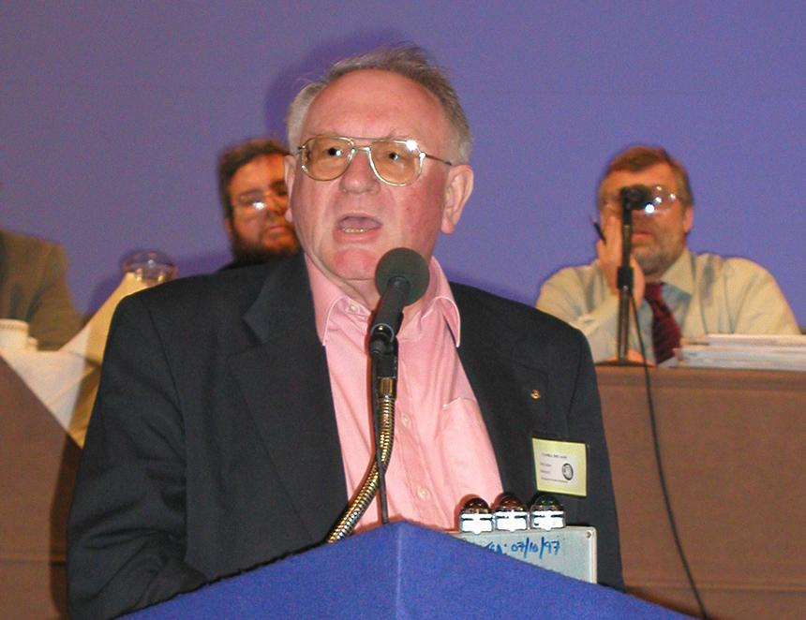

Neil Kellett, a CAMRA pioneer who played a vital role in keeping the Campaign solvent and able to challenge the power of big brewers, has died suddenly aged 83. He was an accountant and CAMRA’s auditor for many years. He also founded the CAMRA Members Investment Club in 1989 that bought shares in breweries. This enabled members to attend brewery AGMs and protest against policies that were not in the interests of cask beer. He was also active in the Campaign’s mainstream activities and was a founder member of the Stockport and South Manchester branch that celebrated its 50th anniversary this year. Chris Holmes, national chairman between 1975 and 76, said he first met Neil on a demonstration in Stamford, Lincolnshire, where Samuel Smith’s had bought the local Melbourn Brothers All Saints brewery and planned to close it. In between his CAMRA activities, Neil was a constant traveller in search of good beer. He did not disguise his support for the Conservatives but nevertheless spent many years travelling behind the Iron Curtain where many Soviet bloc countries offered historic beer styles. The Pilsner and genuine Budweiser beers of Czechoslovakia were especially outstanding, and the writer went on two trips there with him in the 1980s. As a result, whenever we met, he would greet me with “Dobrý den”, Czech for “How are you?” Neil, who came from Cheadle Hulme in Greater Manchester, was also a keen sports fan. He had a season ticket at Manchester City and loved cricket. On one occasion he brought friends – Dietmar and his wife – he had made in East Germany to watch a Test match at Trent Bridge. They were completely bemused by the arcane rituals of the English summer sport. Chris, who was at the game, recalls that Dietmar and his wife thought cricket would be like baseball but quickly discovered it was a very different game. “They even thought the machine used to soak up water after a rain break was part of the game,” he said. Neil was warm and friendly but was blunt where finances were concerned. He became the accountant for Chris’s Castle Rock brewery – now Tynemill – in Nottingham. “One year, when Neil finished the books, I thanked him for keeping me out of trouble,” Chris said. “Neil responded, more likely, I kept you out of jail.” He was equally outspoken about CAMRA’s national accounts. Dave Goodwin, national chairman between 1999 and 2004, said Neil told him he could do the annual audit on the back of a cigarette packet and the accounts were so bad that the Campaign should be wound up. Thanks to his efforts, more rigorous accounts systems at head office were installed and CAMRA became financially efficient and solvent. He launched the investments club as a result of running a similar private club of his own. Dave said the aim of the club was allow CAMRA members to invest in breweries and challenge their priorities. “We couldn’t stop takeovers and mergers, but we could challenge big breweries and their policies,” Dave said. “We owned a chunk of shares in breweries and went to their AGMs to question them and raise concerns about cask ale. “We’re still doing that today and the money we make from the shares is ploughed back into the club, not into member’s pockets. We also organise popular brewery trips.” As Neil prepared to retire, he told friends there were three countries he hadn’t visited. As a result, he went to Andorra, Albania and Malta on one last tour, using trains, planes and boats with the aid of his encyclopaedic knowledge of timetables. Neil never married. He died peacefully at his home where his last act was to send Christmas cards to his legion of friends at home and abroad. “You won’t get emails from me, you will get cards,” he said firmly. The cards numbered 150 – a measure of the man.