Festive beer ham

15/12/2024 by Christian Gott

Opinion

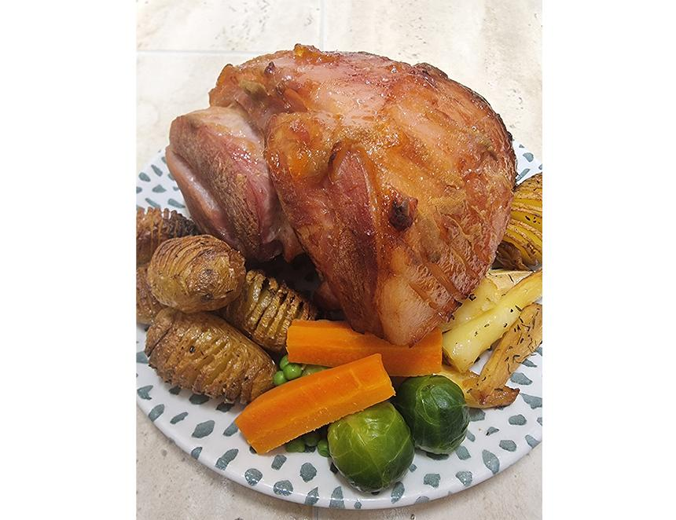

For my last recipe of the year, I wanted to post something which involves beer, is appropriately seasonal and, most of all, reflects my cooking style.  I like big bold flavours and the great combination of sticky, sweet and salty, much like you find in barbecue or Cantonese cooking. If, like me, you like all things American, home of sweet sticky marinades and sauces, then you will know 28 November was Thanksgiving. Much like a classic Christmas dinner, the centrepiece is often a turkey, but it can be a roast ham, which fits the bill for my recipe perfectly. Now being, excuse me, a glutton for punishment at Christmas time, I usually roast a ham on Boxing Day to add to the formidable amount of leftover turkey and then make a pie big enough that we can eat it through until the New Year.  The ham can be studded with cloves and glazed with apricot jam, mustard, and soft brown sugar, but in this recipe, you first need to cook the ham in an American pale ale. Why? Well, simmering the ham in water helps create a joint that carves much better than one that is just cooked in the oven and simmering in beer can add a ton of flavour to your finished roast.  I’ve chosen Hepworth’s Sussex American Pale Ale for a few reasons. Brewed in Horsham, Sussex APA is gluten-free and darker than the average American pale ale. It has plenty of stone fruit aromas and a sweet rather than bitter profile, which pairs perfectly with the ham. The brewery is well worth visiting with several great innovations ensuring maximum sustainability, including sourcing heat from the fermenting beer and using an anaerobic digester to produce energy from what is essentially waste. 2-3kg ham joint2 330ml cans Hepworth’s American Pale Ale100g soft brown sugar100g apricot jam1 onion, peeled1 large carrot, peeled1dsp mustard seeds1tsp coriander seedshalf tsp black peppercorns2 bay leavesCloves (optional) Place the ham in a large pan and cover it with cold water, leave for half an hour and then rinse and repeat the process to remove any excess saltiness. After rinsing again, replace in the pan with the onion, carrot, spices and one tin of beer. Add enough cold water to cover the ham. Bring to a boil and turn down to a gentle simmer. Cook for one hour then remove the pan from the heat and allow the ham to cool in the cooking liquor.  Place the jam, sugar and the second can of beer into a heavy-bottomed pan and slowly reduce by two thirds. You will need to stir to prevent the mix from catching and burning. Very carefully remove the ham from the pan and take off the skin. Score the fat diagonally with a small sharp knife and stud with cloves if required. Preheat your oven to 350F/180C/Gas mark 4 and place the ham in a lined baking tray. Spoon half of the beer glaze over the ham and place into the oven. After 10 minutes, spoon over the remaining glaze and cook for 20 more minutes, spooning the glaze over the ham every five minutes. Remove the ham from the oven and allow to cool for at least 15 minutes before carving.