PUBlic Affairs round up – December

14/12/2024 by Tori Wood

Campaign

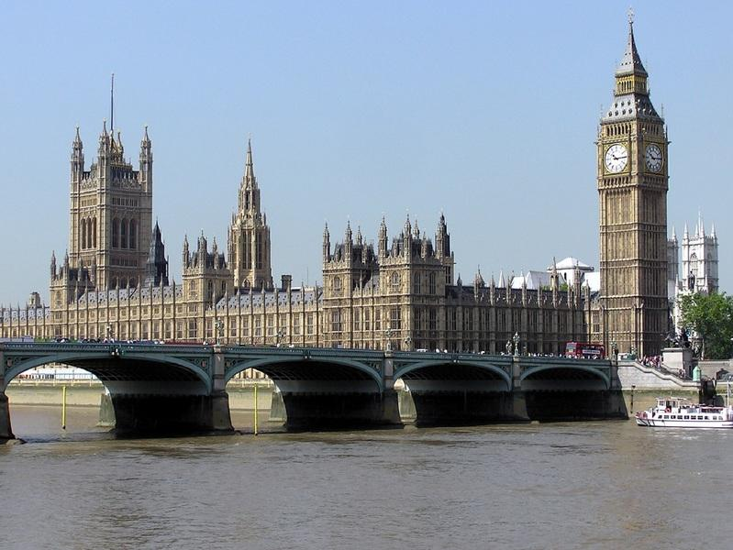

The regular PUBlic Affairs round up returns with 2024’s final update of the year, detailing what CAMRA’s Campaigns and Communications Team has been working on across Westminster, the devolved parliaments and local government in support of consumers, pubs and clubs.    Westminster  House of Commons debates  On 12 November an adjournment debate on Pubs Code and the provision of guest beers took place. CAMRA and the Society of Independent Brewers (SIBA) teamed up to prepare briefings for the debate.  Additionally, the team shared the debate across CAMRA’s social media platforms and thanked Julie Minns MP (Labour, Carlisle) for convening it.   The team also briefed Liz Jarvis MP (Liberal Democrat, Eastleigh) for her Westminster Hall debate Government support for the hospitality sector in Eastleigh on 4 December.   Parliamentary Questions  After successful pre-Budget Parliamentary Questions were asked on business rates and draught duty, the team has continued its work with MPs to ask more Parliamentary Questions to reiterate business rate problems, National Insurance contributions and the status of the government’s review of access to market for independent breweries.   Business Rates  Following the October Budget announcement on a permanent lower multiplier rate for retail, leisure and hospitality businesses in England from 2026/27, more details have been revealed.  The legislation will see no changes in how rates are calculated for pubs, however, broader reforms are due later, and the recognition of high rates for hospitality in comparison to online sales warehouses is a promising start.  Pubs will, however, face a rise in rates prior to the introduction of the new permanent multiplier in 2026, so CAMRA will be urging the government to monitor the financial impact this will have to ensure the loss of more of these businesses is prevented.  The Treasury has published a Transforming business rates discussion paper, and the team will be attending a round-table discussion with hospitality sector representatives and civil servants about reforming the business rates system.   Smoking ban [England only] The government confirmed the proposal to ban smoking in beer gardens has been dropped from the Tobacco and Vapes Bill.  To ensure beer gardens remain dropped, CAMRA will continue to monitor it and potential legislation similar to the UK government’s previous proposal from devolved nations.  High Street Rental Auctions [England only] The High Street Rental Auction scheme went into effect from 2 December. Local authorities can provision the use of any vacant high street property when leasing a premises.  The team has provided CAMRA branches with materials to ask their councils to lease vacant pub premises for pub use, and for their fixtures and fittings to remain, in order to avoid further loss of pub businesses.  Proposed community right to buy [England only] CAMRA hosted a discussion at the Antwerp Arms community pub with civil servants from the Ministry of House, Communities and Local Government to discuss Community Right to Bid plans.  Further discussions on the necessity of Asset of Community Value listings to be aligned across local authority areas were had.   Carlsberg/Britvic merger The team has made a formal submission to the Competition and Markets Authority (CMA) about its concerns regarding Carlsberg Marston’s Brewing Company’s (CMBC) purchase of Britvic.  Deposit Return Scheme The plan to simultaneously introduce Deposit Return Schemes in each UK nation with the use of identical materials has been interrupted due to the Welsh government’s withdrawal.  However, the Welsh government’s announcement states it will proceed with the scheme at a later date and will, additionally, include glass in the scheme, which will not be implemented in England, Wales and Northern Ireland when it commences in 2027.  Our work with civil servants and parliamentarians continues to ensure both schemes are compatible, and that consumer choice, costs to business and the viability of independent breweries and cider makers is minimally impacted.    Scottish government and parliament  Scottish government’s Budget The Scottish government announced its Budget plans on 4 December to match the UK’s 40 per cent business rates relief for the hospitality sector. CAMRA’s announcement can be read here. Cross-Party Group on Beer and Pubs (secretariat service provided in part by CAMRA)  The Cross-Party Group on Beer and Pub’s AGM will take place in January.  Scottish Pubs Code The team continues to attend the six-weekly stakeholder meetings with the Scottish Pubs Code adjudicator, Sarah Havlin in preparation for finalising an approach towards implementing the legislation in April 2025.  The adjudicator confirmed the implementation will not be delayed or implemented in stages and stated the importance of delivering protections for tied tenants as a matter of urgency.  CAMRA provided an official submission to the recent phase three consultation on the Scottish Pubs Code. This included the Market Rent Only process, use of flow monitors on guest beer lines and information for potential tenants before their decision to take on leases.    Welsh government and Senedd Cymru  Welsh government’s Budget The Welsh government confirmed it will be continuing its 40 per cent rates relief for Welsh pubs in its Budget on 10 December.  Ministerial meeting A meeting with the team and Welsh government minister for Economy and Planning, Rebecca Evans MS, has been arranged to discuss our campaigning on planning and business rates issues.  Cross-Party Group on Beer and Pubs (secretariat provided in part by CAMRA)  Joel James MS (Conservative, South Wales Central) was recently elected group chair.  CAMRA will continue to provide secretariat in part with SIBA and the Westminster All-Party Parliamentary Beer Group on official reappointment.   An event for MSs to taste Welsh beers will be held by the group on 12 February 2025.     Northern Ireland executive and assembly  Licensing Review The independent review of the licensing system is due to be handed to the executive, with a response from ministers due in the new year.  Belfast Beer Festival hosted a round table for local producers and MLAs. CAMRA’s Discovery Bar offered campaigning resources to attendees, where more than 1,350 campaigning postcards and 180 e-lobby messages were obtained and sent to MLAs.  The Campaign also received social media traction from MLAs, such as Paula Bradshaw MLA, while others have written to the communities minister and tabled Parliamentary Questions in the Northern Ireland Assembly.  CAMRA’s regional director for Northern Ireland Ruth Sloan and campaigns and communications manager Paul Edgeworth met with Robbie Butler MLA (UUP, Lagan Valley) and John Stewart MLA (UUP, East Antrim) at Stormont.      Non-parliamentary  Carlsberg cask delisting The team exclusively reported on CMBC’s plans to delist 11 beers – including eight cask – before the new year which has received a great deal of press coverage.   CAMRA will continue to prioritise this issue and raise awareness through social media channels and other media outlets.