Making our niche mainstream

14/12/2024 by Laura Hadland

Opinion

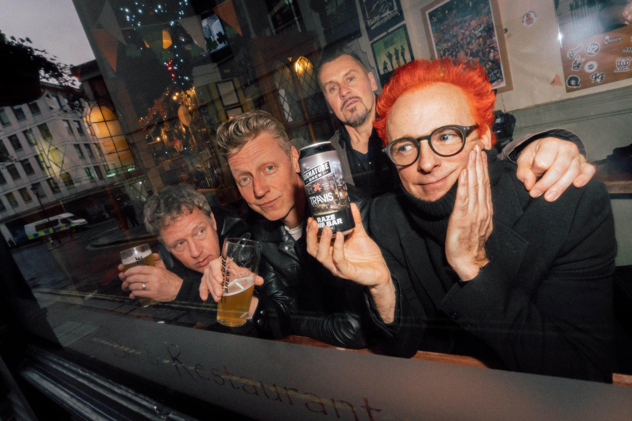

As times get harder, more breweries are seeking collaborations. They strengthen ties within the industry and help reach new audiences. Who among us wasn’t delighted to see the fine union between Timothy Taylor and Northern Monk produce the 4.4 per cent stout Northern Rising? And surely all of us let out a little sigh of pleasure when we saw the stunning label on Three Rules, the first three-way Trappist collab between Tynt Meadow, La Trappe and Zudert Trappist. Not to mention the squeaks of pleasure that occur when tasting the full-bodied 7.4 per cent Dubbel within. A great collaboration project is exciting. Two (or more) of your favourite breweries blending their styles and expertise. I love the thrill of finding a project that I’ve been keeping my eye out for in a pub. The expectation. The satisfaction that the beer is every bit as good as you’d hoped. But I’ve noticed breweries are thinking outside the box with their partnerships and I believe they are doing beer a great service. How does one spark joy with the local crowd better than working with their sports teams? Arguably no one is doing that better right now than Fierce Beer. In the summer, it launched a lager called 1983. It is served in the Fierce Beer 1983 Lounge at Aberdeen FC’s Pittodrie Stadium. A month later, it launched Slapshot – another lager but this time brewed for its friends at the Aberdeen Lynx ice hockey team. I’m sure those two 4.2 per cent lagers are unique, but regardless the brewery has followed up with Wasp, a 4.2 per cent dry Irish-style stout for the football club on the back of 1983’s success. Fierce is getting its beers in front of thousands of sports fans that it might not otherwise reach, presumably at home and away. We’ve got to respect how wonderful it is to see stadiums serving something more exciting than cooking lager to the fans. Music-inspired collaborations do the same job. They are not new, but they certainly seem to have stepped up a notch recently.  Brew York has now released two beers with Britpoppers Shed Seven, for example. The latest was Liquid Gold – a homage to the band from York’s biggest hit, Going For Gold, on the occasion of their 30th anniversary tour. If indie bands aren’t your thing, then maybe Bristolian brewer Moor’s collab with electro-punk-metal darlings Pitchshifter will get your toes tapping. Its session IPA, Genius, was available at certain dates of the band’s recent UK tour. That’s definitely improving beer quality thinking of most of the gigs I’ve ever been to. Bands don’t get much bigger than Glasgow’s Travis, (pictured) who have worked with a brewery steeped in musical heritage – Signature Brew in Walthamstow. Since its foundation in 2011, Signature has collaborated with more artists than any other brewery in the world. The new lager, Raze The Bar, is being stocked across the Travis’ near sold-out UK tour this month. While the official line is that Raze The Bar is “a crisp, refreshing helles with a soft malt backbone”, Travis bassist, Dougie Payne, explained to me that they had asked for the beer to be “a bit like Tennent’s” – a nod to the band’s early days rehearsing in an upstairs room of the Horseshoe Bar in Glasgow. “I’m not a real ale guy,” Dougie said. “I know people will laugh at me for saying it, but a good pint of Tennent’s is the greatest thing in the world for me. We tasted [Raze The Bar] yesterday and it’s great. It’s got that Tennent’s thing, but also this lovely lemon citrus thing. It’s more complex. It’s delicious.” And it doesn’t end there. Siren Craft Brew had a brush with Hollywood over the summer, producing a red berry sour called Something in the Water with the team from Alien: Romulus. The release has been so popular with fans of the film franchise that empty cans of the limited-edition beer have been selling for up to a tenner on eBay. Which we can all agree is utter madness, but it goes to prove how successful collaborations like this are. From the silver to the small screen, the collaboration which inspired me to write this column was Mad Squirrel vs Taskmaster. I don’t think I’ve ever seen anything quite like it. A series of “ludicrous brews” were launched to promote the Taskmaster Live Experience spin-off from the Channel 4 TV show. It seems to be going down pretty well. Every time I’ve checked the webshop, the mixed case has been sold out. “The Taskmaster Collaboration has been extremely well received,” a Mad Squirrel spokesperson told me. “People are enjoying the beer, loving the design and names of the cans, as well as enjoying all the beer on draft at the live experience in London.” As we all know, a love of great beer is strangely niche for a country that sits comfortably in the top ten for volume of beer consumed annually. These enterprising souls are taking our subculture hobby and smashing it into the faces of the mainstream. Blimey, there’s even a Neon Raptor collaboration with Warhammer. These beers are tapping into the magpie instinct that fans often have to collect anything and everything to do with their chosen adoration. It’s fantastic. Travis’ Dougie Payne summarised it better than I could. “I think the novelty of the artwork and having us on the can will be the initial thing. But it’s a really good beer. So hopefully, they’ll come for the novelty and stay for the beer.”