Latest podcast explores malt

11/12/2024 by Timothy Hampson

Campaign

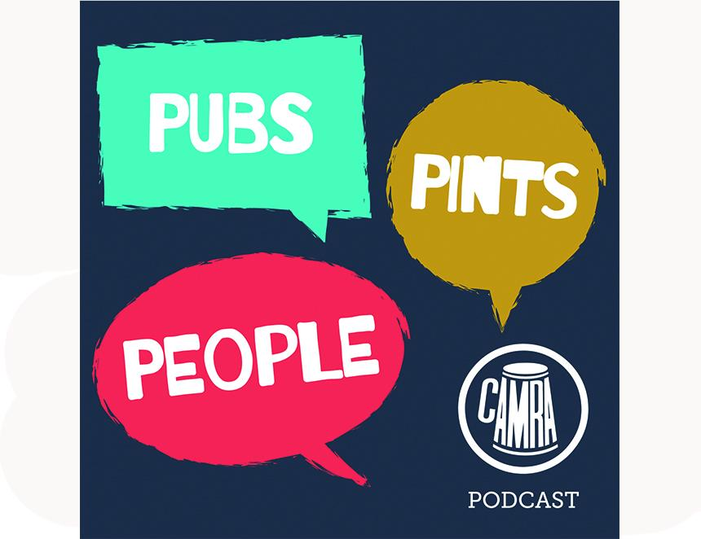

CAMRA’s Pubs. Pints. People. podcast is back with a new episode, this time dedicated to the key beer ingredient, malt.  In this fourth episode of the podcast’s seventh series, there are interviews with industry experts including Dr Dave Griggs of Crisp Maltings and Five Points head brewer Max Descloux. The hosts also chat with British Guild of Beer Writers award winner Mark Dredge and resident chef Christian Gott about the flavours of malt. The team visits family brewer Harvey’s at its Lewes home to speak with head brewer Miles Jenner and get a glimpse of its operation as well as discussing the malting process.   The podcast is produced and edited by a team of volunteers bringing stories about the world of beer, cider and pubs. Its hard work was reflected in the recent British Guild of Beer Writers Awards where the podcast was nominated in the Best Audio or Video Beer Communication category. The latest episode is available on Acast, Spotify and Apple Podcast, and wherever you get your podcasts. You can listen now at: camra.org.uk/about/podcasts