Three B’s buzzing again

10/12/2024 by Timothy Hampson

Campaign

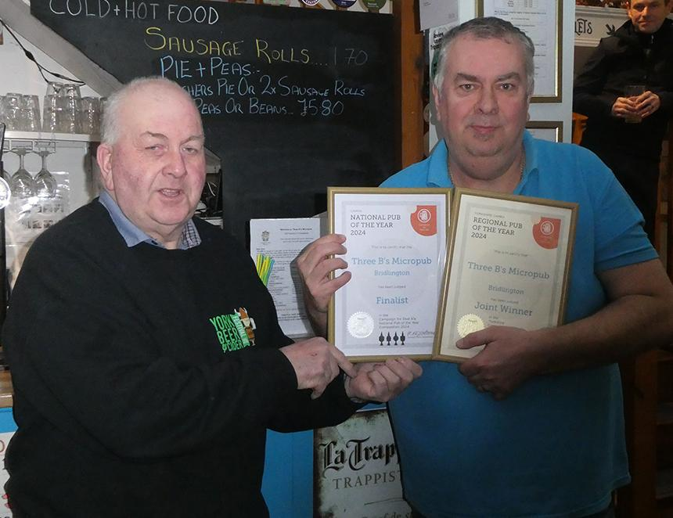

The multi-award winning Three B’s Micropub in Bridlington was recently awarded not one, but two CAMRA awards. CAMRA regional director Kevin Keaveny (above left), presented Three B’s owner and operator Mark Bates (right), with certificates for Joint Yorkshire Pub of the Year 2024 and National Pub of the Year finalist 2024. Kevin said: “The pub has been judged as one of the top four pubs in the country. The pub has also won the Yorkshire Post’s best pub award for 2024.” Mark said: “To win so many awards is truly amazing, we love winning the CAMRA awards but then for us to go on to win one which covers so many diverse pubs across Yorkshire is even more amazing.”