Welcome rates relief for Scottish pubs but review urgently needed

09/12/2024 by Timothy Hampson

Campaign

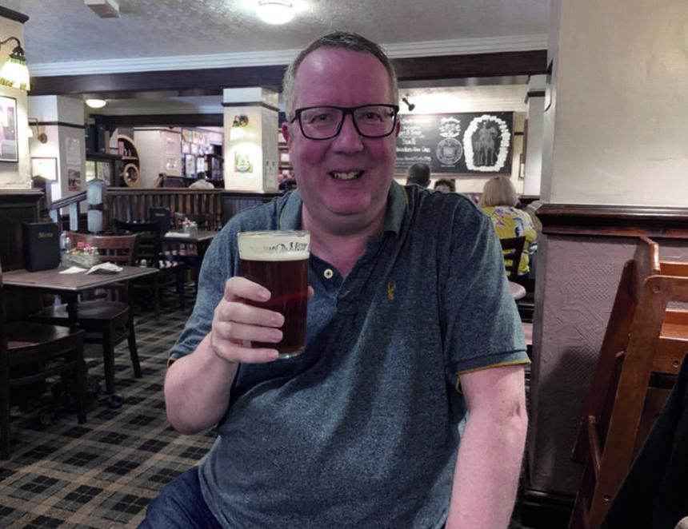

The Scottish government has listened to the country’s licensees and matched the 40 per cent business rates relief for pubs and restaurants announced in the recent UK budget. However, the measure is only for venues with a rateable value up to and including £51,000 – a caveat that will exclude many struggling businesses from this urgently needed financial boost. Now CAMRA is calling for a review of the business rates system. CAMRA director Scotland Stuart McMahon (pictured) said: “Pub-goers and licensees will be raising a glass to the news that the Scottish government is finally introducing help with the burden of business rates that have contributed to scores of pubs having to close their doors in recent years, and at a higher rate than elsewhere on these islands. “Pubs are a vital part of our social fabric, and it is right that they will now get the same 40 per cent reduction in business rates that pubs in England get. It is also encouraging that pubs in island communities will continue to get a 100 per cent reduction with their business rates. “In order to make sure our pubs survive and thrive at the heart of our communities, ministers must now commit to reforming the entire business rates system to make it fairer. The Scottish government should level the playing field between online and bricks-and-mortar businesses and finally end the shocking overpayment that pubs have to cough up under the current system.”