Brewing exit boosts pub profits

08/12/2024 by Timothy Hampson

Industry

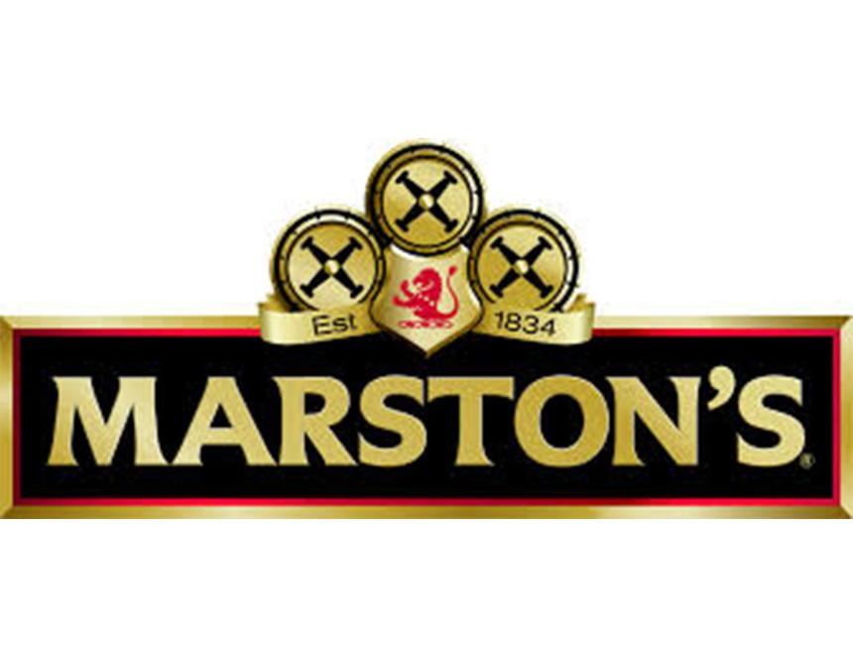

Pub group Marston’s has reported a rise in full-year profit and revenue as it posted an upbeat note about the outlook. Marston’s sold its 40 per cent stake in Carlsberg Marston’s Brewing Company (CMBC) in July and marked defining moment for the company, creating a pure-hospitality business focused on running and operating pubs and hotels. In the 52 weeks to 28 September, underlying pre-tax profit rose 64.5 per cent to £42.1m. Revenue grew 3 per cent to £898.6m and like-for-like sales were up 4.8 per cent, outpacing the broader market, with growth in both food and drink sales. The former brewer highlighted “positive” current trading, with like-for-like sales in the first six weeks up 3.9 per cent, “marking a strong start to the year and demonstrating continued growth ahead of the market”. The company also said Christmas bookings are tracking ahead of last year, with many venues securing high levels of reservations. Chief executive officer Justin Platt said: “2024 has been a defining year for Marston’s as we began an exciting new chapter as a leading pure-play hospitality business.  “The sale of our stake in CMBC has been transformational, enabling us to significantly reduce debt, increase our flexibility and focus on what we do best: running great local pubs. This single-minded focus, combined with our rejuvenated strategy, is already showing in strong financial results.”