Pub low-alcohol sales grow

07/12/2024 by Timothy Hampson

Industry

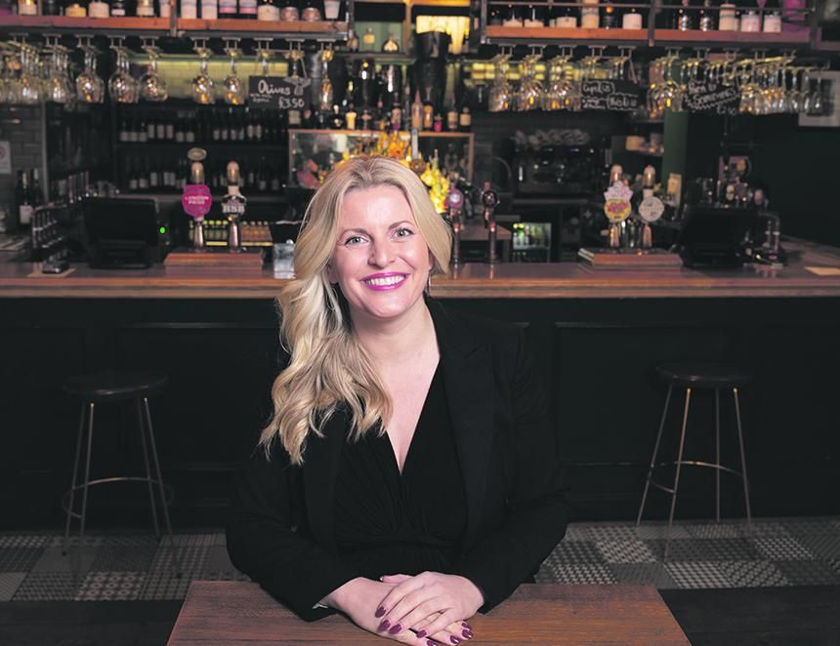

People across the UK are turning away from traditional beers in favour of no and low-alcohol options. Around 86 per cent of pubs and bars were found to be offering alternative options, making them “even more inclusive”. Pubs throughout the country are expected to sell a record 140m pints of low and no-alcohol beer this year, up from 120m last year. With Christmas parties in full swing, no and low alcohol beers are soaring in popularity, with new British Beer and Pub Association (BBPA) figures revealing a growth in sales.  In 2023 more than 120 million pints of no and low-alcoholic beers were drunk across the UK, with BBPA statistics estimating that sales could rise by a further 20m by the end of 2024.  BBPA data shows that pubs’ sales of no and low-alcohol in December 2023 amounted to 12 per cent of all sales for that year alone, up from 11 per cent in 2022. With the industry serving up more options and sales thriving, it means the pub is even more inclusive and welcoming than ever before this festive season, the BBPA said.  With no and low-options growing in popularity, it is important government takes meaningful steps over the coming months to address the disparity in UK descriptors compared to other markets.   The BBPA is calling on government to align existing no and low-thresholds with that of other nations to help drive sales and boost the economy.  BBPA chief executive Emma McClarkin (pictured) said: “Whether someone is choosing moderation, keeping pace with many Christmas festivities, or just doesn’t drink alcohol, these sales show brewers and pubs are catering to all.  “With the popularity of no and low increasing, we stand ready to support the government in taking the necessary steps to align our no and low-alcohol descriptors with other markets. This important move would allow the category to continue to flourish, benefit the consumer, and allow the pub to continue being a home away from home.”   The BBPA said the industry has adapted to changing habits, with more than 425,000 bulk barrels of no and low-alcoholic beer, equivalent to 120m pints, sold in 2023. This is up 14 per cent on 2022, when more than 370,000 bulk barrels were sold.  In the UK the existing threshold for ‘alcohol free’ is 0.05 per cent ABV, whereas many other nations define alcohol free as 0.5 per cent. Aligning the thresholds will provide a level of fairness for UK brewers and will help to contribute towards the government’s commitment to drive growth which will boost the UK economy.  Taking this step will raise awareness of the no and low-options, support innovation, and provide even greater choice to consumers, the BBPA said.  Lucky Saint founder Luke Boase said: “There is an exciting opportunity for the government to support consumers in understanding no and low-drinks, and that will create a hugely positive impact on the health of the nation.  “Clear descriptors that align with other markets will help unlock availability, raise awareness and drive consumption of alcohol-free drinks across the country. We welcome the government’s support for the no and low-category to help realise its potential.”  The no and low-category continues to grow at a rapid rate year-on-year with 86 per cent of pubs now serving an option, and eight per cent serving it on draught, up from just two in 2019. This is compared to 77.8 per cent and 1.7 per cent respectively in 2019.