More choice but at a price

06/12/2024 by Timothy Hampson

Industry

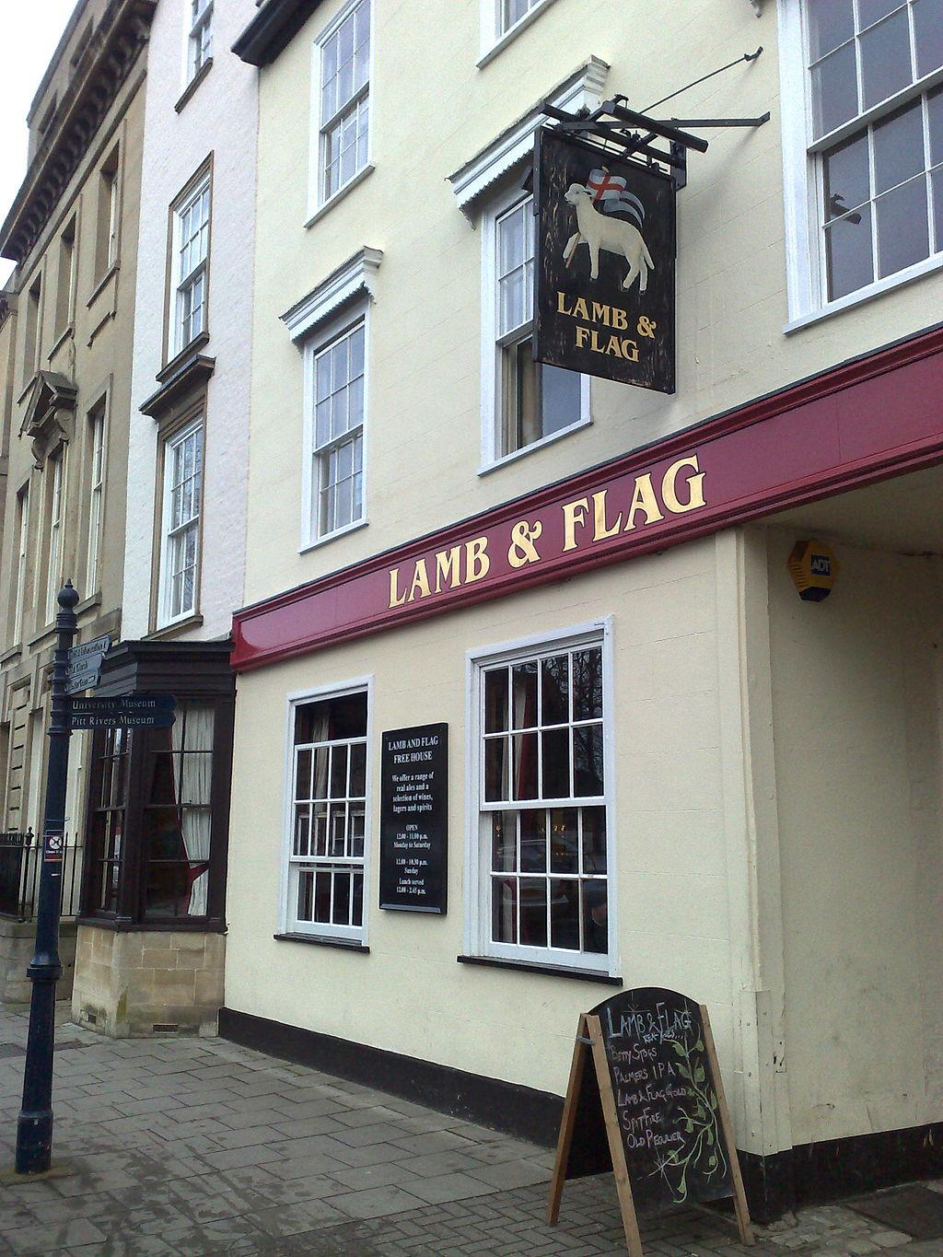

Oxford CAMRA’s annual survey of real ale in the city centre found increases in both prices and choice. Beer prices are moving ever upward, and can be expected to rise still further as pubs grapple with the impact of the recent Budget on employers’ National Insurance contributions and an increase in the National Living Wage. The survey found there were 113 real ales available this year compared to 100 in 2023. Conducted by CAMRA members on a Saturday afternoon in November, the survey considered only traditional cask or real ales – with some craft keg products typically costing £1 a pint more. The 25 pubs covered were in the city centre. The most expensive pint found was £6.55 for a Fuller’s seasonal ale in the newly refurbished Head of the River, followed by £6.45 at the Turf Tavern for a Greene King special beer. Both pubs are popular with visitors to the city. The least expensive pint outside Wetherspoon was still £3.80 in the White Rabbit (same as last year) but the number of pubs where you could not get a pint under £5 has gone up from six to 12. The most commonly occurring price this year was £5.60 as opposed to £4.50 last year. Prices at the two Wetherspoon pubs, the Swan & Castle and Four Candles, were actually down on 2023 with all at £2.49 a pint, except for Greene King IPA at £1.99. In the 2023 survey, all real ales cost £2.88 or £3.11 a pint, with IPA at £1.99. Wetherspoon is still the place to go if you’re on a tight budget, with CAMRA members also having 50p per pint discount vouchers to cut costs even further. The spread of breweries was similar the previous survey when Landlord, Abbot and Doom Bar all turned up four times, and proves how difficult it still is for small local breweries to gain a foothold in city-centre pubs, which are mainly controlled by large breweries such as Greene King or pub companies having deals with national brands. The branch survey took place in light of last month’s Budget when chancellor Rachel Reeves announced a cut of 1.7 per cent to draught duty tax, promising “a penny off a pint in a pub”.