New era for brewery as founder returns

04/12/2024 by Timothy Hampson

Industry

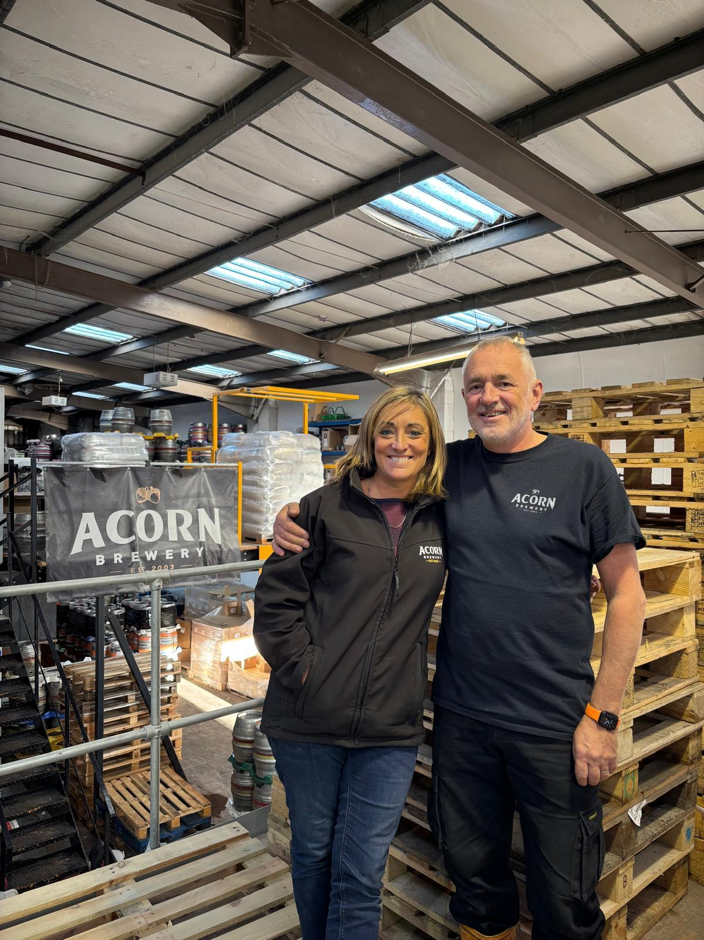

Yorkshire’s Acorn brewery is marking the return of its founder with the roll-out of a six-strong Reboot Series to herald a new lease of life. The series launches as former boss Dave Hughes again takes the helm at the Barnsley brewery, founded in 2003, which quickly expanded to produce on a 25-barrel cask ale plant.  Last year a phased sale was agreed with Manchester-based Sonas Capital.   Now business development company Sonas has relinquished all interest, handing back control of the company (Acorn Brewery Ltd) to the Dave and Christy Hughes as sole directors and opening a new chapter in its award-winning story.  Dave said: “Born as a humble 10-barrel plant in Wombwell, Acorn became successful in a highly challenging business environment.  “Now, we are set to steer the brewery once again with determination and innovation to assure our valued suppliers, treasured trade customers, and loyal beer fans that Acorn goes forward offering the best quality cask ales and first-class service.  “While the Reboot Series brings a touch of nostalgia to revisit brews from our early days, we also promise exciting and innovative new roll-outs to meet the needs of a keenly competitive market. We look forward to again working with long-serving brewer Steve Bunting and the team and thank them for their support.”  The first in the Reboot Series brings Noel (4.5 per cent ABV) a ruby Christmas pudding ale, well-received when first brewed in 2003. Legend, a 4.1 per cent rich red ale from 2005, follows for January, while in July Sun Storm – a 4.5 per cent a summer golden ale from 2008, arrives. Under Acorn’s motto of Innovation with Tradition, new brews will include a vanilla and white chocolate stout for Easter and a pale and well-hopped brew to toast Acorn’s 22 years. Today Acorn has a capacity of 170 brewers barrels (278 hectolitres or close to 49,000 pints) and supplies cask conditioned ale directly to hundreds of pubs and clubs throughout the North and Midlands with sales further afield via wholesalers and pub companies.  The core business remains cask ale while bottled and craft keg beers are also supplied to supermarkets and bottle shops.   Pictured: Dave and Christy Hughes