Plan your winter festival trips now!

03/12/2024 by Matthew Rogers

Campaign

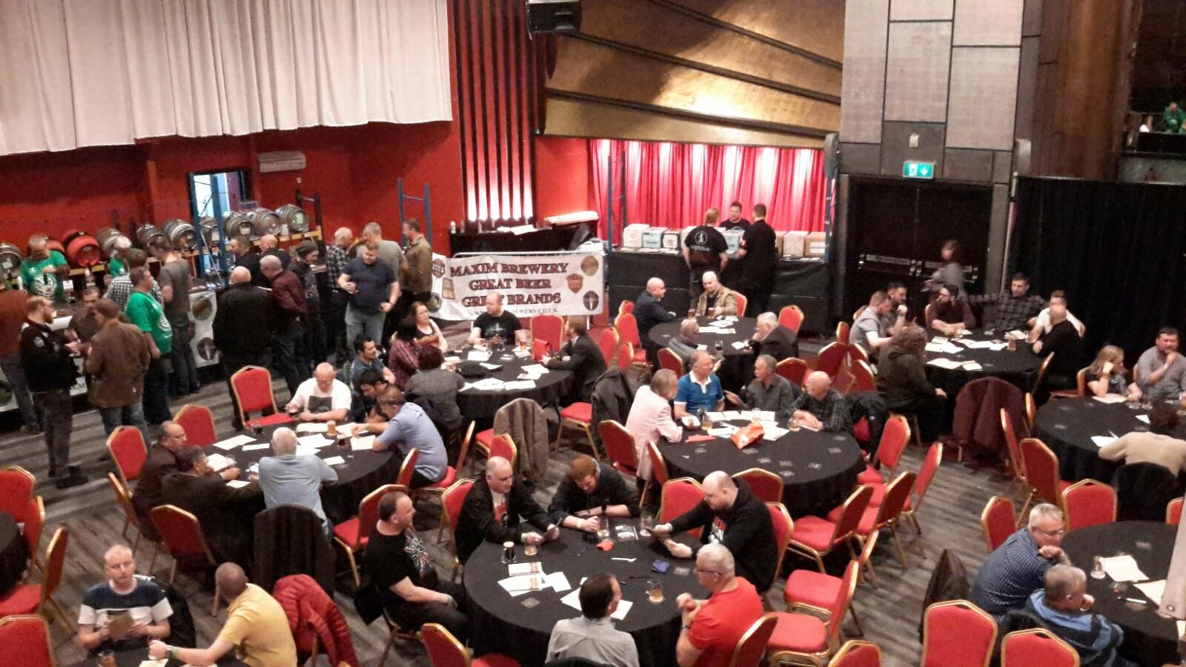

Plan your next festival trip using the list below. To see all upcoming CAMRA events visit https://events.camra.org.uk/   40th Pig’s Ear Festival, 3-7 December Round Chapel, 1d Glenarm Road, Hackney, E5 0LY http://www.pigsear.org.uk/pigs%20ear%20festival.htm   Exeter Festival of Beer, 16-18 January Exeter Corn Exchange, Exeter, EX1 1BW https://exeter.camra.org.uk/viewnode.php?id=147038   Pendle Beer Festival, 30 January-1 February The Muni Theatre, Albert Road, Colne, Lancashire, BB8 0AE https://www.pendlebeerfestival.co.uk/   Dorchester Beerex, 31 January-1 February 26 High East Street, Dorchester, Dorset, DT1 1EZ https://beerex.co.uk/   Bent and Bongs Beer Bash, 6-8 February Atherton Roller Rink, Bolton Road, Atherton, M46 9JG http://www.bentnbongs.com/   Tewkesbury Winter Beer Festival (TWAF2025), 6-8 February 65 Barton St, Tewkesbury, GL20 5PX https://www.facebook.com/profile.php?id=100064840352359   Chesterfield Beer Festival, 7-8 February Holywell Street, Chesterfield, S41 7SA https://chesterfield.camra.org.uk/chesterfield-camra-winter-beer-festival-2025   Great British Beer Festival Winter, 12-15 February Magna Science Adventure Centre, Magna Way, Templeborough, Rotherham, S60 1FD https://winter.gbbf.org.uk/   Liverpool Beer Festival, 13-15 February Metropolitan Cathedral Crypt, Liverpool, L3 5TQ https://www.liverpoolcamra.org.uk/   Darlington Beer Festival, 21-23 February Hopetown Darlington, McNay Street, Darlington, DL36SW https://darlo.camra.org.uk/viewnode.php?id=229748   Bradford Beer and Cider Festival, 27 February-1 March Victoria Hall, Victoria Road, Saltaire, Shipley, BD18 3JS https://www.bradfordcamra.org.uk/bbcf2025   37th Wigan Beer Festival, 27 February-1 March Robin Park Sports Centre, Loire Drive, Newtown, Wigan, WN5 0UL https://beerfestival.wigancamra.org.uk/